**Leitrim County Council**



**Planning and Development Acts 2000 (as amended)**

**Part XI**

*Planning and Development Regulations 2001 (as amended)*

**Part VIII**

**10 No. Dwelling Houses at Lahard, Ballinamore,**

**Co. Leitrim**

**Register Reference number 2021-C-01**

**May 2021**

Contents

1 Introduction 3

1.1 Site History 4

1.2 Site Services 4

1.3 Public Consultation Process 4

2 Policy Context 4

2.1 National Planning Framework - Ireland 2040 4

2.2 Rebuilding Ireland 4

2.3 Quality Housing for Sustainable Communities 2007 4

2.4 Climate Action Plan 2019 – To Tackle Climate Breakdown 5

2.5 Regional Spatial and Economic Strategy 2020-2032 (RSES) 5

2.6 Leitrim County Development Plan 2015-2021 5

2.7 Housing Strategy 6

2.8 Leitrim County Housing Strategy 2015-2021 8

3 Submissions 8

3.1 Internal Submissions 8

3.2 External Submission 9

3.3 Submissions from the General Public 9

4 Assessment 9

4.1 Density 9

4.2 Gradient/Siting 9

4.3 Dwelling Types 10

4.4 Access and Car Parking 10

4.5 Open Space and Landscaping 10

4.6 Boundary Treatments 10

4.7 Overlooking 10

4.8 Public Lighting 11

4.9 Climate and Energy 11

4.10 Environmental Impact Assessment 11

4.11 Appropriate Assessment 11

4.12 Flood Risk 11

5 Conclusion and Recommendation 12

# Introduction

Leitrim County Council is proposing to develop 10 No. dwelling houses at Lahard, Ballinamore, Co. Leitrim. The proposed development will comprise of 4 No. two bedroom units, 6 No. three bedroom units and 4 No. two bedroom units, provision of 23 No. car parking spaces, landscape works to existing open space and connection to existing infrastructure.

The proposed site is a greenfield site measuring approximately 0.915ha (2.6 acres) situated to the south east of Ballinamore Town Centre and to the immediate south of an existing housing estate. The lands are not currently landscaped, there is open space including a hardcore area located to the eastern half of the site. The lands are sloping downwards to the site.

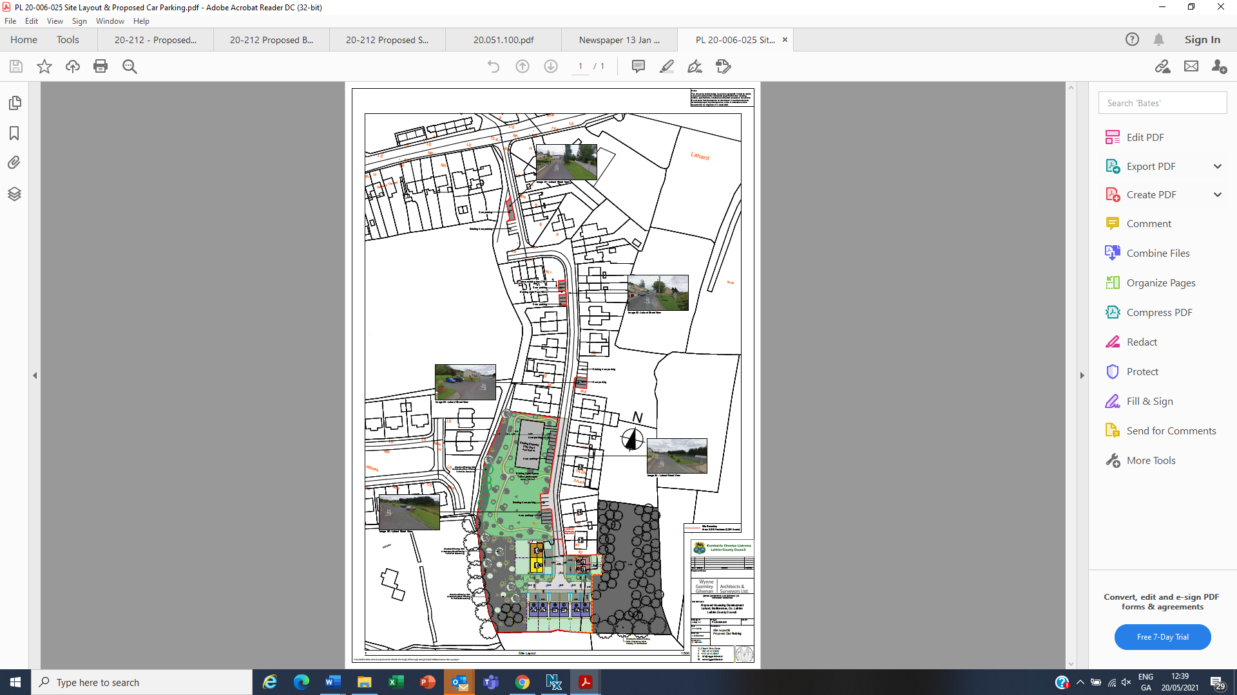

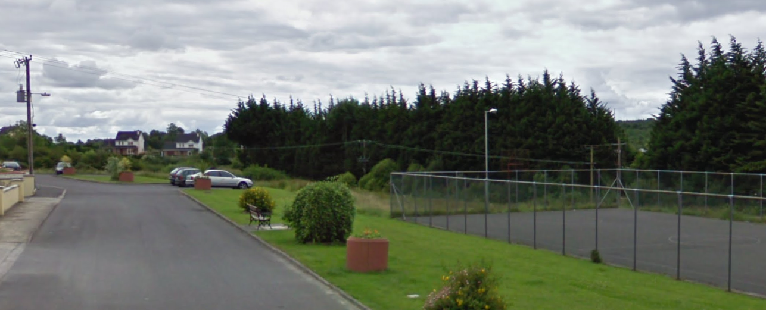

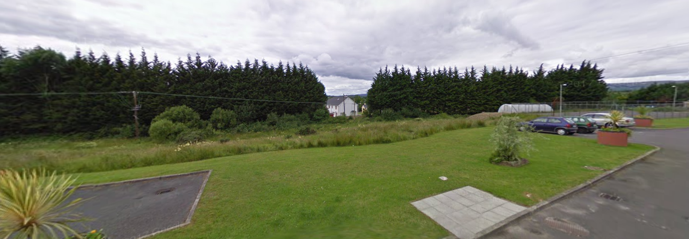

## 

## Site History

There is no planning history associated with the lands subject of these dwellings. There are a number of existing dwellings on the surrounding lands.

## Site Services

The site will be served by connections to the public water supply in the locality and existing foul sewer, both services now in the management of Irish Water. Surface water will be attenuated and drain to the natural drainage system in the area. Full details are provided in the engineering drawings forming part of this application.

## Public Consultation Process

The project was formally advertised for public consultation between 13th January to 24th February. Details of the project were available for inspection during normal office hours at the office of the Planning Authority and also on the Council website.

# Policy Context

## National Planning Framework - Ireland 2040

This document sets out the vision for the future growth of Ireland over the next 20+ years. It seeks to balance the future growth of Ireland and counterbalance the draw of people and resources to the Greater Dublin Area. National Policy Objective 1b sets out a target of population growth within the Northern and Western regions of between 160,000 -180,000. This proposed development contributes to strengthening the existing towns and build a critical mass of users to support economic growth and infrastructure. Ireland 2040 is targeting a greater proportion (40%) of future housing development to be within and close to the existing ‘footprint’ of built-up areas.

## Rebuilding Ireland

The Rebuilding Ireland strategy launched by the Irish Government in July 2016 seeks to address the shortfall in housing supply. This strategy is focused on “5 Pillars”, where Pillar 2 involves the accelerated supply of social housing. With a projected investment of approx. €5.85 billion it is planned to supply 50,000 social houses by 2021, 33,500 of which will be exclusively built as social housing. This proposed development is part of this Government strategy to increase local authority-built housing. This development will supply much needed housing units to the people of Leitrim and is a step to meeting the national targets set by the Government in 2016.

## Quality Housing for Sustainable Communities 2007

The successful design of a good quality sustainable housing project depends on the balance struck between a range of factors. Issues such as accessibility, security, safety, privacy, community interaction, availability of appropriate services and the provision of adequate space, should be given due weight. The needs and reasonable expectations of residents are of fundamental importance. The typical family dwelling will be required to meet the needs of infants, young children, adults and older people, either separately or in combination, at various stages of its lifecycle.

## Climate Action Plan 2019 – To Tackle Climate Breakdown

The accelerating impact of greenhouse gas emissions on climate disruption must be arrested. The window of opportunity to act is fast closing, but Ireland is way off course. As economic recovery has taken hold, it is clear that the link between prosperity and emissions has not been broken.

Agenda 2030 and the Paris Agreement on climate change require a transformational shift of our economies and societies towards climate resilient and sustainable development. Ireland and the international community are responding to this requirement, setting out a profound change in the systems and practices which support our lifestyle. Every home, every community, every workplace and every farm, must be mobilised to get involved. Every network which supports our lives – energy, transport, telecommunication, public service, waste management – must adapt rapidly. If we delay the transition, we as a country, shall most certainly face greater costs and fewer opportunities. The reality is that, only by adapting now, can our enterprises remain competitive and our society resilient.

Some of the key measures which will help create a framework across the entire public sector and beyond to support change shall include:

Buildings;

* Introduce stricter requirements for new buildings and substantial refurbishments.
* Design policy to get circa 500,000 existing homes to upgrade to B2 Building Energy Rating (BER) and 400,000 to install heat pumps.
* Build a supply chain and a model for aggregation where home retrofits are grouped together to allow this level of activity to be funded and delivered.
* Deliver two new district heating systems, and implement a roadmap for delivering District Heating potential
* Increase attention to Energy and Carbon ratings in all aspects of managing property assets.

## Regional Spatial and Economic Strategy 2020-2032 (RSES)

The Regional Spatial and Economic Strategy (RSES) for the Northern and Western Region sets priorities and provides a regional direction for planning at local level.

The health of our towns and villages can be significantly influenced through the delivery of new housing through the utilisation of existing buildings, brownfield/infill sites or otherwise. The NPF target for at least 40% of all new housing to be delivered within the existing built-up areas of cities, towns and villages on infill and/or brownfield sites is an important opportunity for our smaller towns and villages to be re-imagined and therefore it is included as a key objective.

*RPO 3.7.2 Support the regeneration of underused town centre and brownfield/infill lands along with the delivery of existing zoned and serviced lands to facilitate significant population growth and achieve the sustainable compact growth target of 30% of all new homes to be built within the existing built-up urban area*.

## Leitrim County Development Plan 2015-2021

The Leitrim County Development Plan 2015-2021 sets out Leitrim County Council’s policies and objectives for the proper planning and sustainable development of the County from 2015 to 2021. The Plan seeks to develop and improve, in a sustainable manner, the social, economic, cultural, and environmental assets of the County. The making of the Development Plan has been informed by the Housing Strategy, the Retail Strategy and the Strategic Environmental Report.

The requirements in respect to Social Housing, under Part V of the Planning Act, applies to Carrick‐on‐Shannon, Ballinamore, Drumshanbo, Manorhamilton, Carrigallen, Dromahair, Dromod, Kinlough, Leitrim and Tullaghan. In determining the extent to which Part V requirements apply, consideration has been taken of the existing level of social and affordable housing within each of the centres and the capacity of the centre to absorb such a requirement without inhibiting their sustainable development.

The Plan identifies Ballinamore as a Tier 2 town and sets out a number of policies and objectives which support this development at high level.

Section 4.2.1 *Reinforcement of Existing Towns and Villages* states that the Council is aware that much of the social and economic infrastructure of the County (Post Offices, Schools, Small Shops and Sports clubs, etc.) has been under threat from population decline. As such the plan includes Policy 6 set out below whereby development which consolidates existing urban centres is encouraged.

Policy 6 - *It is the policy of the Council to promote the viability of these facilities by encouraging new residential development to locate within the development envelope of existing towns, villages and other centres where these services are available.*

## Housing Strategy

This housing scheme is a response to the local need which is set out in the Leitrim Housing Strategy 2015-2021, which highlights the significant demand that currently exists within the County.

In terms of the Council’s role in housing provision the County Development Plan 2015-2021 addresses this through a number of policies and objectives.

Objective 21 - *It is an objective of the Council to provide Local Authority housing in all areas where the need arises for those persons eligible. The scale of social housing shall be commensurate to the scale of the settlement.*

Objective 22 - *It is an objective of the Council to implement Government policy in relation to all aspects of social housing.*

Policy 38 sets out the Council’s policy with respect to its need to supply social housing – *It is the Council’s policy to assist in the provision of houses or sites on lands acquired as part of the overall housing programme or under the provision of the Planning & Development Act 2000 -2014, or as amended.*

These policies and objectives show the importance which Leitrim County Council place on their role in the provision of housing and meeting national policy in this respect. The proposed development is an ideal location for a development of this nature and aligns with the principles contained within the Leitrim County Development Plan 2015-2021.

## Leitrim County Housing Strategy 2015-2021

The Leitrim County Housing Strategy 2015-2021 sets out a strategy for housing within the County over the lifetime of the County Development Plan, 2015-2021 and it is prepared in the context of the ‘Core Settlement Strategy’ required as part of the Development Plan.

*Housing Strategy Policy 1 - It is the policy of the Council to enable every household to have available an affordable dwelling of good quality, suited to its needs, in a good environment and, as far as possible at the tenure of its choice. The Council will pursue this; a) by the direct provision of housing.*

# Submissions

## Internal Submissions

The application was referred to the following:

* South Leitrim District Engineer. Comments Included:

*The applicant shall sign a connection agreement with Irish Water prior to the commencement of the development and adhere to the standards and conditions set out in that agreement.*

1. *All development shall be carried out in compliance with Irish Water Standards codes and practices.*
2. *Any proposals by the applicant to build over existing water or wastewater services shall be submitted to Irish Water for written approval prior to works commencing.*
3. *Any proposals by the applicant to divert existing water or wastewater services shall be submitted to Irish Water for written approval prior to works commencing.*
4. *Separation distances between the existing Irish Water assets and proposed structures, other services, trees, etc. have to be in accordance with the Irish Water Codes of Practice and Standard Details.*

*Reason: To ensure adequate provision of water and wastewater facilities.*

* Senior Engineer, Water Services Department, Comments Included:
  + *The proposed development lies near a water distribution area serviced by Irish Water.*
  + *The applicant is required to engage with Irish Water through the submission of a Pre-Connection Enquiry (PCE) in order to determine the feasibility of connection to the public water infrastructure.*
  + *Where the applicant proposes to connect to a public water network operated by Irish Water, the applicant must sign a connection agreement with Irish Water prior to the commencement of the development and adhere to the standards and conditions set out in that agreement.*
  + *The contractor shall apply to Leitrim County Council for a road opening licence prior to connection.*
  + *All works and drawings shall comply with the Irish Water Standard Details and the Irish Water Code of Practice for Water Infrastructure, Connections & Developer Services, Design & Construction Requirements for Self Lay Developments.*
* Senior Executive Engineer, Environment – No report.
* Access Officer, Comments Included:
* *Having reviewed the documents attaching to the subject file I have no objections to the subject proposal subject to the following conditions. All external environment infrastructure works are to comply with the guidance contained in Book 1 of Building for Everyone: A Universal Design Approach, published by the National Disability Authority. Details of compliance with the foregoing shall be submitted to the Planning Authority for agreement prior to commencement.*

## External Submissions

The application was referred to the following:

* An Taisce – No report submitted.
* Development Applications Unit. Comments Included:
  + *The applicant is required to engage the services of a suitably qualified archaeologist (licensed under the National Monuments Acts 1930–2004) to carry out pre-development testing at the site. No sub-surface work shall be undertaken in the absence of the archaeologist without his/her express consent.*
* Irish Water, Comments Included:
  + *IW has no objection in principle to the proposed development, in order to protect and ensure appropriate access to IW infrastructure, we respectfully request that any grant of permission and/or part 8 approval be subject to conditions to ensure adequate protection of and access to IW infrastructure.*
* ESB – No report submitted.
* Heritage Council – No report submitted.

## Submissions from the General Public

8 no. submissions were received by the Planning Authority from:

Alice Shiels

Amanda O Connell

Lahard Residents Association

Mildred Keegan

Olive Leddy

Patrick Leddy

Pius Flynn

Rachel Geoghegan

The issues are considered in summary, to be in relation to;

* Traffic –
  + Pedestrian movements restricted due to parking and poor condition.
  + Vehicular parking on the side of foot paths restricting emergency services.
* Green Space – removal and potential lack of open space.
* Vacancy of existing housing stock
* Flood Risk – site has previous history of flooding.
* Justification – Not reflective of Core Strategy.
* Water Capacity – Foul, drinking and storm water.

# Assessment

## Density

The proposed development site (public open space discounted) measures 0.66ha and achieves a rate of 15units per hectare. Given the site contours that exist on the site, it would not be feasible to achieve a higher density without compromising the residential amenity of the proposal or reducing the existing open space. As such the density achieved satisfies national policy while providing a high quality of residential development.

Section 5.3.3 of the Leitrim County Development Plan, states that generally the Council will encourage higher density of dwellings in towns and villages that are deemed to have adequate physical, social and economic infrastructure.

Owing to the character of the town, density of existing housing estate and restriction of the strong sloping lands in parts, it is considered that 10 no. units at this location reflects an appropriate use of lands and an acceptable housing density.

## Gradient/Siting

The housing development has been designed to take into account the significant sloped nature of the site, the total fall across the site being approximately 15.5 metres. This gradient resulted in limitations in the way in which the site could be developed and some retaining walls have had to be incorporated into the development to regularise the slope.

## Dwelling Types

A range of dwelling types and scales have been incorporated. There are 4 house types, as follows:

* Type A Two storey semi-detached: - 3 Bed – 102.5m²
* Type B Two storey mid-terrace: - 2 Bed – 68.1m²
* Type C Two storey semi-detached/end of terrace: 2 Bed – 70.1m²
* Type D Two storey semi-detached: 2 Bed – 80.2m²

|  |  |  |  |  |  |
| --- | --- | --- | --- | --- | --- |
| House Type | No. Units | No. Bedrooms | Floor Space sq.m | Minimum sq.m | Private Open space sq.m |
| A | 6 | 3 | 102.5 | 92 | 90-111 |
| E | 1 | 2 | 68.1 | 60 | 131 |
| F | 1 | 2 | 70.1 | 60 | 148 |
| G | 2 | 2 | 80.2 | 80 | 75-76 |

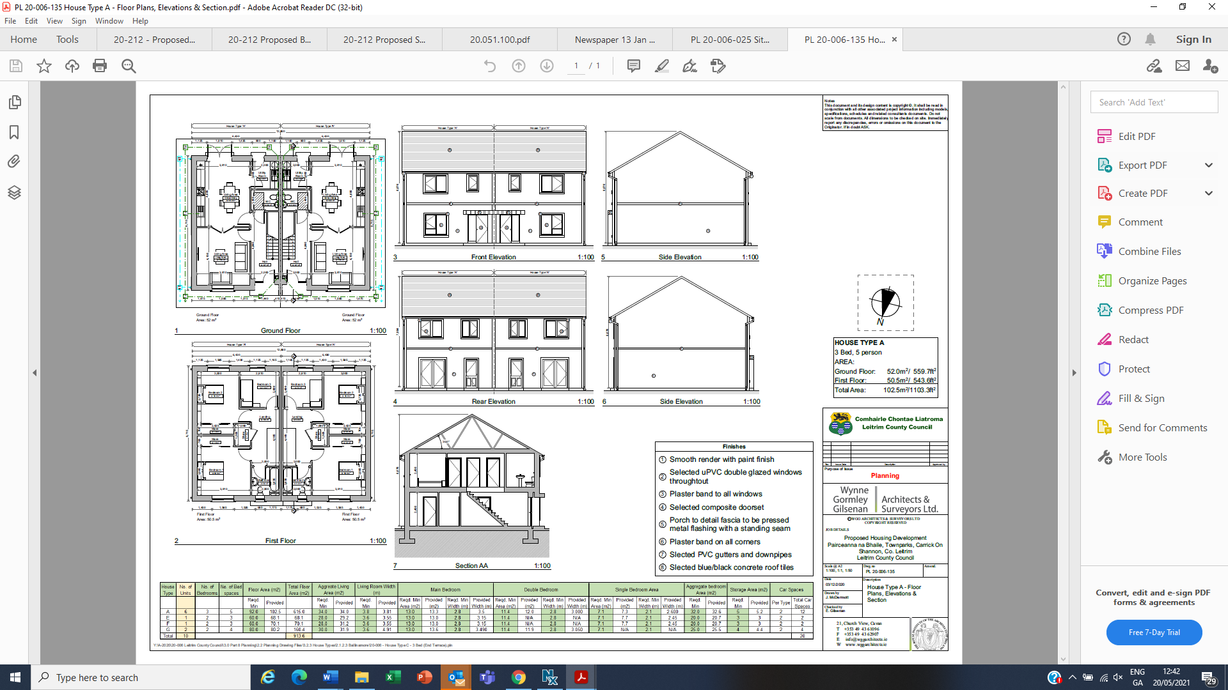

House Type A

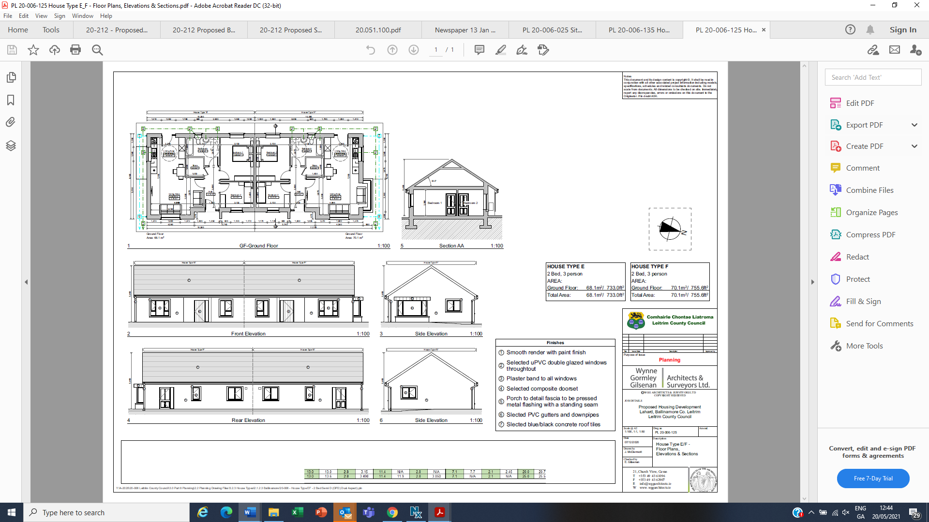

House type E, F

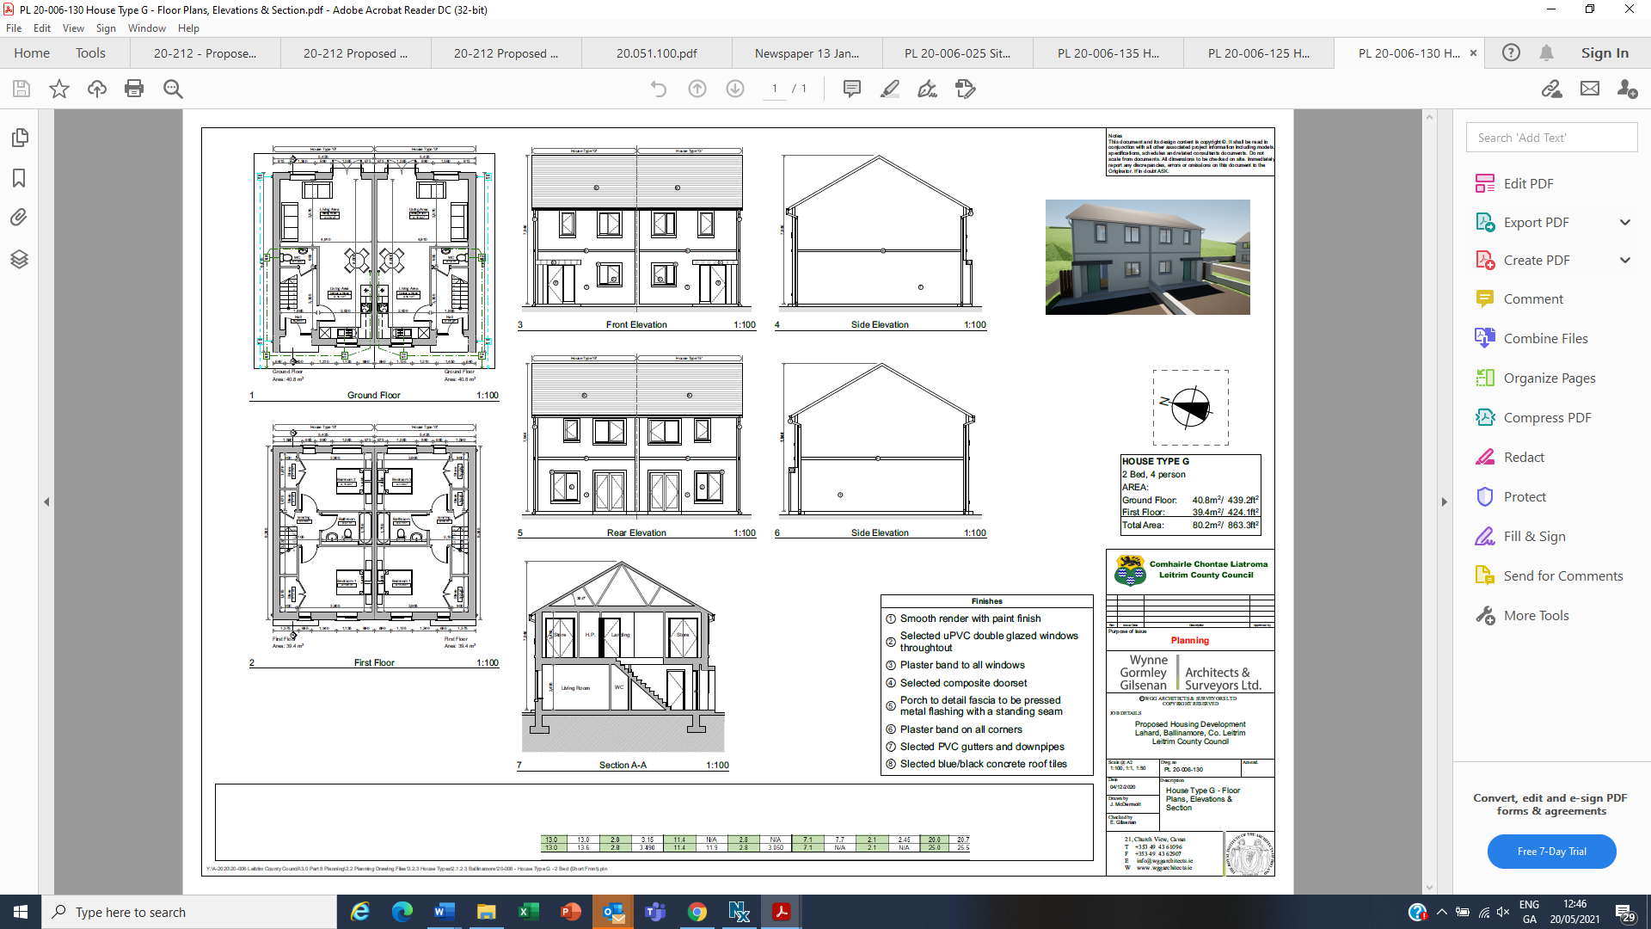

House Type G

## Access and Car Parking

The design team have taken full cognisance of the requirements of DMURS and other relevant guidance/ legislation. There are 2 no. car parking spaces provided to each dwelling located on site to the front of the dwelling. There are an additional 23 no. perpendicular car parking spaces proposed which are located along main access route to the housing estate.

Access to the proposed development site is via the existing Lahard Estate to the regional road R199.

As set out in Table 24 of the Carrick on Shannon Local Area Plan 2015-2021, car parking requirements for dwellings is set at 2 per dwelling. In line with these requirements the application states that all units have been provided with space for 2 no. parking spaces to the front of the houses. This provision of spaces in this manner should reduce the instances of kerb side parking. The additional spaces are provided for visitors to the area.

Proposed site levels will gradually slope and work with the existing site levels. Access to each unit will be in compliance with Part M of the Building Regulations. This is to ensure wheelchair users will be able to easily access each housing unit via a gradual ramp or gently sloping access routes depending on the severity of the site levels for each housing unit.

## Open Space and Landscaping

The proposed development provides 35% of the entire site area as public open space which is to be landscaped and retaining the hard surfaced playing area located to the north of the proposed dwellings.

## Boundary Treatments

A variety of boundaries have been considered, appropriate to the circumstances and locations:

* 1.2-metre-high wall to the front of each dwelling defining the site boundaries.
* 1.8-metre-high wall to the public side of house 51 & 52 (house type e & f)
* 1.8-metre-high wooden fence to each of the shared boundary to the rear of the dwellings.

## Overlooking

There are no existing dwellings located to the rear of the proposed dwellings. The dwellings are sited in such a location as not to give rise to any negative effect to the existing residential amenity.

## Public Lighting

No details have been submitted. This detail can be agreed and submitted thereafter.

## Climate and Energy

No information regarding the intended energy rating of the proposed dwellings have been submitted. It is considered that this can be submitted thereafter.

## Environmental Impact Assessment

A comprehensive EIAR screening assessment was carried out as part of the consideration of the proposed development by the Local Authority. An Environmental Impact Assessment Screening Statement had been prepared by Traynor Environmental Ltd. The proposed development which is 2% of the stated mandatory threshold of 500+ houses requiring the preparation of an Environmental Impact Assessment would not be likely to have a significant effect on the environment and the undertaking of an Environmental Impact Assessment is not required.

Notwithstanding this, a third party, Rachel Geoghegan, made a submission to An Bord Pleanala seeking a determination under Section 120(3)(a) of the Planning and Development Regulations 2001, as amended, in respect of this development.

In addition to reliance upon the Environmental Impact Assessment Screening Statement, the Planning Authority have considered the submission to the Board by Ms. Geoghegan. The Planning Authority would rely to these individual points in the following manner:

1. ‘ *The sewerage and waste water in the town of Ballinamore is already at capacity, which will cause an environmental disaster if expanded.’*

The most recent available data from Irish Water in relation to the Ballinamore WWTW capacity is from April 2020.This data is extracted from the Irish Waters assessment of Wastewater Treatment Capacity for the Towns and Villages in Co. Leitrim that have Wastewater Discharge Authorisations. The data for Ballinamore indicates that the overall capacity of the Wastewater Treatment Plant is 2,100 PE (Population Equivalent) whilst the current loading on the plant is 1,373 PE resulting in a headroom for expansion of 627 PE. The current available headroom is therefore 30% of the design capacity. The proposed development will result in an additional loading equivalent to approximately 30 PE which can be readily catered for should the proposed development proceed.

2.  ‘*Storm water causes flooding in lower lying areas of the town itself, and also at homes in the lower parts of the estate, causing dangerous road conditions on the estate as the water flows down it like a river.’*

A site specific Flood Risk Assessment was carried out on the proposed development repared by Traynor Environmental Ltd. and submitted as part of the Part 8 consultation documentation. Section 9.0 ‘Conclusion’ of the report found as follows:

Based on the site-specific flood risk assessment, it was concluded that the proposed development:

* Will not be at risk of flooding.
* There will be no need for any additional fill on the site.
* Will not obstruct or impede important flow paths.
* Will not result in residual risks to the area and/or development that cannot be managed to an acceptable level.
* The access road is not at risk of flooding.

Stormwater Design

To ensure no additional  storm water will accumulate at the lower end of the estate, all storm water will be collected off the road by a system of road gullies and a suitably sized network of pipes. The overall system has been designed to The Greater Dublin Strategic Drainage Systems (GDSDS) and Sustainable Urban Drainage Systems(SUDS) guidelines with runoff being attenuated in an 11.89m x 6.9m x 0.45m Cellular Tank. The proposed Storm drainage flow is also set to be restricted by a hydrobrake which will limit the overall flow to just 4l/sec. All runoff has also to pass through a petrol interceptor prior to final discharge. This final discharge location is to an existing open watercourse to the west of the site.

3.  ‘*The proposed plan would also cause the destruction of a wildlife area. This area contains very well established hedgerows, trees and ditches, untouched. This area is where an abundance of native species reside, this area should remain as it is, untouched, because according yourselves; Leitrim County Councils website "A dense network of hedgerows across the county give the impression of a well wooded landscape and provide an invaluable source of food, shelter and refuge for flora and fauna."  These animals should not be displaced for human habitation.’*

Under the current proposal, the existing underutilised green area to the front of the existing houses will be repurposed to provide open space for the residents to enjoy. A detailed landscaping plan has been developed for the proposed development which provides a mix of grass and planted borders that will mature with the development. As part of the overall development, a significant area of additional ground will be planted with woodland planting and understorey shrub planting to provide an increased  replacement habitat for animals / plants and insects.

4. *‘The landscape of the proposed development is also cause for concern the fact that in its nature the land dips and is lower lying, the concern would be what they are planning to fill this space in with? Natural product from the hill behind some of the other houses which will destroy another natural feature, or the possibility of the hill collapsing, or will it be hard fill which by its very nature is not environmentally friendly.’*

The proposed project will not require any works to the rear of the existing houses and will not affect any existing features with all works located within the confines of the site. The proposed project has been designed to achieve the necessary road gradients and access gradients by optimising the earthworks balance and minimising the amount of cut and fill. Where cut is required, retaining walls and battering of slopes will prevent the risk of soil slippage. Fill areas will be compacted and topsoiled appropriately to ensure adequate soil permeability and grass growth.

*5. ‘The other parts of the estate which the proposed development is seeking to put car parking spaces and to remove the open green space from the residents, this will be detrimental to people's mental health. There are also very well established trees, plant bedding, shrubs and park benches in these areas which are set out for car parking spaces which will be lost, we need as much soakage as we can in the estate for our own residents and for those in the lower lying areas in the town and the removal of these areas will lead to more water when we have heavy rains.’*

The areas required to provide the additional parking throughout the estate will result in minimal additional surface water runoff. These areas will also allow for provision for safer off street parking for residents or visitors. The current practice of parking the cars on the existing footpaths is causing disruption to the existing residents causing them to leave the footpath to step onto the public road with buggy’s / children’s bikes, etc. It is for safety reasons that the additional parking has been introduced. The proposed new parking will work around any existing trees / shrub / benches, etc. and if any landscaping is displaced to facilitate the new parking, it will be replaced. The existing green area within the estate will be enhanced and developed to provide play area/communal space for the residents and the introduction of a meandering walkway will provide passive surveillance of the green area whilst enjoying nature with its ensuing mental health benefits.

6. ‘*An environmental effect on the residents will be that while the proposal is under development the air quality will be greatly affected for all of the residents while having to live in a building site, with only one narrow entrance and exit onto the main road, the entire estate will have to put up with all the building works.’*

The location of the proposed site is at the southern end of the Lahard estate with the result that construction work will only be taking place beside house no. 41 & 42 with landscaping work taking place in the green area in front of house no. 36-40. It is accepted that the construction will result in additional traffic movements through the estate to facilitate the development. The Project Management Team will ensure that the contractors work practices do not give rise to air quality issues that affect the existing residents. Typical dust prevention and suppression measures such as spraying the access roads with water and installing wheel washes for vehicles will be utilised if required. The contractors works will be restricted to the normal working hours 08:00 – 18:00 Monday to Friday and 08:00 – 14:00 on Saturday.

The Planning Authority , in response to An Bord Pleanála, as party to the determination, considered that a comprehensive EIAR screening assessment was carried out as part of the consideration of the proposed development by the Local Authority. The EIAR Screening report included an assessment of the site, proposed development, assessments undertaken as part of the preparation of the Part 8 public consultation documents and the scale of the development. It is considered that this is a comprehensive determination by the Local Authority for a development of this relatively minor scale.

The project does not meet the thresholds for which the preparation of an EIAR is a mandatory requirement. The legislative requirements that deem whether an EIA is mandatory for a project are outlined in Schedule 5 of the Planning and Development Regulations 2001, as amended. Additionally, the thresholds listed in Part 2(10) (b)(i) of Schedule 5 in relation to “Infrastructure Projects” are not met as the proposed development will seek to construct a development of more than 500 houses.

It is the considered opinion of the Planning Authority that that the development does not require an EIAR to be carried out such is the minor scale of development on a site with no environmental designations or obvious environmental sensitivities.

On 16 April 2021, An Bord Pleanala issued an order with the following decision (Ref: ABP 309310-21):

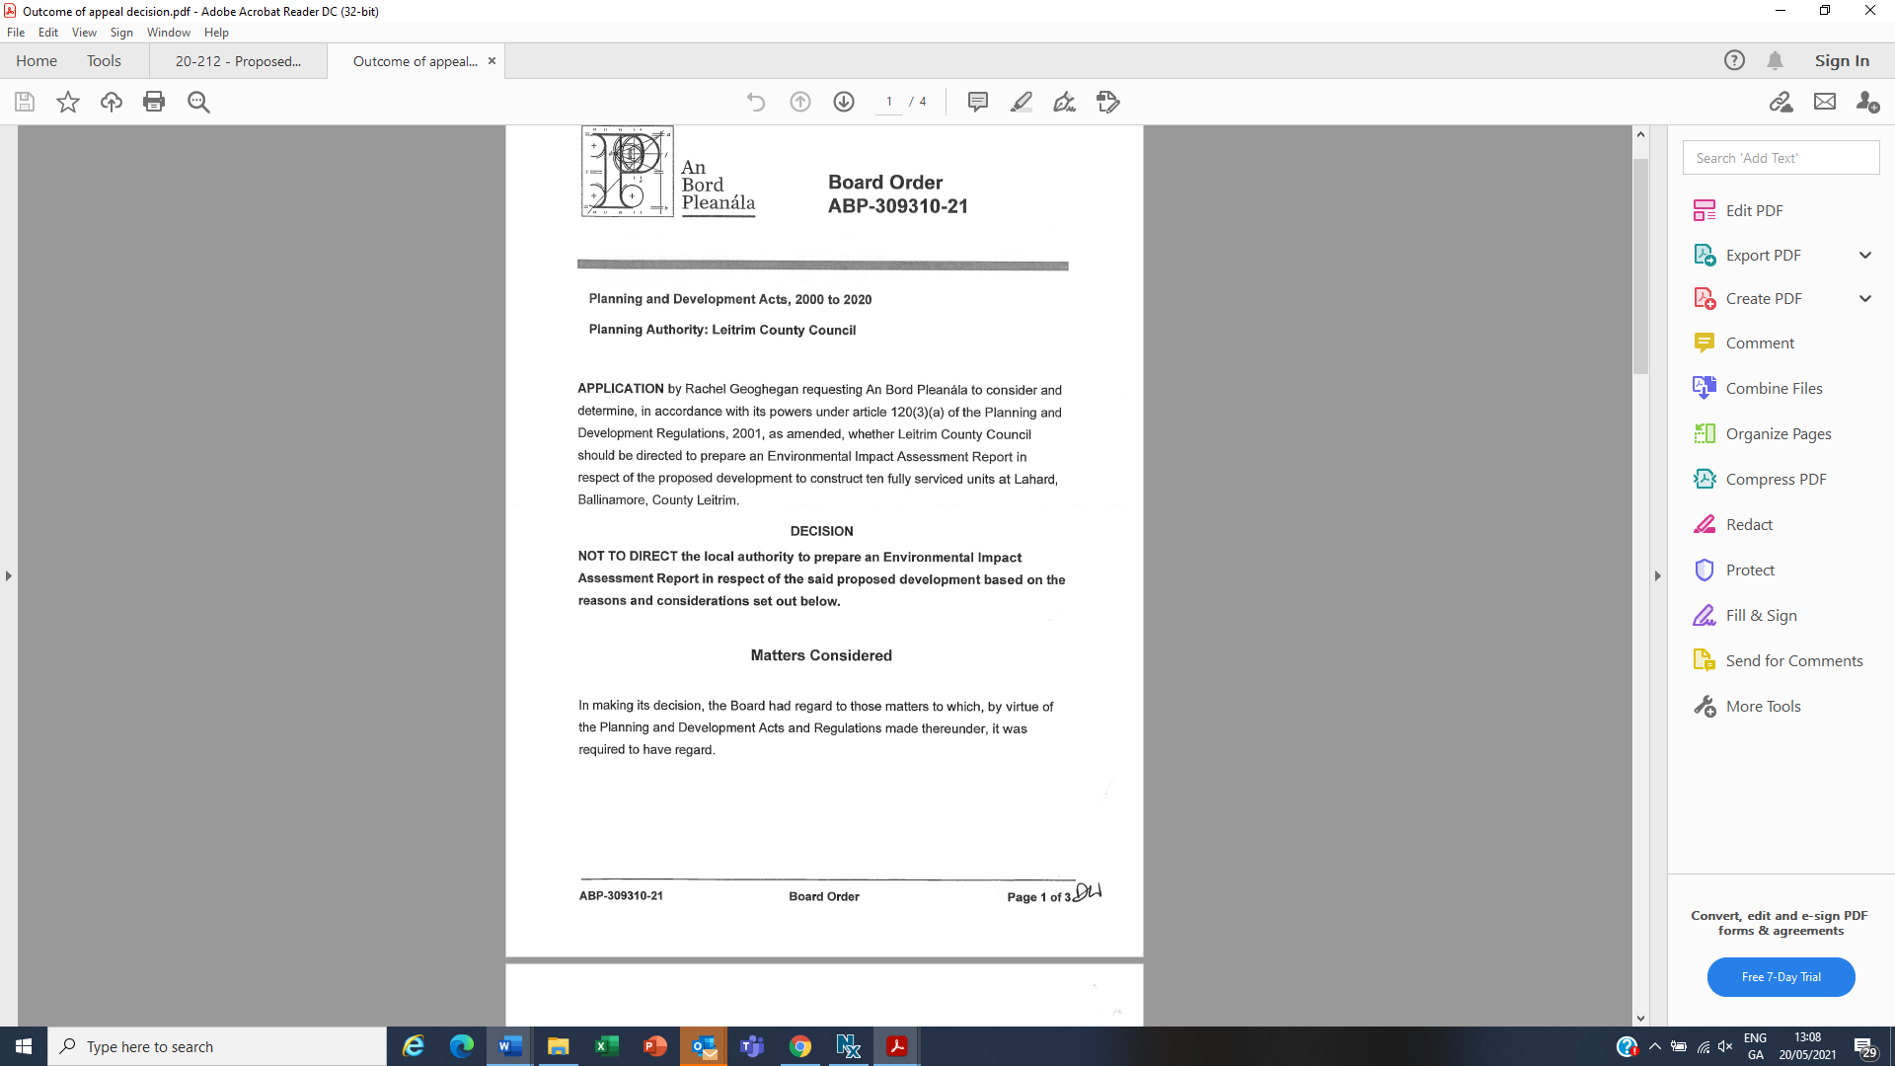

The reasons and considerations in making the determination, are as follows:

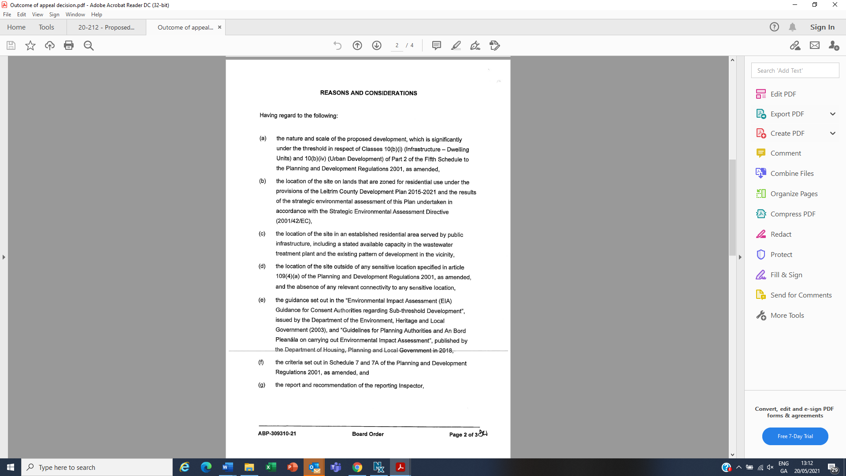

The Board therefore determined that the proposed development would not be likely to have significant effects on the environment and accordingly, that the preparation and submission of an EIAR is not required.

## Appropriate Assessment

Article 6(3) of Council Directive 92/43/EEC (the Habitats Directive) compels competent authorities to undertake an appropriate assessment of any plan or project not directly connected with or necessary to the management of a Natura 2000 site but likely to have a significant effect thereon, either individually or in combination with other plans or projects.

‘Appropriate Assessment of Plans and Projects, Guidance for Planning Authorities’ (2009) provide advice to planning authorities on their obligations under the Habitats Directive. The document, “Appropriate Assessment of Plans and Projects in Ireland: Guidance for Planning Authorities”, states that where, from the nature, size and location of the development, it is unclear if the proposal will have a significant effect on a Natura 2000 site(s), a Natura Impact Statement will be required. The site is not within or directly adjoining any Natura 2000 site.

Having regard to the nature and scale of the proposed development, it is considered that the proposed development would not be likely to have a significant effect individually or in combination with other plans or projects on a European site. The Planning Authority is satisfied that the project does not require Stage II Appropriate Assessment.

## Flood Risk

Traynor Environmental Ltd were appointed to carry out an assessment of flood risk to the proposed development. Following assessment, the report concludes as follows:

*Based on the site-specific flood risk assessment, we conclude that the proposed development:*

*• Will not be at risk of flooding.*

*• There will be no need for any additional fill on the site.*

*• Will not obstruct or impede important flow paths.*

*• Will not result in residual risks to the area and/or development that cannot be managed to an acceptable level.*

*• The access road is not at risk of flooding.*

Having regard to the above and absence of any data suggesting that the site is prone to flooding, it is considered that the site is acceptable in this regard.

# Conclusion and Recommendation

The Planning Department is satisfied that the principle of the proposed development adheres to the provisions of the statutory Leitrim County Development Plan 2015-2021. The Planning Authority is equally satisfied that the proposed works will not adversely impact upon the sensitive local receiving environment and that the development would accord with the proper planning and sustainable development of the area.

Section 179(3) of the Planning and Development Act 2000 as amended, requires the preparation of a report by the Chief Executive of the Local Authority following the placing of the proposed Part VIII application on public display. This report shall culminate in a recommendation “*whether or not the proposed development should be proceeded with as proposed, or as varied or modified as recommended in the report or should not be proceeded with, as the case may be*”.

**It is recommended that the proposed development be proceeded with as proposed subject to the inclusion of the attached recommended conditions in Appendix 1**.



___________________

Vivienne Egan

Senior Executive Planner

______________________

Joseph Gilhooly,

Director of Services,

Planning, Community and Economic Development.

*******************************************************

**Appendix 1 Schedule of Conditions**

1. The services of a suitably qualified archaeologist shall be engaged (licensed under the National Monuments Acts 1930–2004) to carry out pre-development testing at the site. No sub-surface work shall be undertaken in the absence of the archaeologist without his/her express consent.

The archaeologist is required to notify the National Monument Service in writing at least four weeks prior to the commencement of site preparations. This will allow the archaeologist sufficient time to obtain a licence to carry out the work.

The archaeologist shall carry out any relevant documentary research and may excavate test trenches at locations chosen by the archaeologist, having consulted the proposed development plans.

Having completed the work, the archaeologist shall submit a written report to the Planning Authority and to the National Monument Service.

Where archaeological material is shown to be present, avoidance, preservation in situ, preservation by record (excavation) and/or monitoring may be required, the National Monument Service will advise the developer with regard to these matters.

No site preparation or construction work shall be carried out until after the archaeologist's report has been submitted and permission to proceed has been received in writing from the Planning Authority in consultation with the National Monument Service.

1. A connection agreement with Irish Water shall be obtained and signed prior to the commencement of the development and adhere to the standards and conditions set out in that agreement.
2. All development shall be carried out in compliance with Irish Water Standards codes and practices.
3. Any proposals by the applicant to build over existing water or wastewater services shall be submitted to Irish Water for written approval prior to works commencing.
4. Any proposals by the applicant to divert existing water or wastewater services shall be submitted to Irish Water for written approval prior to works commencing.
5. Separation distances between the existing Irish Water assets and proposed structures, other services, trees, etc. have to be in accordance with the Irish Water Codes of Practice and Standard Details.
6. The existing wastewater pipeline running through the site will need to be decommissioned after the new wastewater pipeline is constructed.
7. The proposed new wastewater pipeline and proposed wastewater connection to the existing manhole must be constructed to Irish Water’s requirements found in “Wastewater Infrastructure Standard Details, Connections and Developer Services, Construction Requirements for Self-Self-Lay Developments December 2017.
8. The manhole covers must be IW-CDS-5030-01” D400 standard.
9. All  external environment infrastructure works are to comply with the guidance contained in Book 1 of Building for Everyone: A Universal Design Approach, published by the National Disability Authority.
10. Details of compliance with the foregoing shall be submitted to the Planning Department for agreement prior to commencement.
11. A detailed landscape plan prepared by a suitably qualified arborist for the proposed open space planting arrangement.
12. Details regarding on relevant building energy standards.
13. Public lighting details and a report which demonstrates the suitability of the lamps in terms of height and proposed light omitting. The public lighting should not give rise to any negative amenity effect to the area and shall contain LED lamps.