Proposed Corgar to Aghawillan Greenway,
Co. Leitrim

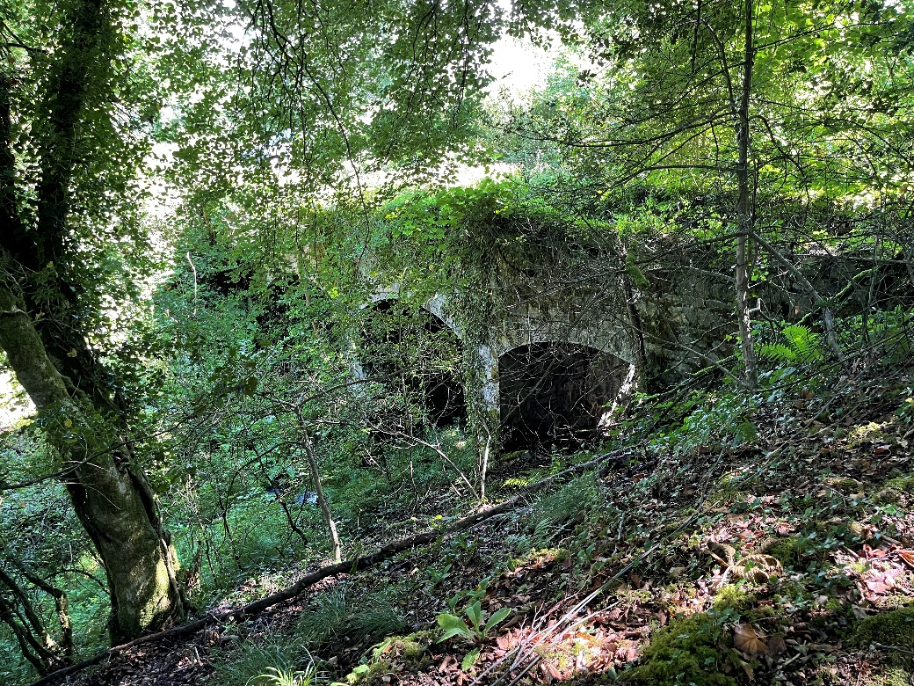

BIODIVERSITY ASSESSMENT

Version (27-07-21) FINAL


Tait Business Centre, Dominic Street, Limerick City, Ireland.
t. +353 61 313519, f. +353 61 414315
e. info@ecofact.ie
w. www.ecofact.ie

EXECUTIVE SUMMARY

The current document provides an ecological impacts assessment for a proposed greenway from Corgar to Lisgruddy and Corramahan townlands, Aghawillan, Co. Leitrim. The proposed scheme is c. 2.9km in length and will follow an existing railway track. The scheme will involve the installation of kissing gates, cattle crossings, culvert creation, vegetation clearance, soil excavation and the use of surface dressing or asphaltic cement to create the greenway path. This is part of the larger Cavan to Leitrim Greenway scheme.

A Screening for Appropriate Assessment was carried out which concluded that there would be no significant impacts on the Natura 2000 network (Ecofact 2021). Habitat loss, disturbance, invasive species and water quality impacts were identified as potentially affecting habitats and flora. In general, the habitats on the proposed development site are of ‘Local Importance Higher Value’ and are habitats that are widespread and common across Ireland. A total of 13 habitats were found at the proposed development site. Evaluations of these habitats range from ‘Local Importance’ to ‘County Importance’.
There are two habitats which are Eutrophic Lakes and Rich Fens and Flushes which are ‘County Importance’ due to their links with Annex I habitats. The proposed Natural Heritage Area Corduff Lough is present c. 1.7rkm downstream and is rated National Importance. No Annex I habitats, rare plants or protected plant species occur within the proposed development site. Direct loss of habitat is inevitable, however this is considered to be a small area and the main habitats affected are not considered to be of great significance. Water quality, non-native invasive species and disturbance impacts are likely to arise and mitigation is provided to avoid these potential impacts. A Construction Environmental Management Plan will have to be completed for the proposed greenway. This CEMP will also include a Waste Management Plan and a Surface Water Management Plan. An Operational Environmental Management Plan will also be completed and will include plans for appropriate signage and maintenance of the route.

Otters are likely present in the area and a potential holt was identified. This is an Annex II species and potential impacts require mitigation. Survey conditions were not ideal and a pre-construction winter mammal survey will have to be carried out. Bats are likely to be present in the study area, and habitats were assessed for bats. While no significant impacts on bats are envisaged, a pre-construction survey for bats will be required, and further mitigation may be prescribed following the results of this survey. Common Frog were widespread during the survey and tadpoles were recorded near the site. A dedicated amphibian survey will also need to be carried out. Mitigation measures are provided to offset or reduce potential impacts on flora and fauna. These include measures to protect habitats, water quality, biosecurity mitigation, measures to reduce disturbance and following relevant guidelines listed in the report.

Providing mitigation and guidelines are followed correctly, the majority of residual impacts have been assessed as ranging from ‘none’ to ‘imperceptible negative’. However further surveys including a pre-construction mammal, bat and amphibian survey are required and may result in further mitigation. It is considered if all mitigation is implemented, the proposed greenway scheme from Corgar to Aghawillan can be appropriately built and operated without significant adverse effects on designated areas, flora and fauna.

TABLE OF CONTENTS
EXECUTIVE SUMMARY 2
1. INTRODUCTION 5
2. METHODOLOGY 7
2.1 Guidelines and legislative context 7
2.2 Desk study 7
2.3 Field Survey 7
2.4 Evaluation 8
3. DESCRIPTION OF PROJECT CHARACTERISTICS 8
4. RECEIVING ENVIRONMENT 9
4.1 Designated Areas 9
4.1.1 Natura 2000 Sites 9
4.1.2 Natural Heritage Areas 9
4.1.3 Other 9
4.2 Habitats and Flora 12
4.2.1 Improved Agricultural Grassland (GA1) 14
4.2.2 Wet Grassland (GS4) 14
4.2.3 Conifer Plantation (WD4) 14
4.2.4 Buildings and Artificial Surfaces (BL3) 14
4.2.5 Hedgerows (WL1) 15
4.2.6 Mixed Broadleaved Woodland (WD1) 15
4.2.7 Treelines (WL2) 15
4.2.8 Scrub (WS1) 16
4.2.9 Eroding / Upland Rivers (FW1) 16
4.2.10 Eutrophic Lakes (FL5) 16
4.2.11 Rich fen and flush (PF1) 17
4.2.12 Drainage Ditches (FW4) 17
4.2.13 Amenity Grassland (GA2) 17
4.3 Fauna 21
4.3.1 Non-volant Mammals 21
4.3.2 Bats 21
4.3.4 Birds 24
4.3.5 Aquatic Ecology 24
4.3.6 Reptiles and Amphibians 25
4.3.7 Terrestrial Invertebrates 25
4.4 Key ecological receptors 26
5. POTENTIAL IMPACTS 28
5.1 Designated Areas 28
5.2 Habitats and Flora 28
5.3 Fauna 29
5.3.1 Non-volant Mammals 29
5.3.2 Bats 30
5.3.3 Birds 30
5.3.4 Aquatic Ecology 30
5.3.5 Reptiles and Amphibians 31
6. MITIGATION MEASURES 32
6.1 Designated Areas 32
6.2 Habitats and Flora 32
6.3 Fauna 33
7. Residual Impacts 35
7.1 Designated Areas 35
7.2 Habitats and Flora 35
7.3 Fauna 35
7.3.1 Non-volant mammals 35
7.3.2 Bats 35
7.3.3 Birds 35
7.3.4 Reptiles and Amphibians 35
8. CONCLUSION 38
REFERENCES 39
APPENDIX 1 PROJECT DRAWINGS 52
APPENDIX 2 NPWS Site Synopsis 53
APPENDIX 3 CRITERIA USED TO EVALUATE HABITATS AND IMPACTS 53
APPENDIX 4 Protected / Threatened Birds 55

1. INTRODUCTION

Ecofact Environmental Consultants Ltd. were commissioned to undertake a biodiversity assessment of the proposed greenway running from Corgar to Lisgruddy and Carramahan townlands, Aghawillan,, Co. Leitrim. The proposed scheme is c. 2.9km in length and will follow a derelict railway track. The location of the proposed development is illustrated in Figure 1. The scheme will involve the installation of kissing gates, cattle crossings, culvert creation, vegetation clearance, soil excavation and the use of surface dressing or asphaltic cement to create the greenway path. The drawings for the scheme are presented in Appendix 1.

This is part of a larger greenway which runs through counties Cavan and Leitrim along a derelict railway. The railway is 54km in length from Belturbet, Co. Cavan to Dromod, Co. Leitrim and passes through the towns of Ballyconnell, Ballinamore and Mohill. A Screening for Appropriate Assessment and a Screening for Environmental Impact Assessment were carried out for the entirety of the proposed works and both concluded that no further assessment was necessary (Roughan & O’Donovan, 2016a; 2016b). Therefore a full biodiversity assessment of the entire greenway has not been carried out.

This report assesses the potential impacts of the proposed Corgar to Aghawillan Greenway, Co. Leitrim on terrestrial and aquatic flora and fauna (ecology). The aim of the study is to identify features of ecological interest along the proposed alignment that may present constraints to development or where special mitigation is necessary. An evaluation is made of the scientific or conservation value of the sites identified and the potential for adverse impacts affecting designated sites following the implementation of appropriate mitigation at the design stage.

The proposed Corgar to Aghawillan Greenway, Co. Leitrim does not lie within any SAC or SPA and a separate Screening for Appropriate Assessment concluded that there was no potential for impacts on any Natura 2000 site from the proposed works (Ecofact, 2021).

This assessment has been prepared in light of current guidance including ‘Advice Notes on Current Practice in the preparation of Environmental Impact Statements’ (EPA, 2003), ‘Guidelines on the information to be contained in Environmental Impact Statements’ (EPA, 2002) along with the ‘Guidelines for Ecological Impact Assessment’ (Institute of Ecology and Environmental Management, 2006).

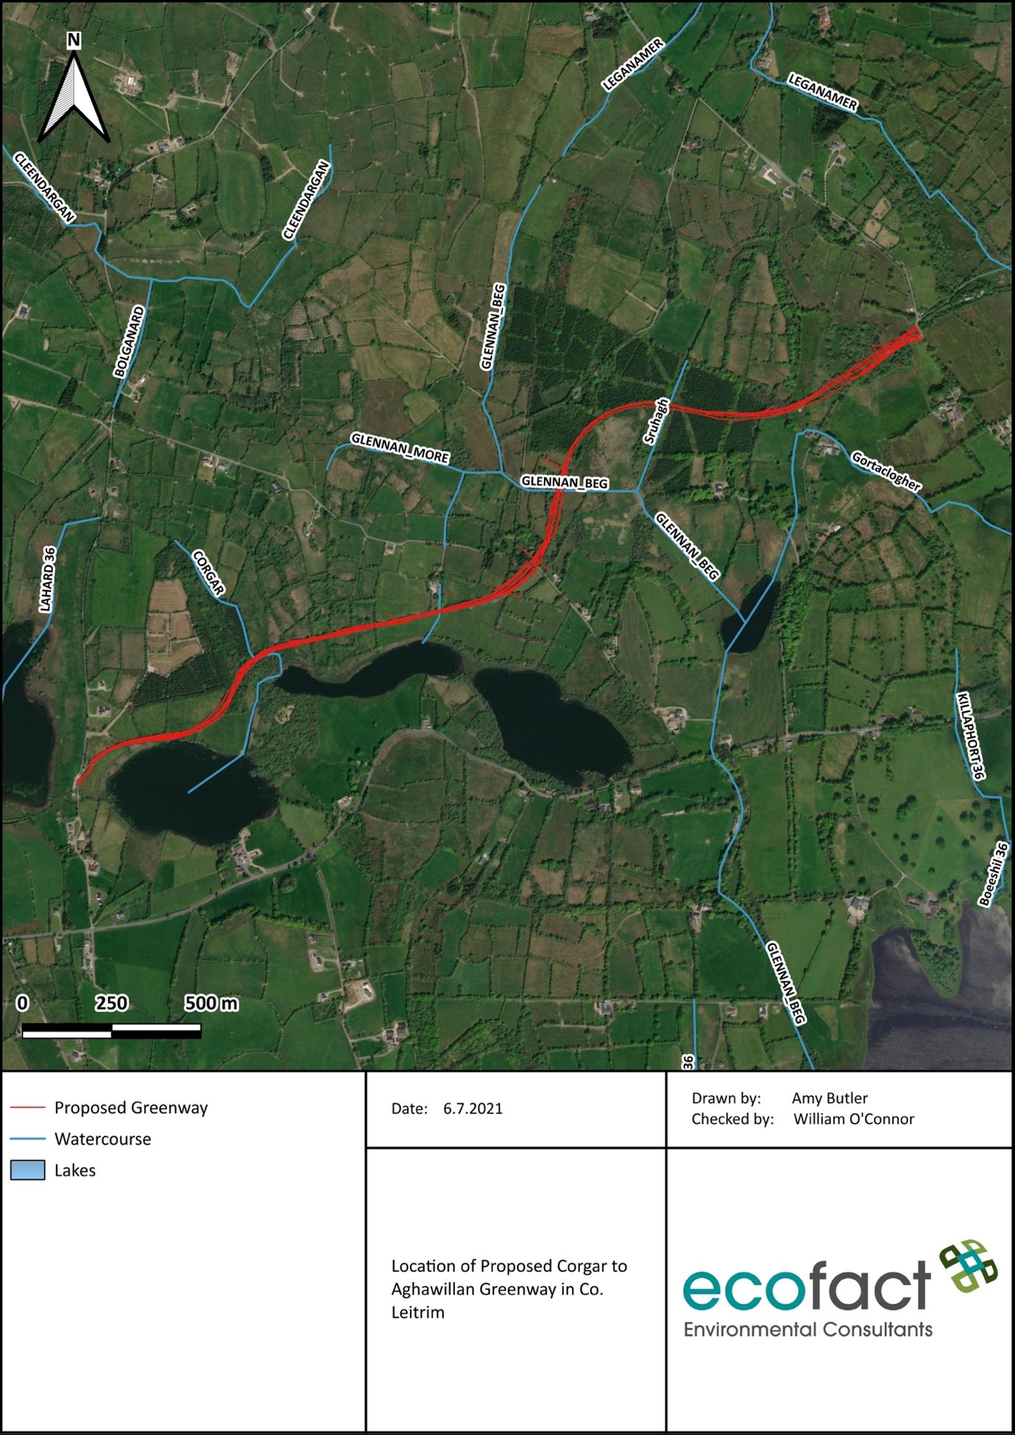
Figure 1 Location of Proposed Corgar to Aghawillan Greenway in Co. Leitrim

2. METHODOLOGY

2.1 Guidelines and legislative context

This assessment has been prepared with regard to the following guidance documents, while further references are provided throughout this chapter:

- EPA (2017) Draft Guidelines on the information to be contained in Environmental Impact Assessment Reports (EIAR);
- European Commission (2017b) Environmental Impact Assessment of Projects: Guidance on the preparation of the Environmental Impact Assessment Report;
- CIEEM (2018) Guidelines for Ecological Impact Assessment in the UK and Ireland: Terrestrial, Freshwater, Coastal and Marine;
- National Roads Authority (2009) Guidelines for Assessment of Ecological Impacts of National Road Schemes; and
- The Heritage Council publication ‘Best Practice Guidance for Habitat Survey & Mapping’ (Smith et al., 2011) was also referenced for habitat mapping.

2.2 Desk study

A desktop study was carried out to identify features of ecological importance within the proposed development site and surrounding areas. The ecological assessment included designated and sensitive areas in the vicinity of the proposed development site to enable sufficient assessment of the likelihood of significant effects on habitats, flora and fauna.

Special Areas of Conservation (SACs), Special Protection Areas (SPAs), Natural Heritage Areas (NHAs) and proposed Natural Heritage Areas (pNHAs) in the vicinity of the proposed development site were identified. This information was collated by accessing the NPWS website.

The online database hosted by the Irish National Biodiversity Data Centre (NBDC) (www.biodiversityireland.ie) was also utilised to assess the importance of the study area for mammals and bats. Other sources accessed to gather information on bats in the study area included The Bat Conservation Trust’s report ‘Distribution Atlas of Bats in Britain and Ireland 1980-1999’ (Richardson, 2000). The ‘Irish Red Data Book 2: Vertebrates - Threatened Mammals, Birds, Amphibians and Fish in Ireland’ (Whilde, 1993) and the updated ‘Irish Red List No. 3: Terrestrial Mammals’ (Marnell et al. 2009) were also reviewed.

2.3 Field Survey

The proposed development site was visited over three days in July 2021 during the growing season. A walkover habitat survey was undertaken during daylight hours. The habitats present in the study area were categorised and photographed and particular attention was paid to the primary habitats and land take to be directly affected by the proposed development, with regard to 'Best Practise Guidance for Habitat Surveying and Mapping' (Smith et al., 2011). Habitat mapping was aided by aerial photography and habitats were assessed and categorised as per ‘A Guide to Habitats in Ireland’ by J.A. Fossitt (2000). The length of the scheme and environs were also inspected for evidence of ecological features of high conservation concern such as those flora and fauna that occur in the closest Natura 2000 sites.

A walkover mammal survey of the proposed development site was completed. The walkover mammal surveys were conducted to assess the potential for mammal activity in the study area, including observing trails, tracks and other mammal signs such as scat. The waterways onsite and nearby lakes were surveyed for any evidence of Otter activity. The main Otter signs which were searched for include spraints (Otter faeces), paw-prints left in mud or silt, runways (pathways across fields, usually at bends in streams or rivers), slides, hair, haul-out places / couches, holts and breeding sites.

The walkover survey also included observations for bat habitat, in particular Potential Roost Features (PRFs), including trees and built structures that were considered likely to be disturbed or removed during the project, i.e. those within the footprint of the proposed greenway area. The survey had regard to the methodology outlined in Bat Mitigation Guidelines for Ireland by Kelleher & Marnell (2006), Bat Surveys for Professional Ecologists: Good Practice Guidelines by Collins (2016) and Bat Tree Habitat Key by Andrews and Gardener (2016). The assessment of features involved careful inspection from the ground to identify evidence indicating the level of potential of each feature as a bat roost and / or the presence of bats. Key indications of potential as a roost habitat that were searched for in the inspection included, rot / knot / woodpecker holes, cracks and splits in stems and branches, cavities from branch tearing, detached bark, ivy growth, gaps between overlapping stems or branches and other hollows.

A general bird and bird habitat survey was also undertaken during the site walkover. The trees and hedgerows on the proposed development site were assessed in terms of their importance for birds.

All waterbodies on the site were also assessed in terms of potential for supporting important aquatic ecology interests. Cognisance of any other ecological features of interest such as the occurrence of any terrestrial invertebrates, reptiles or amphibians of conservation importance, and any invasive species of concern was also noted during the site survey.

2.4 Evaluation

The evaluation of impact significance is a combined function of the value of the affected feature (its ecological importance), the type of impact and the magnitude of the impact. It is therefore necessary to identify the value of ecological features within the study area in order to evaluate the significance and magnitude of possible impacts. Ecological features are assessed on a scale ranging from international-national-county-local importance. The local scale is approximately equivalent to one 10 km square but can be operationally defined to reflect the character of the area of interest. The evaluation criteria used is shown in Appendix 3. The Criteria for assessing impact magnitude is also included in Appendix 3.

3. DESCRIPTION OF PROJECT CHARACTERISTICS

The proposed development is for a 2.9km greenway running from Corgar to Lisgruddy and Corramahan townlands, Aghawillan, Co. Leitrim. The proposed development will involve the change of use of a disused railway track to a greenway. At the beginning of the proposed route kissing gates will be installed for access to the greenway. A single pedestrian gate will be installed near the end of the proposed route for local access. Over the 2.9km stretch, there will be six cattle crossings, one of which will include a four inch service duct. In addition, two 600mm culverts will be installed. An existing stone culvert will be repaired or otherwise replaced with a concrete culvert. Two pedestrian gates will be installed to maintain the existing access for fishermen to Drumlonan Lough. Signage will be installed indicating access The entire greenway will have stock proof fencing.

General construction works for the project will include site clearance of a five metre envelope involving the removal of vegetation and fencing of the site. Soil will also be removed to a depth of < 500mm which will be dependent upon the ground conditions. The dismantled railway line will be improved and the creation of a suitable surface will be carried out which may involve surface dressing or asphaltic cement depending on the site conditions.

4. RECEIVING ENVIRONMENT

4.1 Designated Areas

4.1.1 Natura 2000 Sites

The proposed works do not lie within any SAC or SPA. The closest Special Area of Conservation is the Cuilcagh - Anierin Uplands SAC (Site code: 000584), located c. 7.6km northwest of the proposed development. There are two other Natura 2000 sites located within 15km. These are the Lough Oughter And Associated Loughs SAC (Site code: 000007), c. 32.5rkm downstream and c. 11.86 north-east (straight line) and the Lough Oughter Complex SPA (004049) located c. 15km south-east. These Natura 2000 sites will be discussed in the current report however it is noted that a full assessment of these designated sites is completed in a Screening for Appropriate Assessment Report by Ecofact and it was concluded that there would be no significant impacts on any Natura 2000 site from the proposed works (Ecofact 2021).

4.1.2 Natural Heritage Areas

Natural Heritage Areas (NHAs) are sites of national ecological importance in the Republic of Ireland. NHAs and pNHAs within 5km of the proposed development are illustrated in Figure 3. There are two NHAs within 5km. These are the Corduff Lough pNHA (Site code: 001407) c. 750m away and the Garadice Lough Wood pNHA (Site code: 001413) c. 3km away. Both of these sites are located to the east of the proposed development.

4.1.3 Other

There are no other designated sites, such as Ramsar Sites, or other protected areas within 5km of the proposed development site. However, Lough Oughter is designated as a Ramsar site and will be discussed further as part of the Lough Oughter And Associated Loughs SAC.

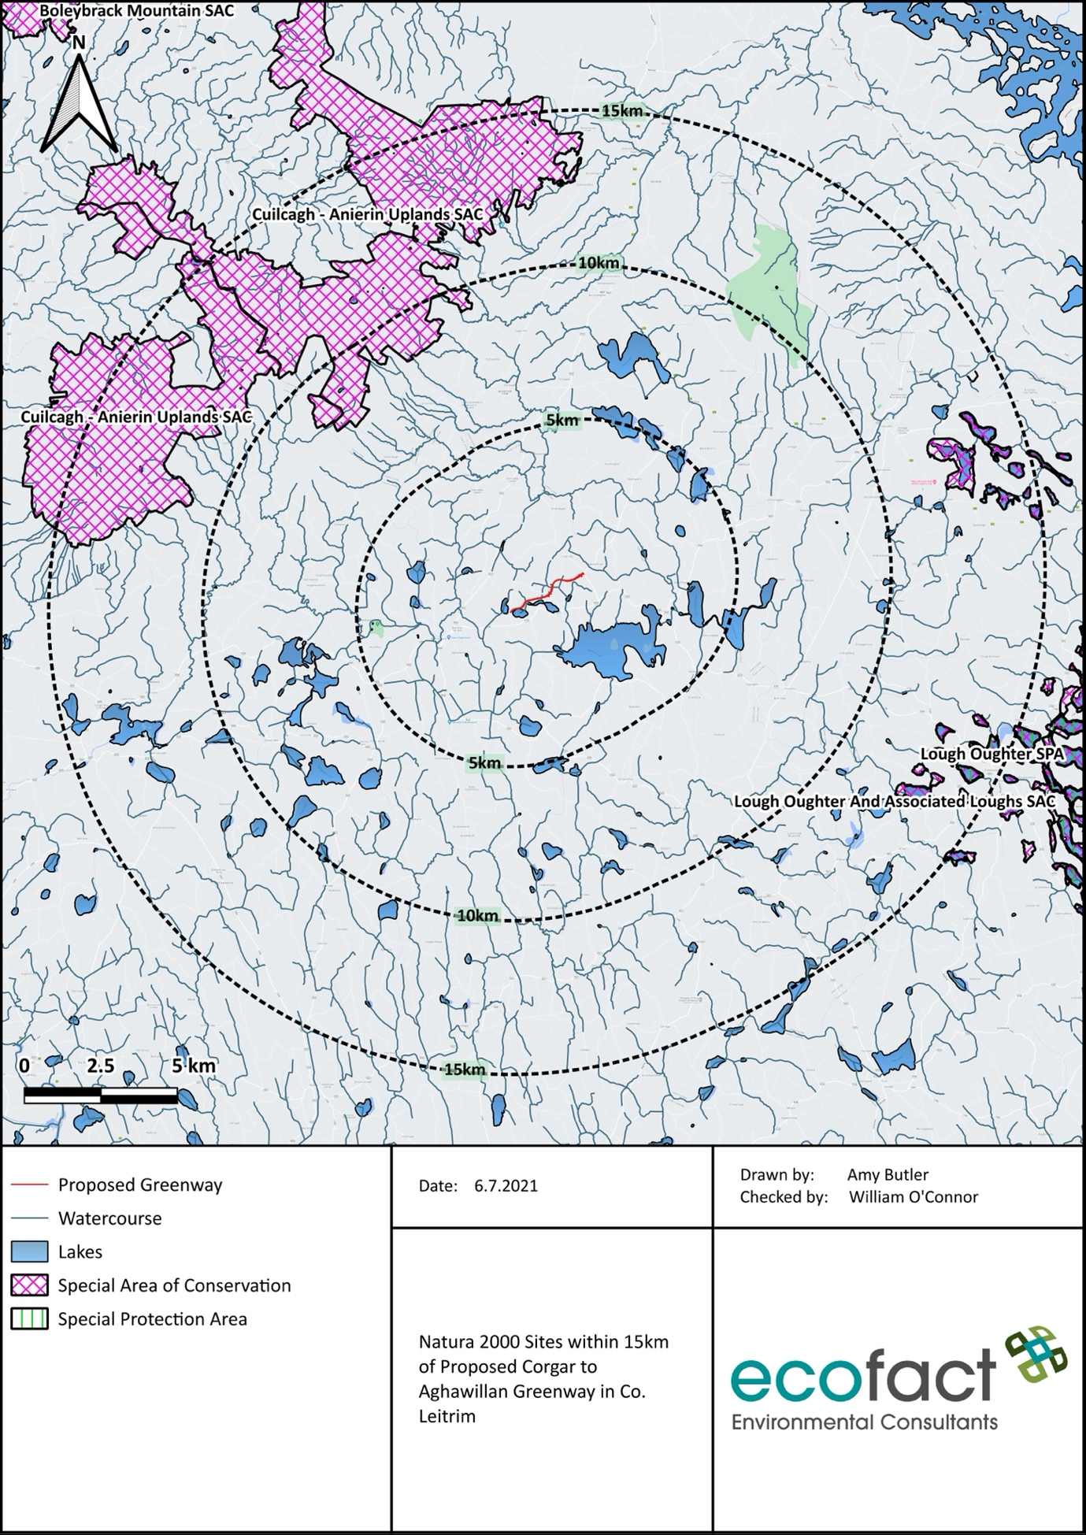
Figure 2 Natura 2000 Sites within 15km of Proposed Corgar to Aghawillan Greenway in Co. Leitrim

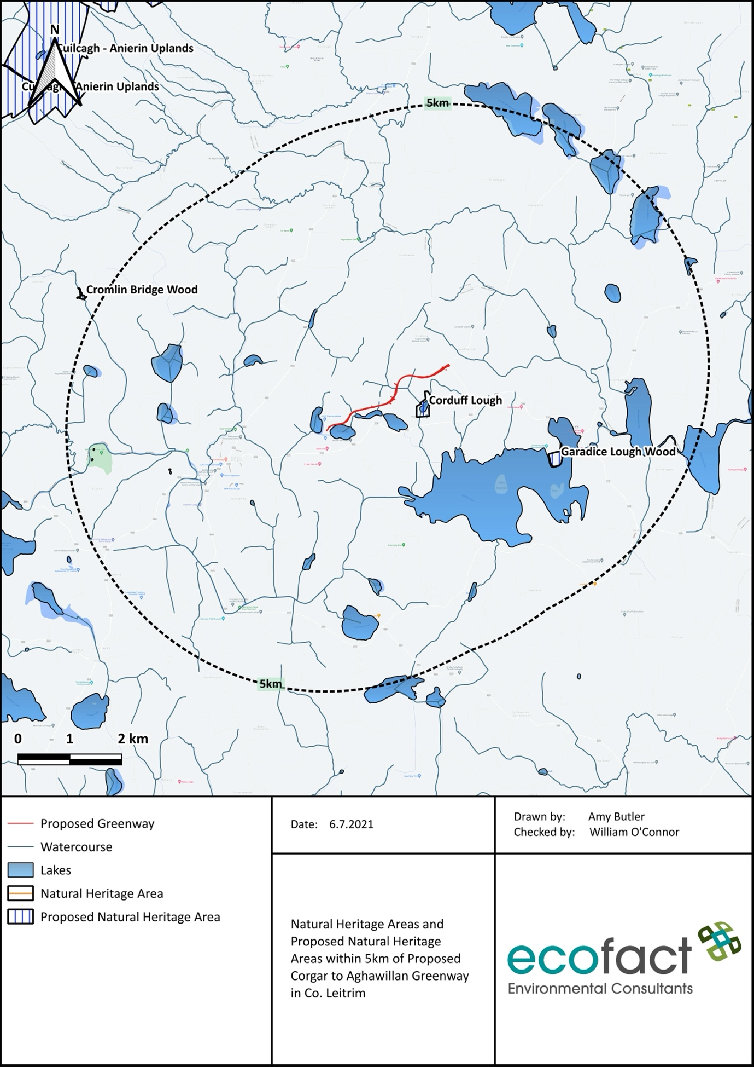
Figure 3 Natural Heritage Areas and Proposed Natural Heritage Areas within 5km of Proposed Corgar to Aghawillan Greenway in Co. Leitrim

4.2 Habitats and Flora

A total of 13 habitats were found at the proposed development site. The dominant habitat types found at the site are Improved Agricultural Grassland (GA1), Wet Grassland (GS4), Mixed Broadleaved Woodland (WD1) and Conifer Plantation (WD4). However, there are also small sections and mosaics of other habitats on the site including Treelines (WL2), Hedgerows (WL1) and Scrub (WS1). Amenity Grassland (GA2) and Rich fen and flush (PF1) also occur in some sections. The watercourses on the site are classified as Eroding / Upland Rivers (FW1) and Drainage Ditches (FW4) and the lakes are Eutrophic Lakes (FL5). Other habitats include Amenity Grassland (GA2). The location of habitats in the study area according to Fossitt (2000) are shown in Figures 5-7.

Table 1 List of the habitat types recorded from the proposed Corgar to Aghawillan Greenway, Co. Leitrim (according to Fossitt, 2000).
Habitat Code | Habitat Type
WL1 | Hedgerows
WL2 | Treelines
FW1 | Eroding / Upland River
FW4 | Drainage Ditches
FL5 | Eutrophic Lake
WD1 | Mixed Broadleaved Woodland
WD4 | Conifer Plantation
GA1 | Improved Agricultural Grassland
GA2 | Amenity Grassland
GS4 | Wet Grassland
WS1 | Scrub
PF1 | Rich fen and flush
BL3 | Buildings and Artificial Surfaces

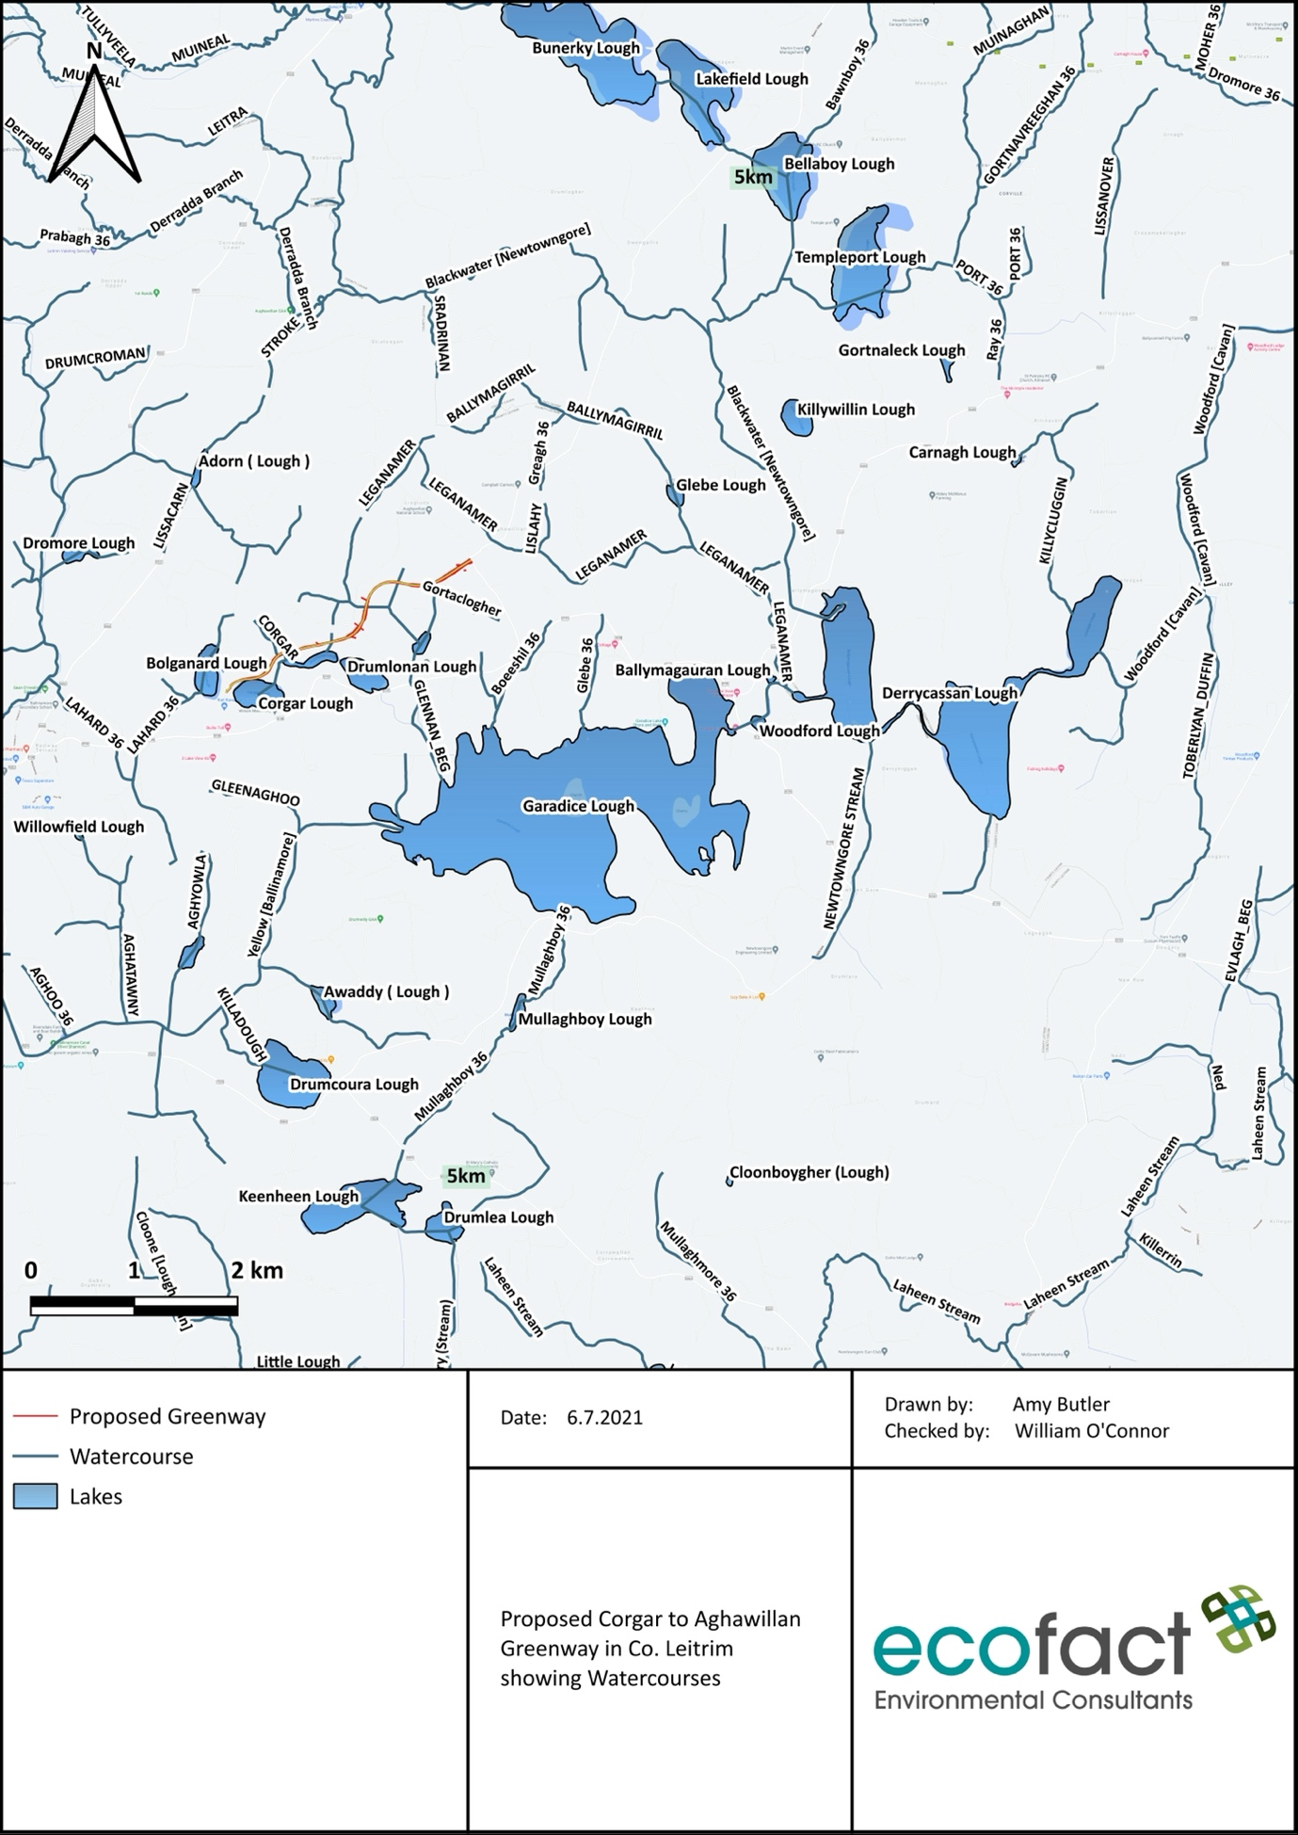
Figure 4 Proposed Corgar to Aghawillan Greenway in Co. Leitrim showing Watercourses

4.2.1 Improved Agricultural Grassland (GA1)

The Improved Agricultural Grassland (GA1) habitat type is one of the most dominant in the study area. This habitat is present in large fields and is well maintained and used for agricultural activities.

Improved Agricultural Grassland (GA1) consists of heavily modified or intensively managed grassland typically used for grazing and / or silage making. This habitat type is generally species-poor with abundant Rye-grass (Lolium sp.) often associated with White Clover (Trifolium repens). Improved Agricultural Grassland comprised of monoculture grasslands and rye-grass leys which typically form part of an arable rotation. Common species which can be found in this type of habitat include Meadow grasses (Poa spp.), Dandelion (Taraxacum spp.), thistles (Cirsium arvense, C. vulgare), and docks (Rumex spp.) (Fossitt, 2000).

Evaluation: This species-poor grassland habitat has been evaluated as being of 'Local Importance'.

4.2.2 Wet Grassland (GS4)

Wet Grassland occurs along the lake shores on the eastern section of the proposed greenway. It in the dominant habitat type at the top western end of the proposed greenway.

Wet grassland typically occurs on wet or waterlogged mineral or organic soils that are poorly drained, and can be found on sloping or flat ground in upland and lowland areas. In some cases, this habitat type can be influenced by seasonal or periodic flooding such as in the River Shannon Callows or the wet grasslands of turlough basins. This habitat type also consists of areas of poorly-drained farmland that has not recently been improved. The most common species that can be found in this type of habitat include rushes (Juncus effusus, J. acutiflorus, J. articulatus, J. inflexus), Yorkshire-fog (Holcus lanatus), Marsh Foxtail (Alopecurus geniculatus) and small sedges (Carex flacca, C. hirta, C. ovalis) (Fossitt, 2000).

Evaluation: This habitat is evaluated as being of ‘Local Importance, Higher Value’. This habitat may be used by wildlife in the area for protection and commuting.

4.2.3 Conifer Plantation (WD4)

There are several stands of conifer plantations in the vicinity of the proposed greenway. They occur in small stands and are more common in the centre of the greenway. The small stands are separated by treelines and hedgerows.

Conifer Plantation (WD4) consists of forestry with less than 25% broadleaved and it is used primarily for commercial purposes. These are generally made up of evenly aged trees planted in a uniform manner. Species diversity is low and commonly consists of only one tree species. These are often non-native species such as Sitka Spruce (Picea sitchensis), Lodgepole Pine (Pinus contorta), Norway Spruce (Picea abies) and larches (Larix spp.).

Evaluation: This species-poor habitat has been evaluated as being of 'Local Importance'.

4.2.4 Buildings and Artificial Surfaces (BL3)

This habitat type is present in the study area in the form of small access roads in the wider area and one road that cuts through the centre of the site. It is also present in the form of residential houses and farm buildings.

Buildings and artificial surfaces is a broad habitat category that includes areas of built land comprising of domestic, industrial, agricultural and community buildings as well as derelict stone buildings and ruins. This habitat category also consists of artificial surfaces such as cement, tarmac, bricks, blocks, paving stones, astroturf, pavements, runways etc. Greenhouses, polytunnels and refuse dumps are not included in this category (Fossitt, 2000).

Evaluation: This habitat is evaluated as being of no ecological value.

4.2.5 Hedgerows (WL1)

Hedgerows, similar to treelines, are present in the study area as field boundaries. They are more common on the northern side of the study area then south of the proposed greenway.

Hedgerows typically form field or property boundaries and consist of linear strips of shrubs and occasional trees. The majority of hedgerows are planted and can occur on raised banks created from the digging of drainage ditches. Typical species that occur in hedgerows include Hawthorn (Crataegus monogyna), Gorse (Ulex europaeus), Dog-rose (Rosa canina), Blackthorn (Prunus spinosa). Species of trees that can be frequently found within hedgerows are Hazel (Corylus avellana), Ash (Fraxinus excelsior) and Willows (Salix spp.) (Fossitt, 2000).

Evaluation: This habitat is evaluated as being of 'Local Importance, Higher Value'. This type of habitat is valuable to wildlife for protection and movement.

4.2.6 Mixed Broadleaved Woodland (WD1)

Mixed broadleaved woodland is present in the study area. The habitat is primarily present west and north-west of Corgar Lough. There are also small areas of Mixed broadleaved woodland throughout the site.

Mixed broadleaved woodland is a category that includes woodland areas with 75-100% cover of broadleaved trees, and 0-25% cover of conifers. It should be used in situations where woodland stands cannot be classified as semi-natural on the basis of the criteria outlined above. Trees may include native and non-native species. Plantations of broadleaved trees are included if the canopy height is greater than 5m, or 4m in the case of wetland areas.

Evaluation: This habitat is evaluated as being of 'Local Importance, Higher Value'. This type of habitat is valuable to wildlife for protection and movement.

4.2.7 Treelines (WL2)

Treelines in the study area are present mainly as field boundaries and separating conifer plantations. This habitat also occurs along the disused railway track.

Treelines includes a single or narrow line of trees that are greater than 5m in height and like hedgerows; they typically occur at field or property boundaries. Hedgerows that are dominated by trees greater than 5m in height are also included within this category. Most treelines are planted and are spaced apart. The majority of treelines comprise non-native tree species such as Sycamore (Acer pseudoplatanus), Beech (Fagus sylvatica), limes (Tilia spp.), some poplars (Populus spp.), Horse Chestnut (Aesculus hippocastanum) and conifers (Fossitt, 2000).
Evaluation: This habitat is evaluated as being of 'Local Importance, Higher Value'. This type of habitat is valuable to wildlife for protection and movement.

4.2.8 Scrub (WS1)

Scrub is present in one section in the study area. It is present in a mosaic with Rich fen and flush in the centre of the proposed development site and bordering the proposed greenway. This is also the dominant habitat type along the disused railway.

Scrub is defined as areas that are dominated by at least 50% cover of shrubs, stunted trees or brambles. The canopy height is generally less than 5m, or 4m in the case of wetland areas. Common species found in this habitat type include spinose plants such as Hawthorn (Crataegus monogyna), Blackthorn (Prunus spinosa) and Gorse (Ulex europaeus) (Fossitt, 2000).

Evaluation: This habitat is evaluated as being of ‘Local Importance’. This can be important for fauna in the study area for protection and movement.

4.2.9 Eroding / Upland Rivers (FW1)

The Eroding / Upland Rivers habitat type is present in the form of several streams adjacent to the existing railway track. There are four streams that fall into this category. There are three 1st order streams – Corgar, Drumlonan and Gortaclogher Stream and one 2nd order Glennan Beg Stream.

Eroding / Upland Rivers consist of watercourses that are actively eroding and where there is little to no sediment deposition. This typically includes the upland sections of natural watercourses where gradients are steep and water flow is fast and turbulent. The watercourses included in this habitat type are typically smaller and shallower than 'depositing / lowland rivers' (FW2) and include small mountain streams that can dry out periodically if a distinct channel exists or wetland plants are present (Fossitt, 2000).

Evaluation: This habitat is evaluated as being of 'Local Importance, Higher Value”. The streams on the site are very small however they do support Common Frogs and there are likely Otters in the area using them for commuting and / or foraging.

4.2.10 Eutrophic Lakes (FL5)

There are four small lakes in the immediate vicinity of the site, three of which have a hydrological connection to the site. In addition Garadice Lough which is the largest lake in the areas is c. 1.7 rkm downstream. These are all eutrophic lakes.

Eutrophic Lakes are lakes and ponds that are base-rich with high levels of nutrients. The water is often turbid and grey to green in colour due to algae and other suspended matter. These can be naturally eutrophic (Annex I habitat) or eutrophic as a result high nutrient loads causing enrichment. Due to poor light penetration submerged aquatic vegetation is not common. Typically reedbeds and dense stands of fringing vegetation are present.

Evaluation: This habitat is evaluated as being of ‘County Importance’. This habitat in Fossit (2000) has potential links to the Annex I habitat Natural eutrophic lakes with Magnopotamion or Hydrocharition — type vegetation. For it to be this habitat the lakes must be naturally eutrophic. The distribution of this habitat is not fully known in Ireland but it does occur in parts of the Leitrim, Cavan, Monaghan drumlin belt (NPWS, 2015). Therefore these lakes are potentially naturally occurring eutrophic lakes and an Annex I habitat under the EU Habitats Directive leading to an evaluation of ‘County Importance’.

4.2.11 Rich fen and flush (PF1)

This habitat is located to the south east of the proposed Greenway near Drumcullion bridge. It is also located along the shores of Bolganard Lough

Rich fen and flush are fed by either groundwater or flowing surface waters. The water which feeds the fen is at least mildly base-rich or calcareous. They are usually found on areas which are limestone bedrock. There is waterlogged peat typically with a high mineral content. Vegetation is typically dominated by Black Bog-rush (Schoenus nigricans) and/or small to medium sedges such as Carex viridula, C. nigra, C. dioica and C. panicea. There are typically also high numbers of rushes.

Evaluation: This habitat is evaluated as being of ‘County Importance’. This habitat can correspond to either of two Annex I habitats which are Alkaline Fens and Calcareous Fens with Cladium mariscus and species of the Caricion davallianae.

4.2.12 Drainage Ditches (FW4)

There are several drainage ditches in the footprint of the proposed works. They are located near the lakes and sometimes along field boundaries likely used to improve drainage in the surrounding lands.

Drainage ditches consist of entirely artificial linear water bodies or wet channels, and also includes small sections of natural watercourses that have been excavated or modified. These water bodies are not used for navigation and are generally created to improve drainage and control the flow of water. This habitat type must either contain water or be wet enough to support wetland vegetation. These water bodies must be maintained and cleared in order to keep them open. Water levels will undergo seasonal fluctuations and these habitats are generally associated with hedgerows (Fossitt, 2000).

Evaluation: Drainage Ditches in the study area may be of use to wildlife during periods of heavy rain. However, this is limited given the state of the ditches on site. Drainage ditches are evaluated as being of ‘Local Importance’.

4.2.13 Amenity Grassland (GA2)

Amenity Grassland is present on the proposed development site in the form of residential gardens. These are very small and contain well managed grassland. This is of limited value to wildlife.

Amenity grassland is improved, or species-poor, and is managed for purposes other than grass production. It includes amenity, recreational or landscaped grasslands, but excludes farmland. Most areas of amenity grassland have been reseeded and are regularly mown to maintain very short swards. Amenity grassland is typically associated with lawns and other managed grassland in gardens, parks, grounds of various buildings or institutions, golf course fairways, grassy sports fields and racecourses. Broadleaved herbs such as Daisy Bellis perennis, Dandelion Taraxacum spp., Clovers Trifolium spp. and plantains Plantago spp. are common.

Evaluation: Amenity grassland in the study area is evaluated as being of ‘Local Importance’.

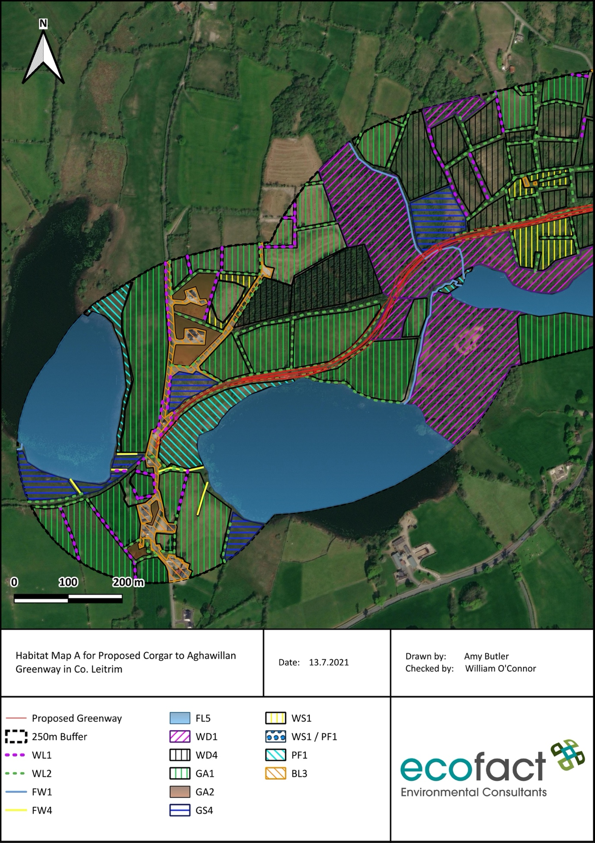
Figure 5 Habitat Map A for Proposed Corgar to Aghawillan Greenway in Co. Leitrim

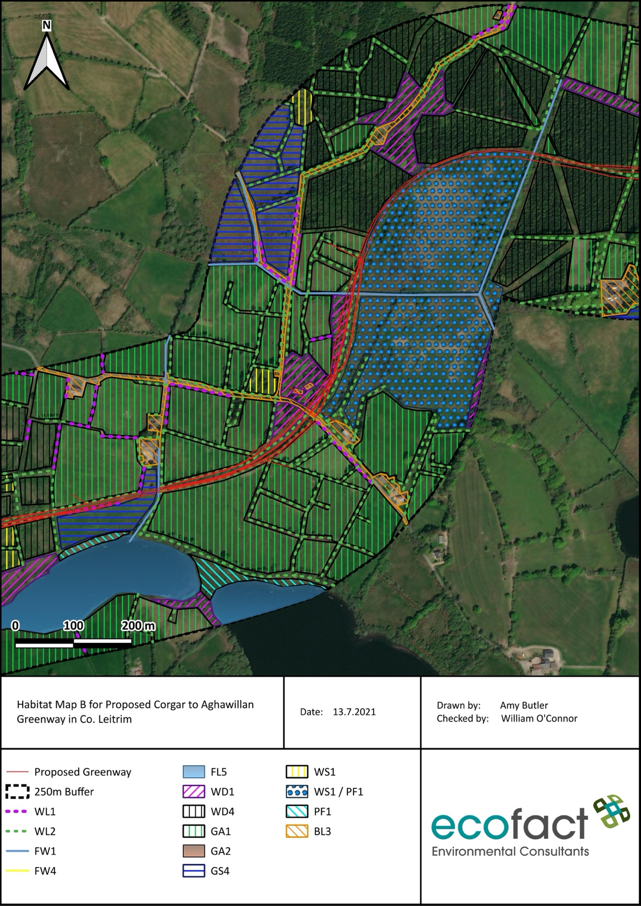
Figure 6 Habitat Map for Proposed Corgar to Aghawillan Greenway in Co. Leitrim

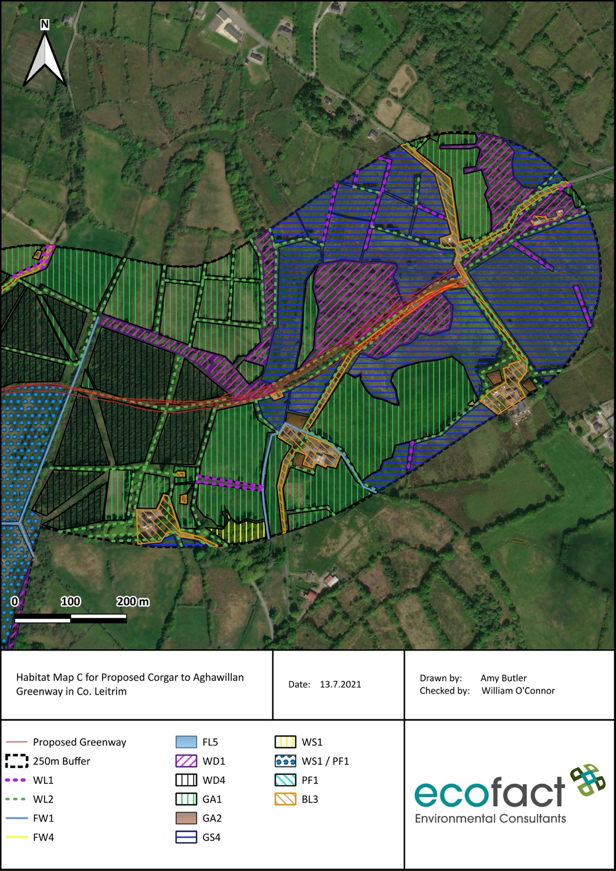
Figure 7 Habitat Map C for Proposed Corgar to Aghawillan Greenway in Co. Leitrim

4.3 Fauna

4.3.1 Non-volant Mammals

The proposed Corgar to Aghawillan Greenway is located in the 10km grid square H11. A review of non-volant mammals within this 10km grid square was undertaken. American Mink (Mustela vison) has not been recorded in the study area since 1989. This is an invasive species but is well established in Ireland. Irish Stoat (Mustela erminea subsp. hiberica) were recorded in the 10km grid square in 2011. Otter (Lutra lutra) have also been recorded in the study area in 2010. During the current survey evidence of Otter was recorded along the proposed greenway route. The site was very overgrown which hindered access to some areas. On Corgar Lough a potential Otter holt was identified which is along the proposed route. Otter may commute along the small streams on the site and Otter may forage in the lakes nearby.

Grey squirrel (Sciruus carolinensis) is also an invasive species and was recorded in 2001. The native Red squirrel (Sciurus vulgaris) was recorded in 2017. There is suitable habitat for squirrels in the broadleaved woodlands around the lake. None were observed during the current survey.

There are also Badger (Meles meles) records for the grid squares, with the latest being from 2012. The soil on the site is wet and compact making conditions poor for mammals that dig dwellings such as Badger. There were no setts were recorded onsite and badger activity was low. It was not possible to access all areas, but mammal activity was low overall.

Rabbit (Oryctolagus cuniculus) were recorded in 1991. Irish Hare (Lepus timidus subsp. hibernicus) were most recently recorded in 2006. These species could utilize the agricultural habitats present in the wider study area. Red fox (Vulpes vulpes) have been recorded most recently in 2010. Red fox are likely to be common in the area as is the case with much of the Irish landscape.

Hedgehog (Erinaceus europaeus) were recorded on one occasion in 1980. Pygmy shrew (Sorex minutus) were recorded in 2003. Hedgehogs and shrews may use the study area and could find protection among the woodland, treelines and hedgerows found throughout the site.

Evaluation: Mammals in the study area are evaluated as being of ‘Local Importance, Higher Value’.

4.3.2 Bats

4.3.2.1 Desk Study

The National Biodiversity Data Centre (NBDC) maps landscape suitability for bats based on Lundy et al., (2011). The maps are a visualisation of the results of the analyses based on a 'habitat suitability' index. The index ranges from 0 to 100, with 0 being least favourable and 100 most favourable for bats. Table 2 below gives the suitability of the study area for the bat species found in Ireland (based on NBDC) along with their Irish Red List Status (from Marnell et al., 2009). The proposed greenway has two different bat suitability ratings. The eastern section is shown in Table 2 and the western section is shown in Table 3. The overall assessments of bat habitats for the current study area are given as 20.67 for the eastern section and 27.22 for the western section. These figures are considered low and low- moderate respectively.

Table 2 Suitability of the eastern section of the study area for the bat species previously recorded in the study area (based on the NBDC data). Irish Red list status also indicated (based on Marnell et al., 2009).
Common name | Scientific name | Suitability index | Irish red list status
All bats | - | 20.67
Common pipistrelle | Pipistrellus pipistrellus | 29 | Least Concern
Leisler’s bat | Nyctalus leisleri | 31 | Near Threatened
Natterer’s bat | Myotis nattererii | 16 | Least Concern
Soprano pipistrelle | Pipistrellus pygmaeus | 32 | Least Concern
Brown long-eared bat | Plecotus auritus | 32 | Least Concern
Lesser horseshoe bat | Rhinolophus hipposideros | 1 | Least Concern
Whiskered bat | Myotis mystacinus | 14 | Least Concern
Daubenton's bat | Myotis daubentonii | 28 | Least Concern
Nathusiius's pipistrelle | Pipistrellus nauthusii | 3 | Least Concern

Table 3 Suitability of the western section of the study area for the bat species previously recorded in the study area (based on the NBDC data). Irish Red list status also indicated (based on Marnell et al., 2009).
Common name | Scientific name | Suitability index | Irish red list status
All bats | - | 27.22
Common pipistrelle | Pipistrellus pipistrellus | 31 | Least Concern
Leisler’s bat | Nyctalus leisleri | 35 | Near Threatened
Natterer’s bat | Myotis nattererii | 28 | Least Concern
Soprano pipistrelle | Pipistrellus pygmaeus | 34 | Least Concern
Brown long-eared bat | Plecotus auritus | 38 | Least Concern
Lesser horseshoe bat | Rhinolophus hipposideros | 5 | Least Concern
Whiskered bat | Myotis mystacinus | 21 | Least Concern
Daubenton's bat | Myotis daubentonii | 32 | Least Concern
Nathusiius's pipistrelle | Pipistrellus nauthusii | 21 | Least Concern

4.3.2.2 Site Assessment

There is suitable bat habitat present in the study area for bats. In terms of roosting habitat there are several old bridges on the site that could be used as bat roosts. No formal bat survey was undertaken but potential habitat was noted. There are several mature trees along the route. Some of these trees were noted to have Potential Roost Features (PRFs) such as ivy, knotholes and lifting bark. Some of the trees have potential to be used as bat roosts.

For foraging / commuting habitat, the most suitable habitat in the study area is along the lakes, treelines / riparian woodland / hedgerows and also along the disused railway track. The majority of our common species of bats typically use linear features in the landscape for foraging and commuting. The streams and lakes nearby, would provide suitable insect production and prey species for bats in the local area. There is no lighting on the site. The species expected to be present would be Soprano pipistrelle Pipistrellus pygmaeus, Common pipistrelle Pipistrellus pipistrellus, Daubenton’s bat Myotis daubentonii and potentially Leisler’s bat Nyctalus leisleri. There is a record of Whiskered Bat Myotis mystacinus c. 6km from the site. There is little known about the species in Ireland and it is difficult to differentiate between it and the other Myotis spp. However there is suitable habitat for the species in the form of the linear railway route and nearby lakes. They will also roost in a variety of habitats such as mature trees and bridges – which are present on the site. There are no records or suitable habitat for the Annex II species Lesser Horseshoe Bat. A pre-construction bat survey will be required. An assessment of habitats present at the site for bat is provided below in table 3.

Table 4 Assessment of the habitat at the site of the proposed road scheme for each species expected to be at the site.
Species Expected | Habitat | Habitat Assessment
Common pipistrelle Pipistrellus pipistrellus | Favour linear features for commuting and foraging along mature hedgerows, treelines, edges of woodlands and within woodlands. Broad foraging niche but often occur near water and other natural land covers. Also positively associated with pasture near roosts. Roost in crevices; the most frequently recorded type of roosting site is buildings but also use trees. | Likely to be present in the area. Potential for mature trees or farm buildings in the study area to be used as roosting habitat. Foraging habitat is present along the lakes and treelines in the study area including along the disused railway route.
Leisler’s bat Nyctalus leisleri | Favour woodland habitat and areas near freshwater but frequently travel up to more than 5km from roost to forage. High-flying species and doesn't rely on linear landscape features for commuting. Roosts in crevices and holes in trees and buildings. | Have been previously recorded in the wider study area c. 7km away. They may use the agricultural habitats and trees in the wider study area. This species frequently roosts in trees and therefore could use suitable PRFs in mature trees on the site.
Soprano pipistrelle Pipistrellus pygmaeus | Favours roosting in areas near freshwater and woodland. Flies low (2-6m) along linear landscape features such as treelines and mature hedgerows. Broad foraging niche but often occur near water and other natural land covers. Roost in crevices; the most frequently recorded type of roosting site is buildings but also use trees. | Have been previously recorded in the wider study area c. 9km away. Potential for mature trees or farm buildings in the study area to be used as roosting habitat. Foraging habitat is present along the lakes and treelines in the study area including along the disused railway route.
Daubenton’s Bat Myotis daubentonii | Frequently roost in stone bridges, canal tunnels, ruins, trees and damp caves. This species forages over freshwater on the surface of rivers, lakes and canals. This is the only species in Ireland that specifically forages only over water. | There is a nearby record of this species on Garadice Lough. May also use bridges or trees in the study area, or derelict buildings nearby especially stone structures. Suitable foraging habitat on the nearby lakes.
Whiskered Bat Myotis mystacinus | Has been known to roost in old buildings, stone crevices and trees but there are few confirmed roosts in Ireland. Typical foraging habitat is along forest tracks and near water. | There is a record on Bunerky Lake c. 6km away. This species may roost in the mature trees or bridges on the site. Suitable foraging habitat along the railway track and nearby lakes.

Evaluation: Bats in the study area are evaluated as being of ‘Local Importance, Higher Value’. No habitat or records of Annex II species Lesser Horseshoe bat is present.

4.3.4 Birds

A full list of protected and threatened bird species is provided in Appendix 4 of the current report. The majority of bird species previously recorded in the 10km grid square H11 are common passerine species that are typical of the agricultural type habitats in the study area, which are widespread across Ireland. Habitats in the study area of the proposed greenway would be likely to support common passerine species, with treelines and hedgerows common, and woodland present. It is likely that birds would nest in the mature trees and dense hedgerows on the site. The nearby lakes would provide good insect production for foraging in the study area. Species such as Blue tit (Cyanistes caeruleus), Common blackbird (Turdus merula), Magpie (Pica pica), Hooded Crow (Corvus cornix), Goldfinch (Carduelis carduelis), Robin (Erithacus rubecula), Great tit (Parus major), Rook (Corvus frugilegus) and Song thrush (Turdus philomelos) have been previously recorded in the study area and would be considered to be present adjacent to the proposed greenway.

According to the NBDC bird records for the 10km grid square H11, which are listed in Appendix 4, there are records of 5 species listed on Annex I of the EU Birds Directive. Only two of these species have been recorded recently which are Common Kingfisher Alcedo atthis and Whooper Swan Cygnus cygnus. Common Kingfisher occurs on freshwater rivers and streams. The freshwater channels on the proposed development are small. These watercourses would not support Kingfisher with no suitable nesting banks, of poor quality and would not provide a sufficient supply of food. The other Annex I bird species recorded recently is Whooper Swan. may occur in nearby fields in the vicinity of the lakes. Whooper Swan are a winter visitor to Ireland and the current survey was carried out during July when Whooper Swans are not present. Whooper Swans would not occur within the boundary of the proposed site. Other threatened species such as Merlin (Falco columbarius), Corncrake (Crex crex) and Common Tern (Sterna hirundo), which are all Annex I birds, have not been recorded in the study area for some time and are not expected to be present due to a lack of suitable habitat. During the walkover survey several common passerines were recorded along the proposed greenway route including the common corvid species. There was a very high number of Wood Pigeon Columba palumbus recorded throughout the site. Corvids and Wood Pigeon were the most common bird species present. On the nearby lakes Canada Geese Branta canadensis were present which is a non-native species that is now well established in Ireland. The native and widespread Mute Swan Cynus olor was also recorded. Great-Crested Grebe Podiceps cristatus were also recorded on the lakes nearby. There were two birds of prey recorded – Kestrel Falco tinnunculus and Buzzard Buteo buteo. Kestrel are red listed in Ireland and were recorded hunting along the proposed route adjacent to Corgar Lough.

Evaluation: Birds in the study area are considered to be of ‘Local Importance, Higher Value”.

4.3.5 Aquatic Ecology

In 2018 Garadice Lough which is 1.7 rkm from the site, was surveyed by Inland Fisheries Ireland to assess the fish stocks present. A total of 8 species were recorded at the site in decreasing order of abundance - Perch Perca fluvialtilis, Roach Rutilus rutilus, Roach x Bream hybrid Rutilus rutilus x Abramis brama, Bream Abramis brama, Pike Esox Lucius, Tench Tinca tinca, Gudgeon Gobio gobio, Brown Trout Salmo trutta and European Eel Anguilla Anguilla. This is a popular angling lake which is assigned “Moderate” ecological status. The lake is semi-regularly surveyed and species composition has remained similar and ecological status has improved (McLoone et al, 2018). The 2nd order Glennan Beg stream is the largest waterway on the site however it is still quite small and provides a hydrological connection to Garadice Lough. Some of the species from the lake may potentially be found in this stream.

There are no threatened aquatic macroinvertebrates recorded in the 10km grid-square. Previous aquatic ecology records from the study area, the 10km grid square H11 include the following insect species: the stoneflies - Isoperla grammatica, Leuctra fusca, Leuctra inermis, Siphonoperla torrentium, Nemoura avicularis, Nemoura cinerea, the mayflies Caenis rivulorum, Baetis rhodani, Serratella ignita, Green Drake Ephemera danica, the dragonflies Azure Damselfly Coenagrion puella, Hairy Dragonfly Brachytron pratense, Banded Demoiselle Calopteryx splendens, Common Hawker Aeshna juncea, Ruddy Darter Sympetrum sanguineum, Variable Damselfly Coenagrion pulchellum, Common Blue Damselfly Enallagma cyathigerum, Common Darter Sympetrum striolatum, Blue-tailed Damselfly Ischnura elegans, Brown Hawker Aeshna grandis, Emerald Damselfly Lestes sponsa, Four-spotted Chaser Libellula quadrimaculata and lastly the caddisfly Ceraclea fulva. The stoneflies were all recorded during 2007 as part of the Stoneflies (Plecoptera) of Ireland databse from 2007. The dragonflies were all recorded from 1999-2003. The mayflies were all recorded from 1993-2007 and the caddisfly record is from 2013. Due to the small nature of the streams onsite it is considered unlikely that they would have this level of macroinvertebrate diversity but some of the species in the 10km grid square are likely present.

Evaluation: Aquatic in the study area are evaluated as being of ‘Local Importance, Higher Value”.

4.3.6 Reptiles and Amphibians

Common frog Rana temporaria has been previously recorded in the study area according to the National Biodiversity Data Centre online maps, as recently as 2019. Smooth newt (Lissotriton vulgaris) have been previously recorded in the 10km grid square as recent as 2014. This record is from 100m grid square which overlaps the site and a section of Corgar Lough. There is suitable habitat for Common Frog and Smooth Newt in the wetter areas around the lakes and on the site. During the field survey a significant number of Common Frog were recorded throughout the site. Tadpoles were recorded in one area in a stream outside the proposed greenway location. The site is suitable for Common Frog and breeding habitat is present. Smooth newt breed in similar habitats to Common Frog and while none were recorded during the present survey they are present in the area. The proposed development site is also considered to be outside the range of Natterjack toad (Epidalea calamita) and there are no records of this amphibian here.

There are no records of reptiles for the study area and there is generally a paucity of suitable habitat for reptiles at the site. The only reptile in Ireland is the Common lizard (Zootoca viviparia). This species can be found in a range of habitats including woodland, marshes, bogs and moors.

Evaluation: Reptiles and Amphibians in the study area are considered to be of ‘Local Importance, Higher Value”.

4.3.7 Terrestrial Invertebrates

The terrestrial invertebrates previously recorded in the 10km grid square H11 are as follows: Meadow Brown (Maniola jurtina), Ringlet (Aphantopus hyperantus) and Painted Lady (Vanessa cardui) recorded most recently in 2020, Orange-tip (Anthocharis cardamines) recorded most recently in 2019 and
Green-veined White (Pieris napi), Large White (Pieris brassicae), Small Copper (Lycaena phlaeas), Small Tortoiseshell (Aglais urticae), Small White (Pieris rapae), Speckled Wood (Pararge aegeria), Painted Lady (Vanessa cardui) which have not been recorded since 1975. Recent recordings are part of the Butterflies of Ireland database on the NBDC maps, either in 2019 and 2020.

Evaluation: Terrestrial invertebrates in the study area are evaluated as being of ‘Local Importance”.

4.4 Key ecological receptors

The key ecological receptors identified from the ecological interests (designated sites, habitats, flora and fauna) recorded within the study area are presented in Table 3.
Table 3 Identification of key ecological receptors in the study area (based on NRA, 2009).
Ecological receptors | Summary description of the ecological receptors | Evaluation of the ecological receptors (Key ecological receptors are those identified as being > local importance (lower value))
Natura 2000 sites | There are three Natura 2000 sites within 15km. A Screening for Appropriate Assessment Report has been prepared, which assessed impacts on the Qualifying Interests and found that there would be no significant impacts in any Natura 2000 site (Ecofact 2021). | International Importance
Natural Heritage Areas | There are also two proposed NHAs located within 5km of the proposed works which are Corduff Lough pNHA and Garadice Lough Wood pNHA. | National Importance
Hedgerows (WL1) | Network of hedgerow habitats which function as wildlife corridors. | Local Importance, Higher Value
Treelines (WL2) | Network of treeline habitats which function as wildlife corridors. | Local Importance, Higher Value
Eroding / Upland Rivers (FW1) | There are two 1st order streams – Corgar, Drumlonan and Gortaclogher Stream and one 2nd order Glennan Beg Stream. | Local Importance, Higher Value
Mixed Broadleaved Woodland (WD1) | Woodland habitats within the site are important to wildlife for protection and movement. | Local Importance, Higher Value
Wet Grassland (GS4) | This habitat within the site is important to wildlife for protection and movement. | Local Importance, Higher Value
Eutrophic Lakes (FL5) | There are four small lakes in the study area. They are likely important for mammals and birds in the areas for commuting and foraging. On one of these lakes a potential Otter holt was identified. | County Importance
Rich fen and flush (PF1) | Located to the south east of the proposed Greenway near Drumcullion bridge. Also located in a mosaic with scrub in the centre of the site. This is an area with a high diversity of plants and important for wildlife commuting and protection. | County Importance
Mammals | There is a potential Otter holt onsite. There was badger activity recorded but this was low overall. Ground is compact and wet which is considered sub-optimal for badgers. | Local Importance, Higher Value
Bats | Bats may use some hedgerows and treelines in the study for foraging and commuting. Bats are protected under Annex IV of the E.U. Habitats Directive. | Local Importance, Higher Value
Birds | Buzzard and Kestrel were the only birds of prey noted during the walkover surveys, along with common passerines including corvid species. Wood pigeon were common throughout the site. Canada Geese, Mute Swan and Great Crested Grebe were recorded on the nearby lakes. | Local Importance. Higher Value
Reptiles and Amphibians | Common Frog is present on the site. This is a protected species, under Annex V of the E.U. Habitats directive. Smooth Newt is likely present. | Local Importance, Higher Value
Aquatic Ecology | Common coarse fish downstream as well as Eel and Brown Trout. Common Frog present and Otter likely | Local Importance, Higher Value

5. POTENTIAL IMPACTS

5.1 Designated Areas

The potential impacts on designated areas arising from the proposed Corgar to Aghawillan Greenway, Co. Leitrim are discussed and assessed in the accompanying Screening for Appropriate Assessment Report. This report concluded that there is no potential for impacts on any Natura 2000 site and an NIS is not required (Ecofact, 2021).

There are potential impacts on the Corduff Lough pNHA (Site code: 001407) which is c. 1.5rkm downstream of the proposed works. This is a pNHA due to the presence of Elongated Sedge (Carex elongata). This species occurs in a small marsh at the southern end of Corduff Lough (NPWS, 2009). Water quality or non-native invasive species impacts occuring from the proposed works could impact this species downstream. Changes in water quality due to the proposed works could favour different plant species and as Elongated Sedge is easily outcompeted by taller vegetation this would be a negative impact. Water quality impacts would be considered short-term, moderate negative and in the county context.

Similarly, non-native invasive species could impact Elongated Sedge by out-competing it. The non-native invasives Japanese Knotweed Reynoutria japonica and Giant Knotweed Fallopia sachalinensis are recorded in discrete areas at the site. In addition these species are present to the west of the proposed greenway. There is the potential for the works to spread these non-native species through the site as well as to other sites. These non-natives could travel downstream to Corduff Lough and result in significant impacts on the pNHA. In addition, there is the potential for invasive species to be brought onto the site from machinery, tools or personnel accessing the site during the construction phase. Japanese knotweed, can be easily spread in this manner and can out compete native species, resulting in a loss of ecosystem balance. Non-native species impacts are considered moderate negative, long term and in the county context.

The other pNHA within 5km is located 5.2rkm downstream on the shore of Gardice Lake. This pNHA, Garadice Lough Wood (Site code: 001413) is a terrestrial habitat. Due to this and distance, it is not considered that there could be impacts on this pNHA from the proposed works.

5.2 Habitats and Flora

The proposed development will lead to direct impacts on habitats and flora that are present on the site. Potential impacts are related to direct habitat loss, water quality, disturbance and invasive species.

There will be a direct loss of habitats within the footprint of the proposed development. This will lead to a loss of small footprints of the following habitat types: Treelines, Mixed Broadleaved Woodland, Conifer Plantation, Eroding / Upland River, Scrub and Wet Grassland, Drainage Ditches, Scrub/Rich fen and flush mosaic and Buildings and Artificial Surfaces. These habitats will be lost due to the actual laying of the greenway track as well as works around the path including access roads and culvert installation. Vegetation will also be cleared resulting in the loss of treelines and some Mixed Broadleaved Woodland. Habitat loss impacts would be long-term but negligible and in the local context.

Water quality and disturbance impacts could arise during the construction phase. All works around watercourses including laying of asphaltic cement / surface dressing, vegetation clearance, soil excavation and instream works could potentially lead to water quality impacts and disturbance of the habitats in these areas. Dust impacts and concrete works during construction could also lead to alterations in water chemistry. A deterioration in water quality could also arise through runoff of soil from excavated areas and soil deposition areas. Uncured concrete can also alter water chemistry and pH resulting in a change in the native ecosystem. Operational phase water quality includes impacts from increased agriculture and forestry activities which will be facilitated by improved access. The waterways on the site are evaluated as being of ‘Local Importance, Higher Value’. The lakes nearby are classified as ‘County Importance’. Water quality impacts are considered, in the absence of mitigation, to be negative, short-term and in the local context.

Non-native invasive species impacts can also arise and adversely affect habitats and flora in the vicinity.
The non-native invasives Japanese Knotweed Reynoutria japonica and Giant Knotweed Fallopia sachalinensis are recorded in discrete areas at the site. In addition these species are present to the west of the proposed greenway. There is the potential for the works to spread this non-native species through the site as well as to other sites. In addition, there is the potential for invasive species to be brought onto the site from machinery, tools or personnel accessing the site during the construction phase. Japanese knotweed, can be easily spread in this manner and can out compete native species, resulting in a loss of ecosystem balance. Non-native invasive species impacts are evaluated as being moderate negative, long term and in the local context.

5.3 Fauna

5.3.1 Non-volant Mammals

Impacts on non-volant mammals at the site primarily concern disturbance impacts, that could arise during the construction phase due to increased machinery, human activity and noise. This could affect all mammals in the study area. Red Squirrel, Badger, Fox and Hare may use areas in the vicinity of the site. Overall mammal activity was low across the site with few trails found. General habitat loss will also impact mammals that may utilise the proposed development site, which would also result in displacement and fragmentation. While habitat loss, as assessed above in section 5.2., is considered to be minor overall in the context of the site and land take is minimal, the presence of an Otter holt if confirmed would make this a significant negative impact. Otter have been confirmed to use the site and a potential Otter holt was identified making the site important for this species. If unmitigated this potential holt could be at best majorly disturbed and at worst destroyed and by the proposed works. Therefore impacts on mammals are considered to be at least slight negative, long term and in the local context. This will need to be updated pending further surveys.

Invasive species impacts as discussed above in Section 5.2 could also adversely affect mammals by reducing habitat quality. Operational phase impacts may also arise relating to disturbance, as this will facilitate a complete change of use for the site from low levels of activity to relatively high levels. It is very likely that mammals in the area will be displaced. Impacts regarding disturbance are evaluated as being at least moderate negative, long-term and in the local context however this will need to be confirmed with further surveys.

A dedicated winter mammal survey when vegetation has died back will need to be undertaken to confirm the presence of an Otter holt and to access the inaccessible areas onsite and confirm whether or not there are other mammal dwellings onsite.

5.3.2 Bats

Mature trees and bridges in the area have some potential to be used as bat roosts. The bridges on the site are old and also have suitable crevices for bats to roost in. It is expected that works will be carried out on or in the immediate vicinity of these bridges and could result in disturbance to bats. In addition if any mature trees are removed this could result in the loss of bat habitat. Bat suitability in the area is low – moderate as shown by the NBDC results. However these results are for a large areas and conditions at specific sites can vary. There is some potential for disturbance to bats in the local area during the construction and operational phases of the development. Increased noise and human activity on site, as well as the usage of the road, may result in disturbance to local bat species. In addition there is a stone culvert that will be repaired on the site. This will need to be inspected for bats prior to works commencing. A pre-construction survey for bats will still be required to fully quantify impacts.

5.3.3 Birds

There is potential for some disturbance impacts to common bird species to arise. There are several treelines and some broadleaved woodland in the proposed study area which would be used by common bird species. During the site clearance for the proposed works, the removal of vegetation has the potential to result in disturbance impacts on birds. If these works take place within the bird nesting season, birds’ nests could be destroyed. The increase in noise and human activity could also result in the disturbance of birds in the wider area. During the operational phase, there will be increased activity in the area which could also lead to disturbance to birds using the area. During the walkover survey the majority of species encountered on the site were common passerines. There will be some minor loss of habitat for these species on the site. Birds of prey and waterbirds were recorded near the site and along with the common species recorded on the site there is the potential for disturbance impacts.

Impacts regarding disturbance to birds are evaluated as being slight negative, long-term and in the local context. Impacts regarding habitat removal are considered as being slight negative, long-term and in the local context.

5.3.4 Aquatic Ecology

The proposed development will lead to impacts on aquatic ecology in the study area in the absence of mitigation. Potential impacts are related to water quality, disturbance and invasive species.

Water quality and invasive species impacts on aquatic ecology would be the same as those described in section 5.2 for Habitats and Flora. All works around watercourses including laying of asphaltic cement / surface dressing, vegetation clearance, soil excavation and instream works could potentially lead to water quality impacts and disturbance of the habitats in these areas. Dust impacts and concrete works during construction could also lead to alterations in water chemistry. A deterioration in water quality could also arise through runoff of soil from excavated areas and soil deposition areas. Uncured concrete can also alter water chemistry and pH resulting in a change in the native ecosystem. Operational phase water quality includes impacts from increased agriculture and forestry activities which will be facilitated by improved access. The waterways on the site are evaluated as being of ‘Local Importance, Higher Value’. Water quality impacts on aquatic ecology are considered, in the absence of mitigation, to be negative, short-term and in the local context.

Non-native invasive species impacts can also arise and adversely affect habitats and flora in the vicinity, as described in Habitats and Flora Section 5.2. Non-native invasive species impacts are evaluated as being moderate negative, long-term and in the local context.

5.3.5 Reptiles and Amphibians

Common Frog have been confirmed to use the site in high numbers. There is breeding habitat adjacent to the streams onsite. There may also be breeding habitat downstream. Slow flowing and wet sections of habitat in and around the streams could be used by Common frog during the breeding season as well as lake edges. Therefore, there is the potential for disturbance and water quality impacts to arise affecting amphibians in the area.

Water quality impacts on amphibians would be the same as those described in section 5.2. for Habitats and Flora. All works around watercourses including laying of asphaltic cement / surface dressing, vegetation clearance, soil excavation and instream works could potentially lead to water quality impacts and disturbance of the habitats in these areas. Dust impacts and concrete works during construction could also lead to alterations in water chemistry. A deterioration in water quality could also arise through runoff of soil from excavated areas and soil deposition areas. Uncured concrete can also alter water chemistry and pH resulting in a change in the native ecosystem. Operational phase water quality includes impacts from increased agriculture and forestry activities which will be facilitated by improved access. The waterways on the site are evaluated as being of ‘Local Importance, Higher Value’. Water quality impacts are considered, in the absence of mitigation, to be slight negative, short-term and in the local context. This could affect Common frog breeding success, due to a deterioration in water quality and habitat degradation. Trampling and disturbance impacts could also arise while working on the site leading to direct mortality. Smooth Newt were not recorded during the survey but if they are present on the site impact would be the same. A dedicated amphibian survey will be recommended and will inform this further.

Impacts on amphibians in the absence of mitigation are considered long-term / permanent negative and in the local context

6. MITIGATION MEASURES

6.1 Designated Areas

The potential impacts on designated areas arising from the Proposed Corgar to Aghawillan Greenway, Co. Leitrim are discussed and assessed in an accompanying Screening for Appropriate Assessment Report. The Screening for Appropriate Assessment did not identify the need for mitigation measures regarding Natura 2000 sites (Ecofact, 2021).

Due to the hydrological connection and distance to the Corduff Lough pNHA, there is the potential for water quality and non-native invasive species impacts. Mitigation for this will be the same as discussed below in Section 6.2.

6.2 Habitats and Flora

A Construction Environmental Management Plan will have to be completed for the proposed road improvement scheme. This CEMP will also include a Waste Management Plan and a Surface Water Management Plan. In addition an Operational Environmental Management Plan should be drawn up to include informational signage, replanting strategy and vegetation maintenance.

A Site Ecologist will be appointed by the relevant County Council for the proposed works. The role of the Ecologist will be to approve the contractor’s CEMP and OEMP, ensure the CEMP and OEMP contains all mitigation in the EcIA and ensure that it is implemented on site. In addition a site ecologist must be present onsite to monitor the works.

Habitats that are removed during the vegetation clearance such as treelines and woodland where possible should be replanted. In addition areas of scrub and wet grassland should be recreated where possible. Landscaping and new habitat creation will use native species only and will mitigate for the minor habitat loss envisaged. For mature trees that are being retained, a buffer zone should be created around each to protect them from machinery used for the works. Any further planting included as part of the proposed development should include native species only. Pollinator-friendly and diverse native plant species should be chosen. Vegetation clearance should be kept to a minimum throughout the scheme and particularly around the waterways and lakes.

Strict water quality protection measures are provided to ensure adverse water quality impacts do not arise during the construction phase. It is noted that the entire site is quite wet and therefore extra caution will be needed to ensure excessive run off does not occur. Silt fences will be erected around the entire works areas and the site compound. Terrastop Premium Silt Fences, or an equivalent alternative, will be used to intercept any run-off from these areas. The site ecologist will ensure that the silt fences are correctly placed and that they are effectively managed on site. Particular attention will be paid to silt fencing around the works area by the waterways present on site which will require instream works and adjacent to Corgar Lough.

Any oils or fuels that may be required for machinery used during the proposed works will be stored appropriately in bunded tanks in the site compound to ensure no spillages occur. Machinery will be well-maintained and checked for leaks prior to its use on site. Spill kits will be available in the event of any spillages.

Any tool washing and waste / grey water from the site will be stored securely until it can be removed from site. Contained portaloo toilets will be used and all sewage appropriately removed from the site to an authorised treatment plant.

Storage areas for asphaltic cement / surface dressing required for the works will be included in the site compound. Waste from any site clearance works will be dealt with appropriately away from the waterways onsite. The duration of subsoil exposure to be kept to a minimum to prevent run-off.

The precise process of instream works and culvert installation will be detailed in the Method Statement and will follow mitigation and relevant guidelines. Silt fencing will be used around the works area, silt fences will be placed on the outside of instream works areas first, with sand bags placed inside to ensure no impacts regarding suspended solids arise. Details of the sandbags, if required, will be included in the CEMP. The site ecologist will ensure that any sand bags if required and silt fences are erected correctly. Also the works area will be fenced to avoid trampling or disturbance by personnel outside the works area or by public access. No concrete / cement mixing will be carried out at the river bank area; mixing within a mixing area in the site compound will be controlled by the contractor, with all wash water, tool washings and any waste/grey water stored securely and removed; no waste will be stored beside the watercourse; concrete / cement work must be carried out behind the silt fencing and sandbags, in the dry works area. Storage areas for concrete / cement required for the works will be included in the site compound. The waste from any vegetation removal and spoil will also have to be dealt with appropriately away from the stream. These works will take place during dry weather and low flow conditions to minimise run-off and water contamination / sedimentation.

Regarding non-native invasive species, the ‘Guidelines on the Management of Noxious Weeds and Non-Native Invasive Plant Species on National Roads’ (NRA, 2010), will be followed. All construction plant and equipment should be checked in advance of use on site for the presence of invasive species and washed prior to use. Construction personnel should be trained in the identification of common invasive species in Ireland. Invasive species are present on the site and should be eradicated prior to works commencing so that they are not spread. If invasive species are found during the works, works will cease and the invasive will be treated and removed, excavated soil will be reused on site or treated before use on another site, and natural colonisation will be allows to take place. Particular attention will also be given to sterilising all equipment / work gear that will come in contact with the waterways onsite, by using suitable disinfectants such as Virkon Aquatic.

6.3 Fauna

Prior to the commencement of the works a dedicated winter mammal survey will need to be undertaken. During winter when vegetation has natural died back there will be more access to the site and mammal dwelling can be more easily identified. A dedicated Otter survey will need to be carried out either in connection with the winter mammal survey or standalone. This will confirm whether or not there is an Otter holt present on Corgar Lough or anywhere else in the study area. There are strict guidelines regarding works near holts which will generally follow the NRA 2008 guidelines ‘Guidelines for the treatment of otters prior to the construction of National Road Schemes’. If this is a confirmed holt since it is directly on the proposed route it would need to be dealt with in the correct manner. A derogation licence from NPWS would have to be applied for before this could occur. In addition all works regarding the Otter holt should be supervised by the site ecologist.

Works should be limited to daylight hours to avoid potential disturbance to nocturnal animals potentially foraging nearby, namely Otter. Works should be limited to between 7 am and 7 pm. In addition Otters will be protected from indirect impacts by the water quality mitigation provided above in Section 6.2. Fish which is the main prey source of Otters would be adversely impact by water quality deteriorations resulting in an indirect impact on the local Otter population.

The works areas should be delineated once arriving on site to ensure that trampling and / or disturbance of adjacent habitats are minimised insofar as possible. A site compound should be set up on a hard stand area away from a watercourse. Following this, the work for site clearance of treelines should be done slowly, to allow any mammals present sufficient time to escape if needed. The following guidelines by the NRA will be followed during construction: 'Guidelines for the treatment of Badgers prior to the construction of National Road Schemes' (NRA, 2005); 'Guidelines for the Treatment of Otters prior to the Construction of National Road Schemes' (NRA, 2006a). The fencing along the development should allow the free movement of mammals across the greenway and ensure that no mammals would get trapped inside the greenway of be stopped from crossing. Additional mitigation may be required pending the results of the winter mammal survey

A pre-construction bat survey is required to be undertaken at the site. Further recommendations may be required following the results of this survey. There are mature trees present along the proposed route which are suitable for roosting bats and therefore a formal bat survey will be required. Tree removal should take place in the period from late August to late October / early November. During this time all bats (young and old) are capable of flight and are not yet in hibernation, and so, can escape the danger. It is recommended that the proposed tree-felling follows the tree-felling procedures outlined in the NRA (2005) 'Guidelines for the Treatment of Bats during Construction of National Road Schemes'. According to NRA guidelines, features identified as having bat roost potential should also undergo a close-up re-inspection immediately prior to the commencing of felling / removal. If no indications of bat presence are found removal can commence. Warning must be given to any tree-roosting bats prior to felling which is done by nudging the tree two to three times, with a pause of approximately 30 seconds between nudges, to warn bats that may be present and encourage them to become active and escape. The guidelines highlight that the rate of fall of cut trees should not be accelerated by the use of chain and vehicle. This would cause a heavy impact which any occupying bat would not survive. Also, as a precaution knocked / cut trees should be left for a period of 24hrs before they are sawn up or mulched to ensure bats that could have been present have escaped. Any lighting, if required, should follow Bat Conservation Ireland’s Bats & Lighting: Guidance Notes for Planners, Engineers, Architects and Developers (2010). In addition to this the bridges on site will need to be surveyed for bat activity if works are being carried out on them. Light spill should be minimised by using shields, masking or louvres, light columns should be kept as low as possible, some light restrictions may be considered during dark hours, mercury or metal halide lamps should be avoided as these have a greater impact on bats, as they attract high levels of insects and low pressure sodium lights have a minimal effect on bats and therefore would be preferred.

To minimise disturbance impacts on birds, any site clearance works should take place outside the bird nesting season, from the 1st of March to the 31st of August. Again, site clearance works being undertaken slowly will also benefit birds.

Prior to works a pre-construction a dedicated amphibian survey must be undertaken. Common Frog have been recorded in high numbers on the site and are confirmed breeding. Mitigation will therefore be required. Pending surveys will inform this mitigation but it will likely include carrying out works outside the amphibian breeding season (Common frog breeding season runs from mid-February to July each year and the Smooth Newt breeding season from late January/early February to March), translocation of individuals and / or spawn using pitfall traps or drift fences and amphibian proof fencing. These guidelines are in line with mitigation NRA (2009) ‘Ecological Surveying Techniques for Protected Flora and Fauna during the Planning of National Road Schemes’. Once works are completed if amphibian breeding and / or foraging habitat has been removed this could be recreated in suitable locations adjacent to the greenway.

Water quality impacts are outlined in detail above in Section 6.2 for Habitats and Flora and will be the same for Fauna.

7. Residual Impacts

Residual impacts are those which occur following the implementation of mitigation measures. The mitigation measures proposed will provide robust and effective protection to each species/habitat identified and as a result residual impacts are not anticipated to occur.

7.1 Designated Areas

The Screening for Appropriate Assessment report prepared for the proposed development determined that mitigation measures are not required and that there is no potential for impacts on the Natura 2000 network (Ecofact, 2021).

Subject to the implementation of the measures outlined above, there will be no residual impacts on the Corduff Lough pNHA. The residual impact on this site is assessed as ‘none’.

7.2 Habitats and Flora

Subject to the implementation of mitigation measures, the proposed development will not result in the significant impacts on habitats and flora. The residual impact on habitats and flora is assessed as ‘imperceptible negative’.

7.3 Fauna

7.3.1 Non-volant mammals

A pre-construction dedicated winter mammal survey is required at the site which may result in further mitigation measures being prescribed for non-volant mammals. This survey will inform residual impacts for non-volant mammals.

7.3.2 Bats

A pre-construction bat survey is required at the site which may result in further mitigation measures being prescribed for bats. Residual impacts cannot be assessed in absence of further surveys.

7.3.3 Birds

Subject to the implementation of the targeted measures outlined above, there will be no residual impacts on birds. The residual impact on birds is assessed as ‘slight negative’.

7.3.4 Reptiles and Amphibians

A pre-construction dedicated amphibian survey is required at the site which will inform mitigation measures. Residual impacts cannot be assessed in absence of further surveys.

Table 4 Identification of potential impacts, mitigation and residual impacts taking mitigation into account
Ecological receptors | Potential Impact | Mitigation Measures | Residual Impact
Natura 2000 sites | None | Screening for AA concluded no significant impacts on Natura 2000 Network (Ecofact 2020) | None
Corduff Lough pNHA | Water Quality; Invasive species | CEMP; OEMP; Water quality protection mitigation will include silt fences, bunds, dry weather windows, duration of exposed subsoils minimised, waste appropriately dealt with, portaloos provided, precast concrete wherever possible, spill kits, machinery checked for leaks, dedicated refuelling / oiling station, site compound on dry land, emergency procedures, storage to avoid double handling, buffer zones and, NRA guidelines for biosecurity, construction machinery checked for plant material and washed prior to use, personnel training in invasive species, invasive species onsite removed prior to works, cease works if invasive found and deal with it appropriately, virkon aquatic used where work comes in contact with the river; site ecologist to monitor all works | Imperceptible Negative
Hedgerows (WL1) | Habitat loss; Disturbance; Invasive Species | Landscape treatments, buffer zones and tree protection areas, further planting using native species only, NRA guidelines for biosecurity, construction machinery checked for plant material and washed prior to use, personnel training in invasive species, cease works if invasive found and deal with it appropriately; invasive species onsite removed prior to works | Imperceptible Negative
Treelines (WL2) | Habitat loss; Disturbance; Invasive Species | Landscape treatments, buffer zones and tree protection areas, further planting using native species only, NRA guidelines for biosecurity, construction machinery checked for plant material and washed prior to use, personnel training in invasive species, cease works if invasive found and deal with it appropriately; invasive species onsite removed prior to works | Imperceptible Negative
Rich Flush and fen (PF1) | Habitat loss; Disturbance; Invasive Species | Landscape treatments, buffer zones and tree protection areas, further planting using native species only, NRA guidelines for biosecurity, construction machinery checked for plant material and washed prior to use, personnel training in invasive species, cease works if invasive found and deal with it appropriately; invasive species onsite removed prior to works | Imperceptible Negative
Wet Grassland (GS4) | Habitat loss; Disturbance; Invasive Species | Landscape treatments, buffer zones and tree protection areas, further planting using native species only, NRA guidelines for biosecurity, construction machinery checked for plant material and washed prior to use, personnel training in invasive species, cease works if invasive found and deal with it appropriately; invasive species onsite removed prior to works | Imperceptible Negative
Eroding / Upland Rivers (FW1) | Disturbance; Invasive Species; Water Quality | CEMP; OEMP; Water quality protection mitigation will include silt fences, bunds, dry weather windows, duration of exposed subsoils minimised, waste appropriately dealt with, portaloos provided, precast concrete wherever possible, spill kits, machinery checked for leaks, dedicated refuelling / oiling station, site compound on dry land, emergency procedures, storage to avoid double handling, buffer zones and, NRA guidelines for biosecurity, construction machinery checked for plant material and washed prior to use, personnel training in invasive species, cease works if invasive found and deal with it appropriately, virkon aquatic used where work comes in contact with the river | Imperceptible Negative
Mixed Broadleaved Woodland (WD1) | Disturbance; Invasive Species | Landscape treatments, buffer zones and tree protection areas, further planting using native species only, NRA guidelines for biosecurity, construction machinery checked for plant material and washed prior to use, personnel training in invasive species, cease works if invasive found and deal with it appropriately | Imperceptible negative
Eutrophic Lakes (FL5) | Water Quality; Disturbance; Invasive Species | CEMP; OEMP; Water quality protection mitigation will include silt fences, bunds, dry weather windows, duration of exposed subsoils minimised, waste appropriately dealt with, portaloos provided, precast concrete wherever possible, spill kits, machinery checked for leaks, dedicated refuelling / oiling station, site compound on dry land, emergency procedures, storage to avoid double handling, buffer zones and, NRA guidelines for biosecurity, construction machinery checked for plant material and washed prior to use, personnel training in invasive species, cease works if invasive found and deal with it appropriately, virkon aquatic used where work comes in contact with the river | Imperceptible negative
Non-volant mammals | Disturbance; Invasive Species | CEMP; OEMP; dedicated winter mammal survey, mitigation for Otters will be pending further survey but will likely include limiting works to daylight hours only, water quality protection mitigation as listed for Habitats and Flora, pre-construction mammal survey, works areas delineated, site clearance done slowly to allow mammals to escape, NRA guidelines for Badgers and Otters and potentially mitigation for holt exclusion; NRA guidelines for biosecurity, construction machinery checked for plant material and washed prior to use, personnel training in invasive species, cease works if invasive found and deal with it appropriately | Further surveys for mammals required and residual impacts cannot be assessed in the absence of this
Bats | Disturbance | CEMP; OEMP; Pre-construction survey, Tree removal from late August to late October / early November, NRA guidelines for bats, re-inspection of trees / bridge crevices before felling; warning and nudging the trees to allow bats to become active prior to felling; trees felled left on ground for 24 hours to allow bats to escape at night, any lighting should follow BCI guidelines, shields masking and / or louvres used for lighting, light restrictions considered during dark hours, mercury or halide lamps avoided and low pressure sodium lights used where possible | Further surveys for bats required and residual impacts cannot be assessed in the absence of this
Birds | Disturbance; Invasive Species | Clearance works will take place outside the bird nesting season (1st of March to the 31st of August); be undertaken slowly to allow birds escape; landscaping with native species | Imperceptible Negative
Reptiles and Amphibians | Water Quality; Disturbance; Invasive Species | CEMP; OEMP; Water quality protection mitigation will include silt fences, bunds, dry weather windows, duration of exposed subsoils minimised, waste appropriately dealt with, portaloos provided, precast concrete wherever possible, spill kits, machinery checked for leaks, dedicated refuelling / oiling station, site compound on dry land, emergency procedures, storage to avoid double handling, buffer zones and, NRA guidelines for biosecurity, construction machinery checked for plant material and washed prior to use, personnel training in invasive species, cease works if invasive found and deal with it appropriately, virkon aquatic used where work comes in contact with the river; pre-construction survey, mitigation likely to include - works outside of Common Frog and Smooth Newt breeding season (mid-February to July); if appropriate all amphibians should be removed from the site prior to works using pit fall traps, drift fences and netting to appropriate areas; habitat recreation | Further surveys for amphibians required and residual impacts cannot be assessed in the absence of this

8. CONCLUSION

The proposed Corgar to Aghawillan Greenway in Co. Leitrim is approximately 2.9 km in length. The scheme will involve the installation of kissing gates, cattle crossings, culvert creation, vegetation clearance, soil excavation and the use of surface dressing or asphaltic cement to create the greenway path. The drawings for the scheme are presented in Appendix 1.

It is considered that Hedgerows and Treelines are likely to be severed during the construction of the proposed greenway, as well as the habitat loss and disturbance of other habitats of ‘Local Importance, Higher Value’ and ‘Local Importance’. There is the potential for impacts affecting water quality due to the waterways onsite due to the construction. Non-native invasive species impacts may also arise in the absence of mitigation measures. Disturbance impacts on fauna were also identified. Mitigation measures are provided to offset or reduce potential impacts on flora and fauna.

Providing mitigation and guidelines are followed correctly, the majority of residual impacts have been assessed as ranging from ‘none’ to ‘imperceptible negative’. However further surveys including a pre-construction mammal, bat and amphibian survey are required and may result in further mitigation. It is considered that if all mitigation is implemented, the proposed greenway scheme from Corgar to Aghawillan can be appropriately built and operated without significant adverse effects on designated areas, flora and fauna.

REFERENCES

Bowers-Marriott, B., (1997). Practical Guide to Environmental Impact Assessment: A Practical Guide. Published by McGraw-Hill Professional, 1997, 320 pp.

Chris Smal, (1995). The Badger and Habitat Survey of Ireland. National Parks and Wildlife Service, The Office of Public Works, 51 St. Stephen's Green, Dublin 2.

Ecofact, (2021). Screening for Appropriate Assessment Report: Proposed Corgar to Aghawillan Greenway, Co. Leitrim. Ecofact Environmental Consultants Ltd., Tait Business Centre, Dominic Street, Limerick City, Ireland.

EPA, (2003) Advice Notes on Current Practice in the preparation of Environmental Impact Statements. Environmental Protection Agency, Ireland. https://www.epa.ie/pubs/advice/ea/guidelines/EPA_advice_on_EIS_2003.pdf

EPA, (2002) Guidelines on the information to be contained in Environmental Impact Statements. Environmental Protection Agency, Ireland. http://www.epa.ie/pubs/advice/ea/guidelines/EPA_Guidelines_EIS_2002.pdf

Fossitt, J. (2000) A guide to habitats in Ireland. The Heritage Council, Kilkenny. https://www.npws.ie/sites/default/files/publications/pdf/A%20Guide%20to%20Habitats%20in%20Ireland%20-%20Fossitt.pdf

IEEM, (2016) Guidelines for Ecological Evaluation and Assessment. Institute of Ecological and Environmental Management. https://www.cieem.net/data/files/Publications/EcIA_Guidelines_Terrestrial_Freshwater_and_Coastal_Jan_2016.pdf

Kelleher, C. & Marnell, F. (2006) Bat Mitigation Guidelines for Ireland. Irish Wildlife Manuals, No. 25. National Parks and Wildlife Service, Department of Environment, Heritage and Local Government, Dublin, Ireland. https://www.npws.ie/sites/default/files/publications/pdf/IWM25.pdf

McLoone, P., Connor, L., Morrissey, E., Coyne, J., Corcoran, W., Cierpial, D., Gavin A., Brett A., Delanty, K., Rocks, K., Gordon, P., O’ Briain, R., Matson, R., McCarthy E. and Kelly, F.L. (2018) Fish Stock Survey of Garadice Lough, August 2018. National Research Survey Programme, Inland Fisheries Ireland, 3044 Lake Drive, Citywest Business Campus, Dublin 24.

NPWS, (2009). Site Synopses for pNHAs - Corduff Lough (Site Code: 001407).National Parks and Wildlife Service, Department of Arts, Heritage, Regional, Rural and Gaeltacht Affairs.

NRA, (2005) Guidelines for the Treatment of Bats prior to the construction of National Road Schemes. Dublin: National Roads Authority. https://www.tii.ie/tii-library/environment/construction-guidelines/Guidelines-for-the-Treatment-of-Bats-during-the-Construction-of-National-Road-Schemes.pdf

NRA, (2006) Guidelines for the Treatment of Otters prior to the Construction of National Road Schemes. Dublin: National Roads Authority. http://www.tii.ie/tii-library/environment/construction-guidelines/Guidelines-for-the-Treatment-of-Otters-prior-to-the-Construction-of-National-Road-Schemes.pdf

NRA, (2008) Guidelines for the Crossing of Watercourses During the Construction of National Road Schemes. National Roads Authority, St Martin's House, Waterloo Road, Dublin 4. http://www.tii.ie/tii-library/environment/construction-guidelines/Guidelines-for-the-Crossing-of-Watercourses-during-the-Construction-of-National-Road-Schemes.pdf

NRA, (2009) Guidelines for Assessment of Ecological Impacts of National Road Schemes: Rev. 2. National Roads Authority, Dublin. http://www.tii.ie/technical-services/environment/planning/A_Guide_to_Landscape_Treatments_for_National_Road_Schemes_in_Ireland.pdf

NRA, (2010) Guidelines on the Management of Noxious Weeds and Non-Native Invasive Plant Species on National Roads. National Roads Authority http://www.tii.ie/technical-services/environment/construction/Management-of-Noxious-Weeds-and-Non-Native-Invasive-Plant-Species-on-National-Road-Schemes.pdf

O Connor, Á. (2015) Habitats Directive Annex I lake habitats: a working interpretation for the purposes of site-specific conservation objectives and Article 17 reporting. National Parks and Wildlife Service, Department of Arts, Heritage and the Gaeltacht, Ireland.

Roughan & O’Donovan, (2016a) Cavan and Leitrim Railway Proposed Greenway - Screening for Appropriate Assessment. Roughan & O’Donovan Consulting Engineers Arena House, Arena Road, Sandyford, D18 V8P6.

Roughan & O’Donovan, (2016b) Cavan and Leitrim Railway Proposed Greenway - Screening for Environmental Impact Assessment, Roughan & O’Donovan Consulting Engineers Arena House, Arena Road, Sandyford, D18 V8P6.

Smith, G.F., O’Donoghue, P., O’Hora, K. and Delaney, E. (2010) Best practice guidance for habitat survey and mapping. The Heritage Council, Kilkenny. http://www.heritagecouncil.ie/content/files/best_practice_guidance_habitat_survey_mapping_onscreen_version_2011_8mb.pdf

PLATES
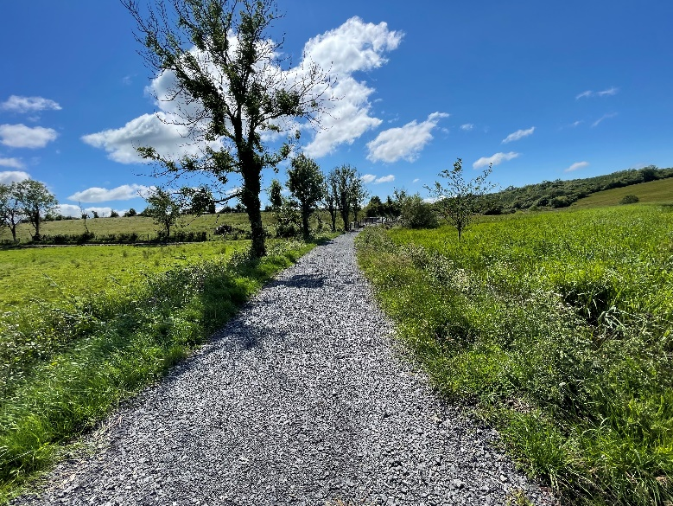
Plate 1 Greenway section under construction to the west of the subject scheme (not part of the current application).

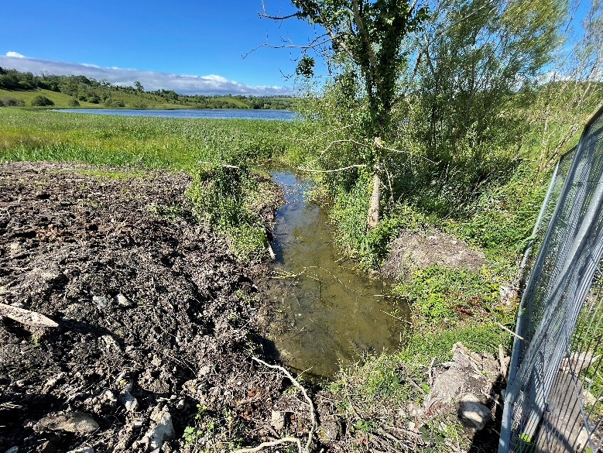
Plate 2 Impacts to shoreline of Bolganard Lough from current ongoing Greenway construction works.

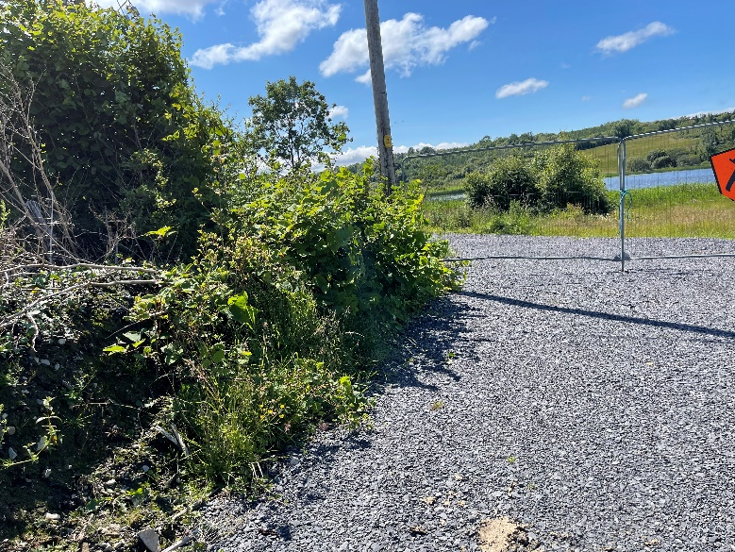
Plate 3 Western end of the proposed scheme and current Greenway section under construction. Japanese knotweed is present in this area and has been dispersed by the works.

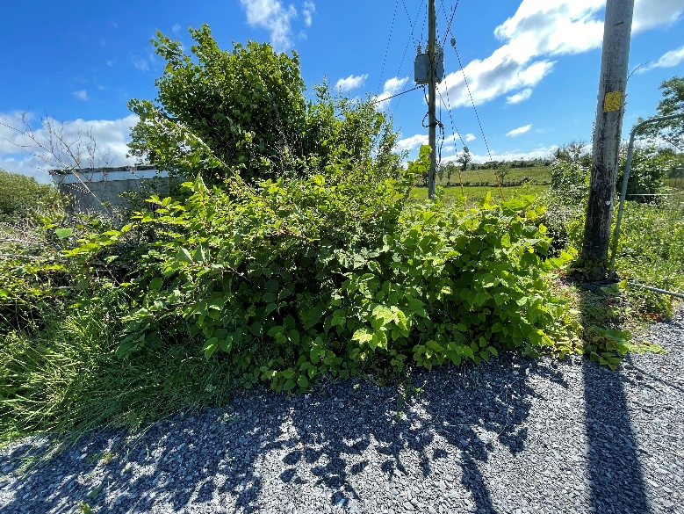
Plate 4 Japanese knotweed stand at the western end of the proposed scheme and current Greenway section under construction.

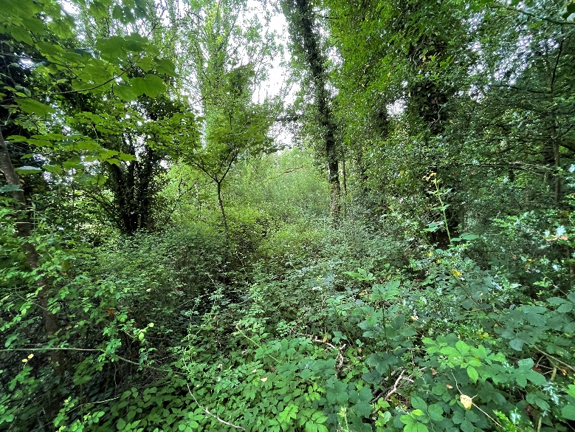
Plate 5 Proposed Greenway route in woodland beside Drumlonan Lough.

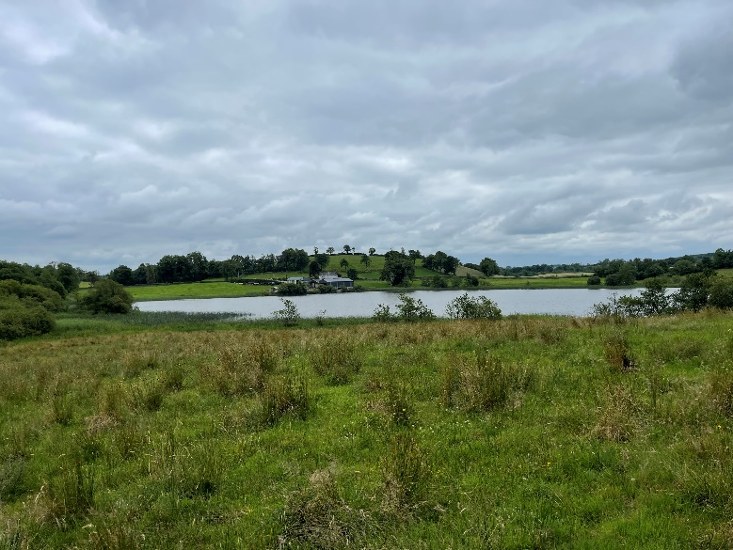
Plate 6 Corgar Lough viewed from the proposed Greenway route.

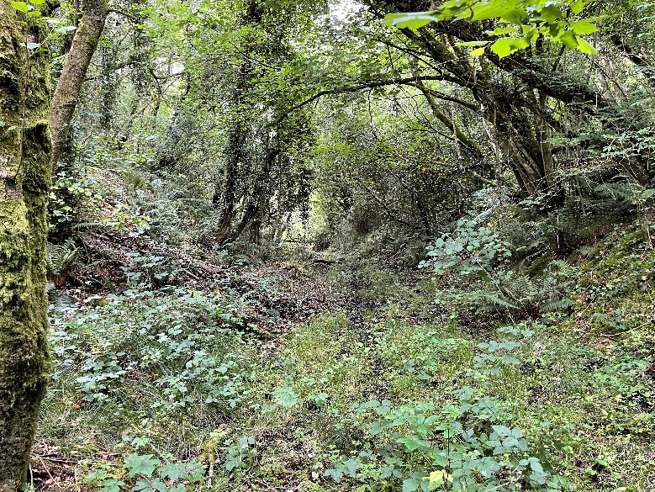
Plate 7 Western end of the proposed Greenway route near Corgar Lough.

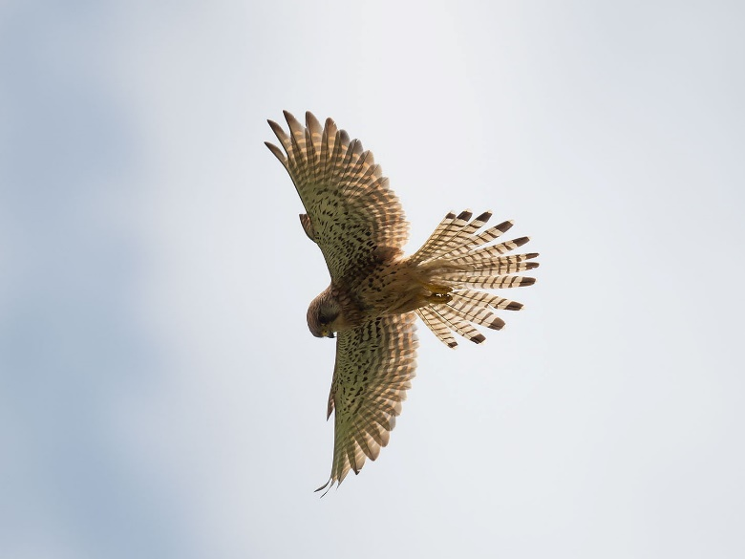
Plate 8 Kestrel foraging along the proposed Greenway route beside Corgar Lough.

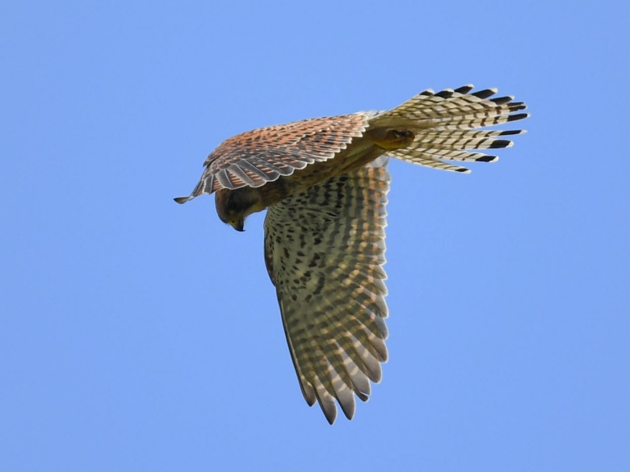
Plate 9 Kestrel foraging along the proposed Greenway route beside Corgar Lough.

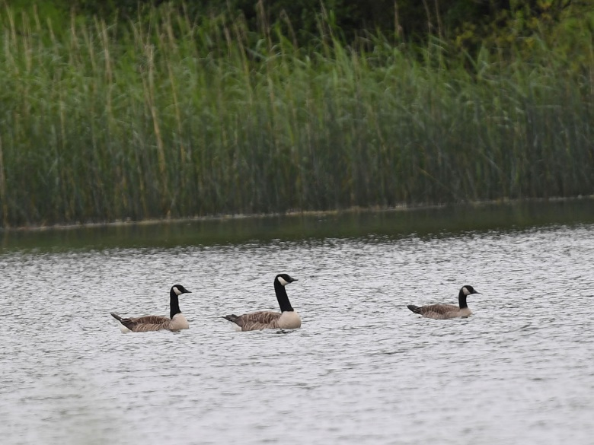
Plate 10 Non-native Canada Geese (Branta canadensis) on Corgar Lough.

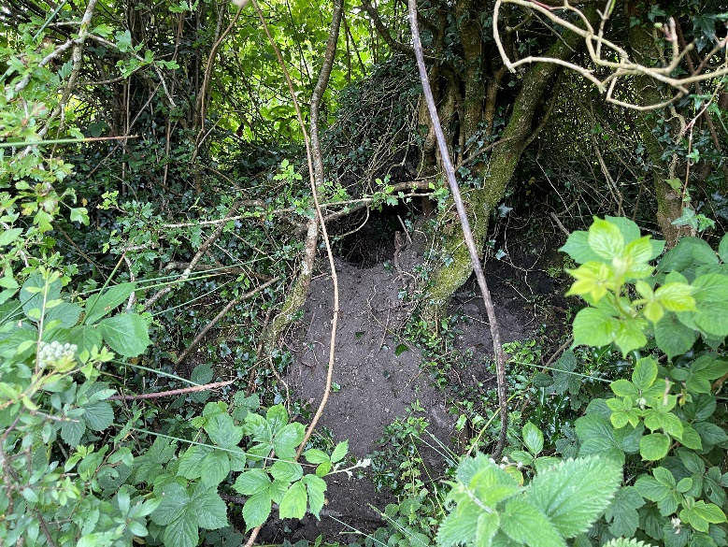
Plate 11 Mammal dwelling on the proposed Greenway route beside Corgar Lough. This will require further survey work and monitoring. It is possibly an Otter holt.

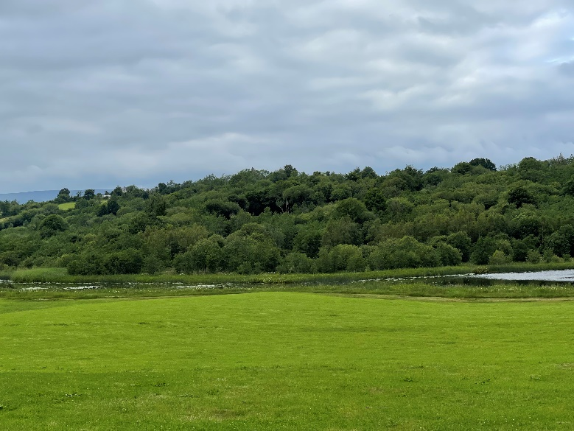
Plate 12 The proposed Greenway route runs through this woodland that fringes Corgar Lough (viewed from the R199 road).

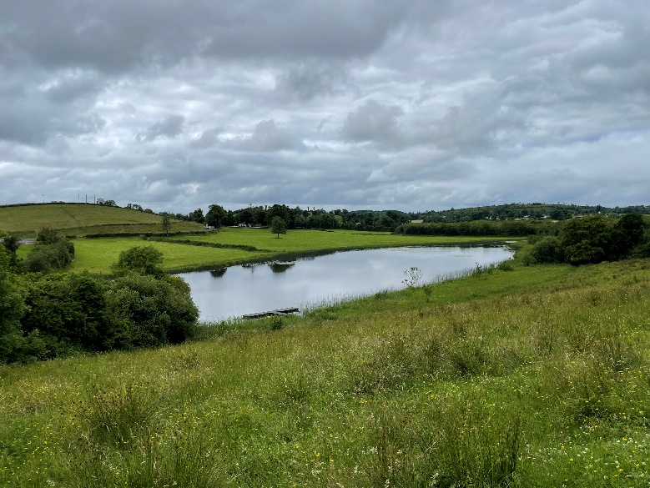
Plate 13 Drumlonan Lough viewed from the proposed Greenway route

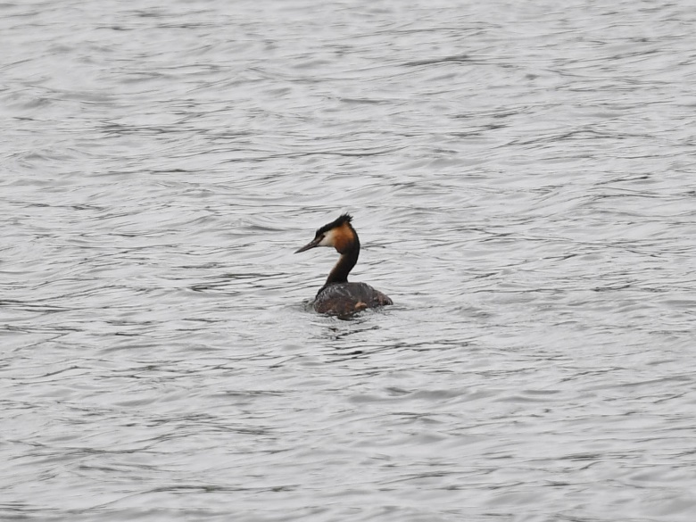
Plate 14 Great-crested grebe on Drumlonan Lough.

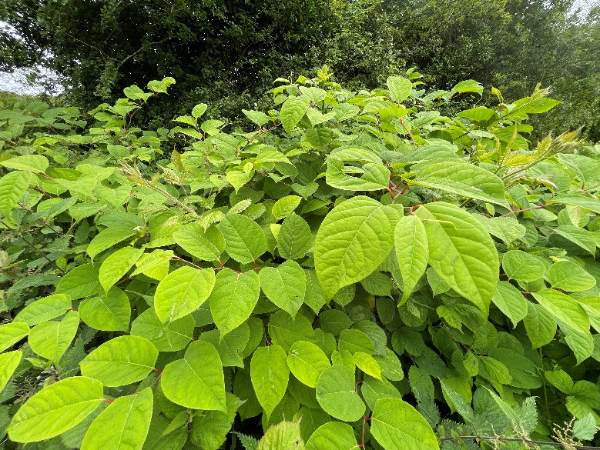
Plate 15 Japanese knotweed on the proposed Greenway route to the west of Drumcullion bridge (at the gate into the field beside Drumlonan Lough).

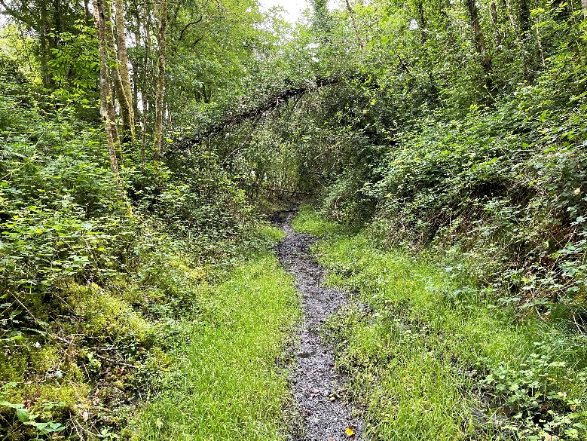
Plate 16 Proposed Greenway route to the west of Drumcullion bridge.

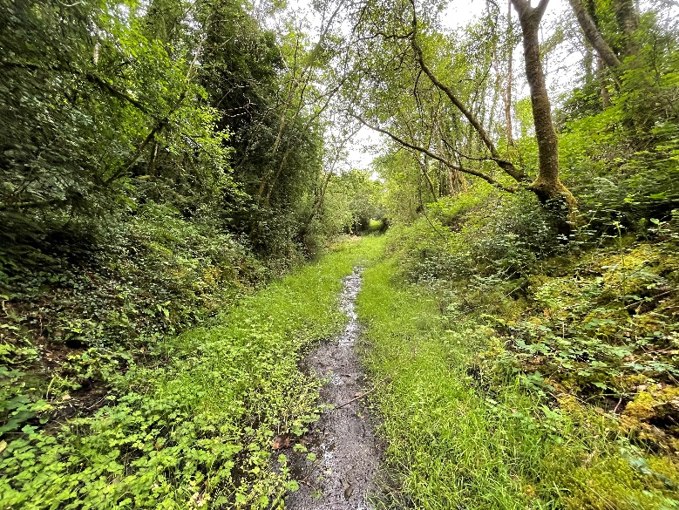
Plate 17 Proposed Greenway route to the west of Drumcullion bridge.

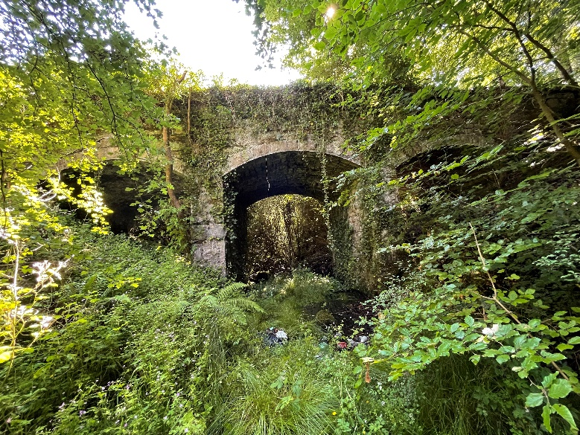
Plate 18 Bridge at Drumcullion. This bridge also provides potential habitat for bats.

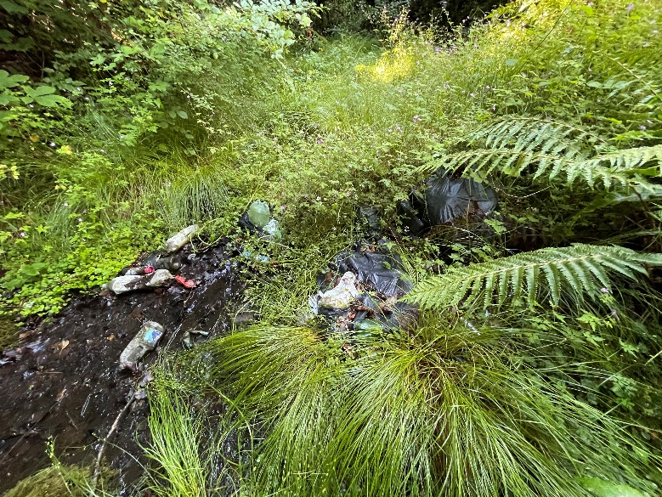
Plate 19 Rubbish dumping at the Bridge at Drumcullion.

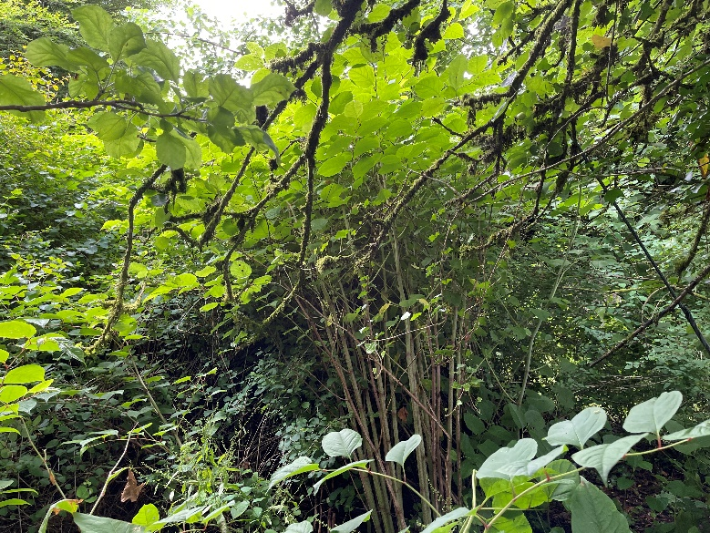
Plate 20 Japanese Knotweed to the east of Drumcullion bridge. This is not online and is associated with derelict dwelling / farm buildings in this area

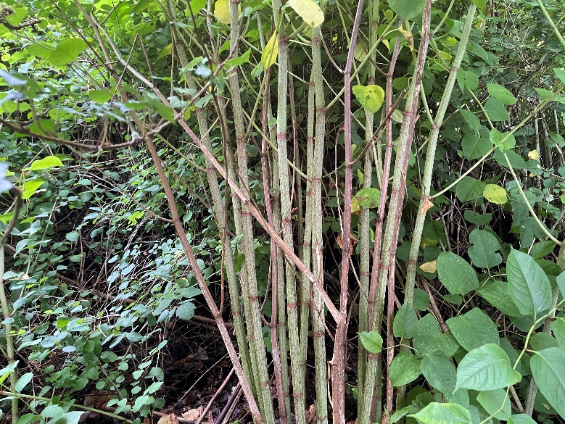
Plate 21 Japanese Knotweed to the east of Drumcullion bridge. This is not online and is associated with derelict dwelling / farm buildings in this area

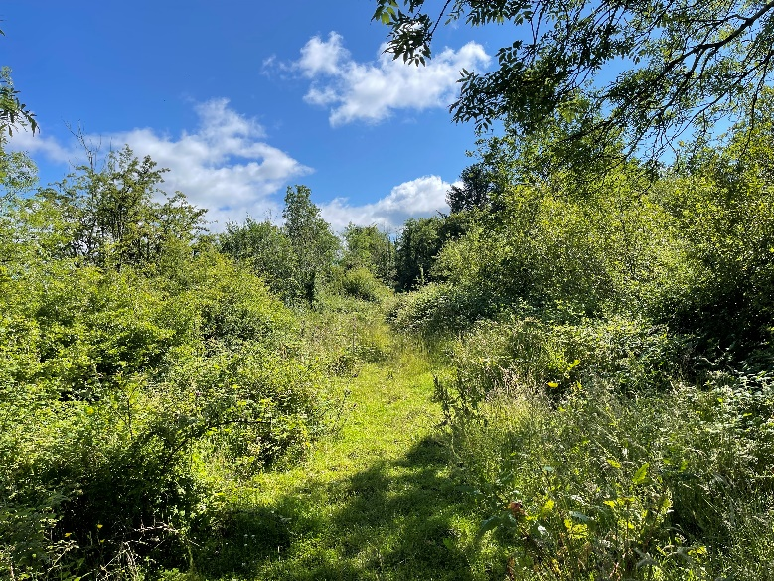
Plate 22 Proposed Greenway route to the east of Drumcullion bridge.

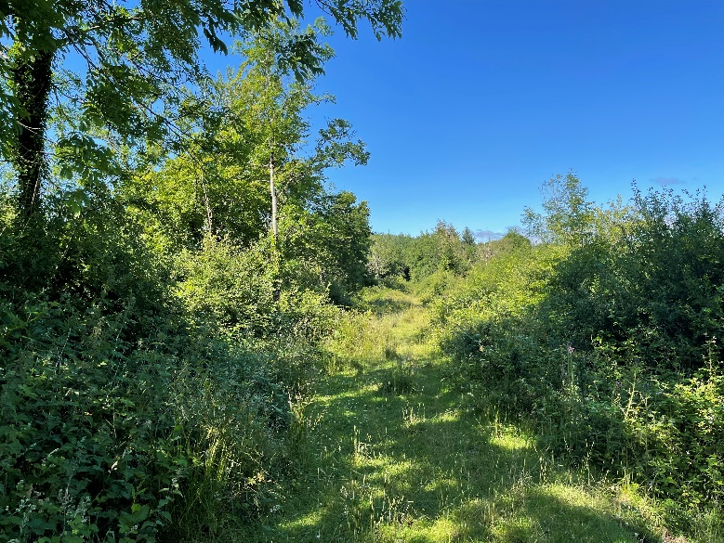
Plate 23 Proposed Greenway route to the east of Drumcullion bridge.

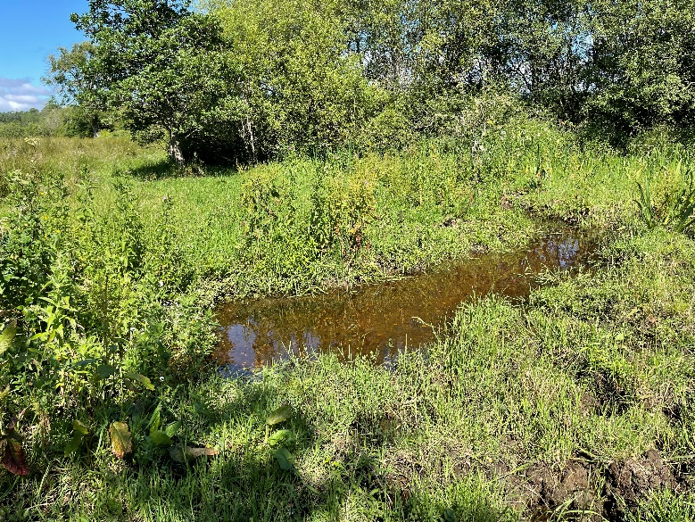
Plate 24 Stream to the east of Drumcullion bridge. Frogs are breeding in this stream and were frequently seen in the study area.
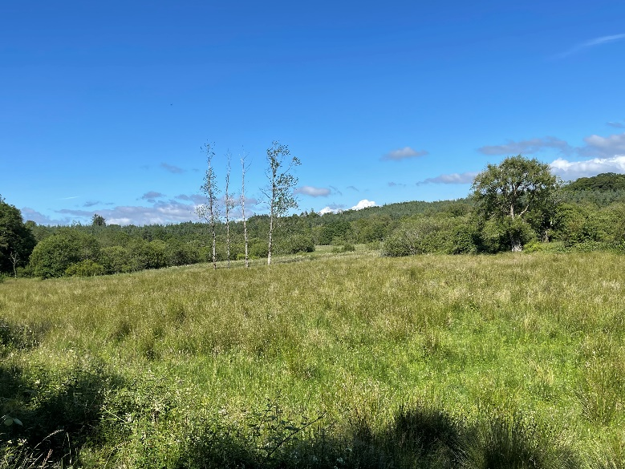
Plate 25 Very nice fen habitat to the south east of the proposed Greenway near Drumcullion bridge.

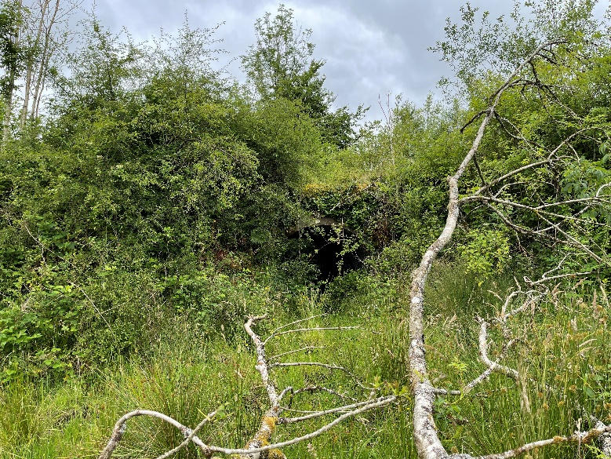
Plate 26 Minor bridge on the proposed Greenway route to the east of Drumcullion bridge, near the forestry plantation. This structure is unlikely to be used by bats.

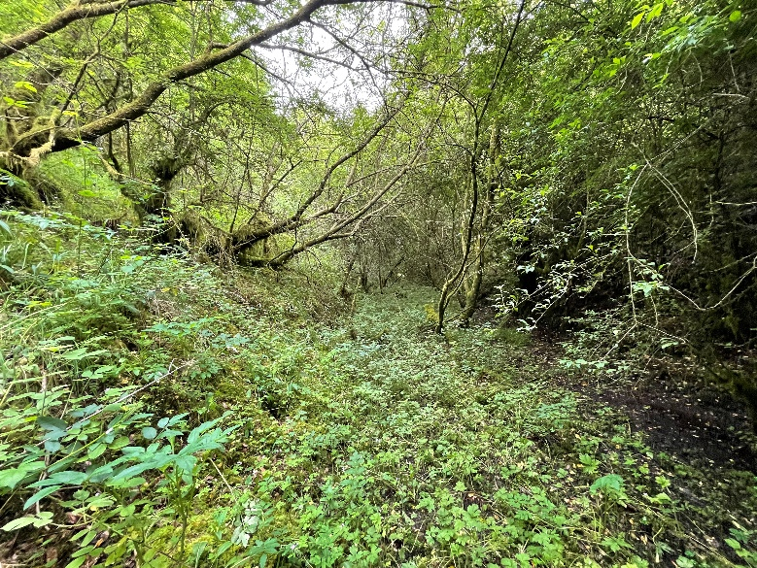
Plate 27 Proposed Greenway route as it runs through the forestry plantation to the east of Drumcullion bridge.

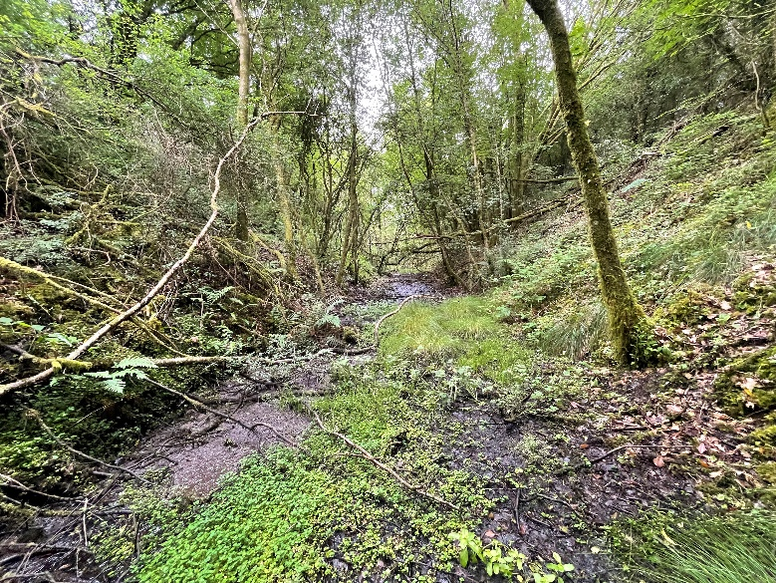
Plate 28 Proposed Greenway route as it runs through the forestry plantation to the east of Drumcullion bridge,

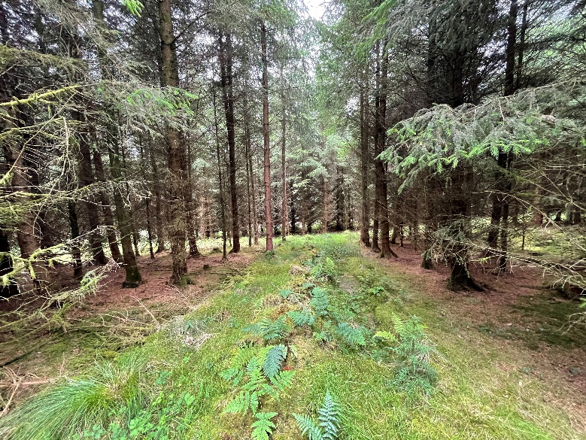
Plate 29 Forestry plantation to the east of Drumcullion bridge. The proposed route is not planted.

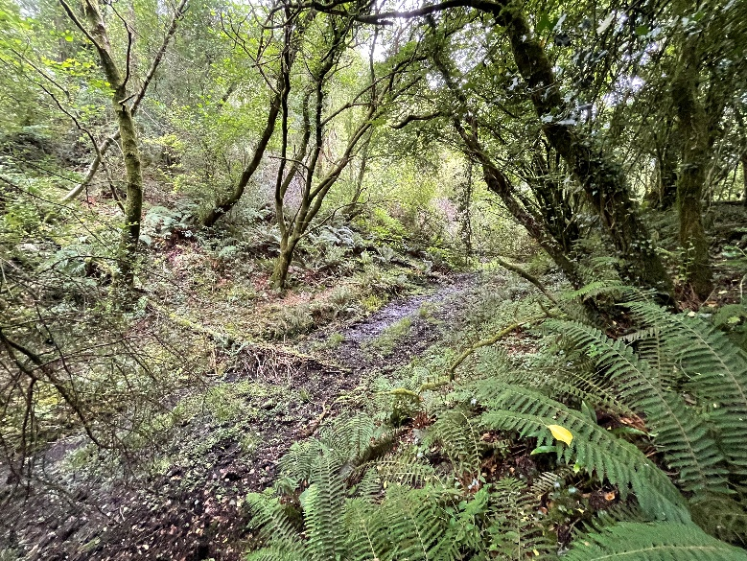
Plate 30 Western end of the proposed Greenway route near Corgar Lough.
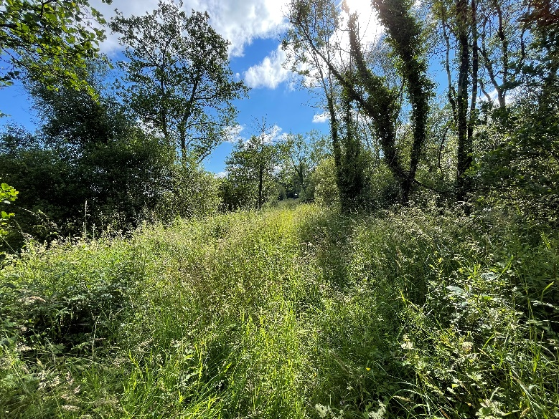
Plate 31 Propsoed Greenway route west of Aughawillan Bridge.

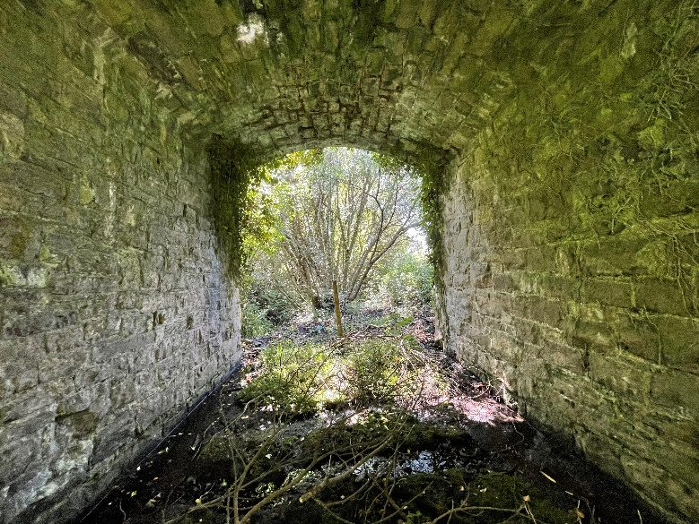
Plate 31 Bridge at Aughawillan. This bridge provides potential habitat for bats.

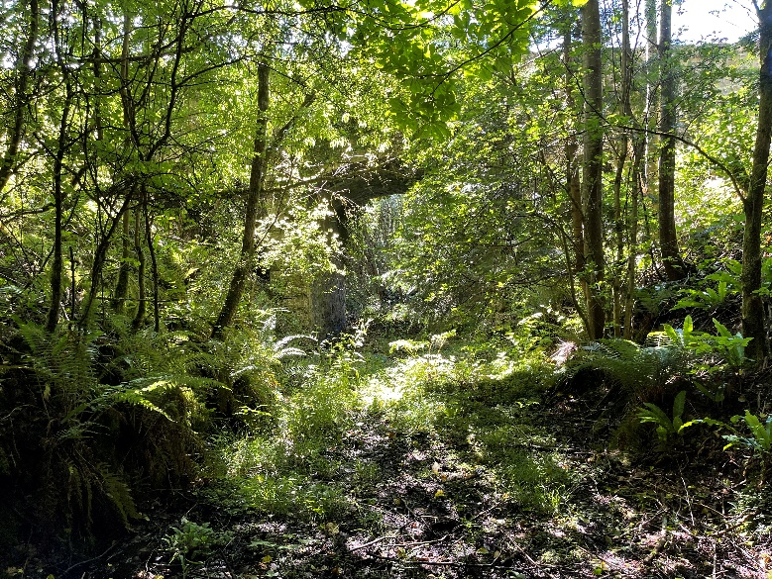
Plate 32 Bridge at Aughawillan. This is the north-eastern end of the proposed Greenway scheme section.

APPENDIX 1 PROJECT DRAWINGS

APPENDIX 2 NPWS Site Synopsis

SITE NAME:
SITE CODE:

APPENDIX 3 CRITERIA USED TO EVALUATE HABITATS AND IMPACTS

Table A.1 Criteria used to determine the value of ecological resources (taken from NRA, 2009).
 |  | Criteria
International Importance | ‘European Site’ including Special Area of Conservation (SAC), Site of Community Importance (SCI), Special Protection Area (SPA) or proposed Special Area of Conservation.  Proposed Special Protection Area (pSPA). Site that fulfils the criteria for designation as a ‘European Site’ (see Annex III of the Habitats Directive, as amended).  Features essential to maintaining the coherence of the Natura 2000 Network  Site containing ‘best examples’ of the habitat types listed in Annex I of the Habitats Directive.  Resident or regularly occurring populations (assessed to be important at the national level) of the following:  - Species of bird, listed in Annex I and/or referred to in Article 4(2) of the Birds Directive; and/or  - Species of animal and plants listed in Annex II and/or IV of the Habitats Directive.  - Ramsar Site (Convention on Wetlands of International Importance Especially Waterfowl Habitat 1971).  - World Heritage Site (Convention for the Protection of World Cultural & Natural Heritage, 1972).  - Biosphere Reserve (UNESCO Man & The Biosphere Programme)  - Site hosting significant species populations under the Bonn Convention (Convention on the Conservation of Migratory Species of Wild Animals, 1979).  - Site hosting significant populations under the Berne Convention (Convention on the Conservation of European Wildlife and Natural Habitats, 1979).  - Biogenetic Reserve under the Council of Europe.  - European Diploma Site under the Council of Europe.  - Salmonid water designated pursuant to the European Communities (Quality of Salmonid Waters) Regulations, 1988, (S.I. No. 293 of 1988).
National Importance | Site designated or proposed as a Natural Heritage Area (NHA).  Statutory Nature Reserve. Refuge for Fauna and Flora protected under the Wildlife Acts.  National Park.  Undesignated site fulfilling the criteria for designation as a Natural Heritage Area (NHA); Statutory Nature Reserve; Refuge for Fauna and Flora protected under the Wildlife Act; and/or a National Park. Resident or regularly occurring populations (assessed to be important at the national level) of the following:  - Species protected under the Wildlife Acts; and/or  - Species listed on the relevant Red Data list.  - Site containing ‘viable areas’ of the habitat types listed in Annex I of the Habitats Directive.
County Importance | Area of Special Amenity. Area subject to a Tree Preservation Order.  Area of High Amenity, or equivalent, designated under the County Development Plan.  Resident or regularly occurring populations (assessed to be important at the County level) of the following:  - Species of bird, listed in Annex I and/or referred to in Article 4(2) of the Birds Directive;  - Species of animal and plants listed in Annex II and/or IV of the Habitats Directive;  - Species protected under the Wildlife Acts; and/or  - Species listed on the relevant Red Data list.  Site containing area or areas of the habitat types listed in Annex I of the Habitats Directive that do not fulfil the criteria for valuation as of International or National importance.  County important populations of species; or viable areas of semi-natural habitats; or natural heritage features identified in the National or Local BAP; if this has been prepared.  Sites containing semi-natural habitat types with high biodiversity in a county context and a high degree of naturalness, or populations of species that are uncommon within the county.  Sites containing habitats and species that are rare or are undergoing a decline in quality or extent at a national level.
Local Importance (higher value) | Locally important populations of priority species or habitats or natural heritage features identified in the Local BAP, if this has been prepared;  Resident or regularly occurring populations (assessed to be important at the Local level) of the following:  - Species of bird, listed in Annex I and/or referred to in Article 4(2) of the Birds Directive;  - Species of animal and plants listed in Annex II and/or IV of the Habitats Directive;  - Species protected under the Wildlife Acts; and/or  - Species listed on the relevant Red Data list.  Sites containing semi-natural habitat types with high biodiversity in a local context and a high degree of naturalness, or populations of species that are uncommon in the locality;  - Sites or features containing common or lower value habitats, including naturalised species that are essential in maintaining links and ecological corridors between features of higher ecological value.
Local Importance (lower value) | Sites containing small areas of semi-natural habitat that are of some local importance for wildlife;  Sites or features containing non-native species that are of some importance in maintaining habitat links.

Table A.2 Criteria for assessing impact magnitude (NRA, 2009).
Impact magnitude | Definition
No change: | No discernible change in the ecology of the affected feature.
Imperceptible Impact: | An impact capable of measurement but without noticeable consequences.
Slight Impact: | An impact which causes noticeable changes in the character of the environment without affecting its sensitivities.
Moderate Impact: | An impact that alters the character of the environment that is consistent with existing and emerging trends.
Significant Impact: | An impact which, by its character, magnitude, duration or intensity alters a sensitive aspect of the environment.
Profound Impact: | An impact which obliterates sensitive characteristics.

APPENDIX 4 Protected / Threatened Birds

Table A.3 List of protected / threatened bird species recorded in H11 national 10km grid squares.
Group | Species | Scientific name | Designation
Bird | Barn Swallow | Hirundo rustica | Protected Species: Wildlife Acts || Threatened Species: Birds of Conservation Concern || Threatened Species: Birds of Conservation Concern >> Birds of Conservation Concern - Amber List
Bird | Black-headed Gull | Larus ridibundus | Protected Species: Wildlife Acts || Threatened Species: Birds of Conservation Concern || Threatened Species: Birds of Conservation Concern >> Birds of Conservation Concern - Red List
Bird | Canada Goose | Branta canadensis | Invasive Species: Invasive Species || Invasive Species: Invasive Species >> High Impact Invasive Species || Invasive Species: Invasive Species >> Regulation S.I. 477 (Ireland) || Protected Species: Wildlife Acts || Protected Species: EU Birds Directive || Protected Species: EU Birds Directive >> Annex II, Section I Bird Species
Bird | Common Coot | Fulica atra | Protected Species: Wildlife Acts || Protected Species: EU Birds Directive || Protected Species: EU Birds Directive >> Annex II, Section I Bird Species || Protected Species: EU Birds Directive >> Annex III, Section II Bird Species || Threatened Species: Birds of Conservation Concern || Threatened Species: Birds of Conservation Concern >> Birds of Conservation Concern - Amber List
Bird | Common Goldeneye | Bucephala clangula | Protected Species: Wildlife Acts || Protected Species: EU Birds Directive || Protected Species: EU Birds Directive >> Annex II, Section II Bird Species || Threatened Species: Birds of Conservation Concern || Threatened Species: Birds of Conservation Concern >> Birds of Conservation Concern - Amber List
Bird | Common Grasshopper Warbler | Locustella naevia | Protected Species: Wildlife Acts || Threatened Species: Birds of Conservation Concern || Threatened Species: Birds of Conservation Concern >> Birds of Conservation Concern - Amber List
Bird | Common Kestrel | Falco tinnunculus | Protected Species: Wildlife Acts || Threatened Species: Birds of Conservation Concern || Threatened Species: Birds of Conservation Concern >> Birds of Conservation Concern - Amber List
Bird | Common Kingfisher | Alcedo atthis | Protected Species: Wildlife Acts || Protected Species: EU Birds Directive || Protected Species: EU Birds Directive >> Annex I Bird Species || Threatened Species: Birds of Conservation Concern || Threatened Species: Birds of Conservation Concern >> Birds of Conservation Concern - Amber List
Bird | Common Linnet | Carduelis cannabina | Protected Species: Wildlife Acts || Threatened Species: Birds of Conservation Concern || Threatened Species: Birds of Conservation Concern >> Birds of Conservation Concern - Amber List
Bird | Common Pheasant | Phasianus colchicus | Protected Species: Wildlife Acts || Protected Species: EU Birds Directive || Protected Species: EU Birds Directive >> Annex II, Section I Bird Species || Protected Species: EU Birds Directive >> Annex III, Section I Bird Species
Bird | Common Pochard | Aythya ferina | Protected Species: Wildlife Acts || Protected Species: EU Birds Directive || Protected Species: EU Birds Directive >> Annex II, Section I Bird Species || Protected Species: EU Birds Directive >> Annex III, Section II Bird Species || Threatened Species: Birds of Conservation Concern || Threatened Species: Birds of Conservation Concern >> Birds of Conservation Concern - Amber List
Bird | Common Sandpiper | Actitis hypoleucos | Protected Species: Wildlife Acts || Threatened Species: Birds of Conservation Concern || Threatened Species: Birds of Conservation Concern >> Birds of Conservation Concern - Amber List
Bird | Common Snipe | Gallinago gallinago | Protected Species: Wildlife Acts || Protected Species: EU Birds Directive || Protected Species: EU Birds Directive >> Annex II, Section I Bird Species || Protected Species: EU Birds Directive >> Annex III, Section III Bird Species || Threatened Species: Birds of Conservation Concern || Threatened Species: Birds of Conservation Concern >> Birds of Conservation Concern - Amber List
Bird | Common Starling | Sturnus vulgaris | Protected Species: Wildlife Acts || Threatened Species: Birds of Conservation Concern || Threatened Species: Birds of Conservation Concern >> Birds of Conservation Concern - Amber List
Bird | Common Swift | Apus apus | Protected Species: Wildlife Acts || Threatened Species: Birds of Conservation Concern || Threatened Species: Birds of Conservation Concern >> Birds of Conservation Concern - Amber List
Bird | Common Tern | Sterna hirundo | Protected Species: Wildlife Acts || Protected Species: EU Birds Directive || Protected Species: EU Birds Directive >> Annex I Bird Species || Threatened Species: Birds of Conservation Concern || Threatened Species: Birds of Conservation Concern >> Birds of Conservation Concern - Amber List
Bird | Common Wood Pigeon | Columba palumbus | Protected Species: Wildlife Acts || Protected Species: EU Birds Directive || Protected Species: EU Birds Directive >> Annex II, Section I Bird Species || Protected Species: EU Birds Directive >> Annex III, Section I Bird Species
Bird | Corn Crake | Crex crex | Protected Species: Wildlife Acts || Protected Species: EU Birds Directive || Protected Species: EU Birds Directive >> Annex I Bird Species || Threatened Species: Birds of Conservation Concern || Threatened Species: Birds of Conservation Concern >> Birds of Conservation Concern - Red List
Bird | Eurasian Curlew | Numenius arquata | Protected Species: Wildlife Acts || Protected Species: EU Birds Directive || Protected Species: EU Birds Directive >> Annex II, Section II Bird Species || Threatened Species: Birds of Conservation Concern || Threatened Species: Birds of Conservation Concern >> Birds of Conservation Concern - Red List
Bird | Eurasian Teal | Anas crecca | Protected Species: Wildlife Acts || Protected Species: EU Birds Directive || Protected Species: EU Birds Directive >> Annex II, Section I Bird Species || Protected Species: EU Birds Directive >> Annex III, Section II Bird Species || Threatened Species: Birds of Conservation Concern || Threatened Species: Birds of Conservation Concern >> Birds of Conservation Concern - Amber List
Bird | Eurasian Wigeon | Anas penelope | Protected Species: Wildlife Acts || Protected Species: EU Birds Directive || Protected Species: EU Birds Directive >> Annex II, Section I Bird Species || Protected Species: EU Birds Directive >> Annex III, Section II Bird Species || Threatened Species: Birds of Conservation Concern || Threatened Species: Birds of Conservation Concern >> Birds of Conservation Concern - Amber List
Bird | Eurasian Woodcock | Scolopax rusticola | Protected Species: Wildlife Acts || Protected Species: EU Birds Directive || Protected Species: EU Birds Directive >> Annex II, Section I Bird Species || Protected Species: EU Birds Directive >> Annex III, Section III Bird Species || Threatened Species: Birds of Conservation Concern || Threatened Species: Birds of Conservation Concern >> Birds of Conservation Concern - Amber List
Bird | Great Cormorant | Phalacrocorax carbo | Protected Species: Wildlife Acts || Threatened Species: Birds of Conservation Concern || Threatened Species: Birds of Conservation Concern >> Birds of Conservation Concern - Amber List
Bird | Great Crested Grebe | Podiceps cristatus | Protected Species: Wildlife Acts || Threatened Species: Birds of Conservation Concern || Threatened Species: Birds of Conservation Concern >> Birds of Conservation Concern - Amber List
Bird | Greylag Goose | Anser anser | Invasive Species: Invasive Species || Invasive Species: Invasive Species >> Regulation S.I. 477 (Ireland) || Protected Species: Wildlife Acts || Protected Species: EU Birds Directive || Protected Species: EU Birds Directive >> Annex II, Section I Bird Species || Protected Species: EU Birds Directive >> Annex III, Section II Bird Species || Threatened Species: Birds of Conservation Concern || Threatened Species: Birds of Conservation Concern >> Birds of Conservation Concern - Amber List
Bird | House Martin | Delichon urbicum | Protected Species: Wildlife Acts || Threatened Species: Birds of Conservation Concern || Threatened Species: Birds of Conservation Concern >> Birds of Conservation Concern - Amber List
Bird | House Sparrow | Passer domesticus | Protected Species: Wildlife Acts || Threatened Species: Birds of Conservation Concern || Threatened Species: Birds of Conservation Concern >> Birds of Conservation Concern - Amber List
Bird | Lesser Black-backed Gull | Larus fuscus | Protected Species: Wildlife Acts || Threatened Species: Birds of Conservation Concern || Threatened Species: Birds of Conservation Concern >> Birds of Conservation Concern - Amber List
Bird | Little Grebe | Tachybaptus ruficollis | Protected Species: Wildlife Acts || Threatened Species: Birds of Conservation Concern || Threatened Species: Birds of Conservation Concern >> Birds of Conservation Concern - Amber List
Bird | Mallard | Anas platyrhynchos | Protected Species: Wildlife Acts || Protected Species: EU Birds Directive || Protected Species: EU Birds Directive >> Annex II, Section I Bird Species || Protected Species: EU Birds Directive >> Annex III, Section I Bird Species
Bird | Merlin | Falco columbarius | Protected Species: Wildlife Acts || Protected Species: EU Birds Directive || Protected Species: EU Birds Directive >> Annex I Bird Species || Threatened Species: Birds of Conservation Concern || Threatened Species: Birds of Conservation Concern >> Birds of Conservation Concern - Amber List
Bird | Mute Swan | Cygnus olor | Protected Species: Wildlife Acts || Threatened Species: Birds of Conservation Concern || Threatened Species: Birds of Conservation Concern >> Birds of Conservation Concern - Amber List
Bird | Northern Lapwing | Vanellus vanellus | Protected Species: Wildlife Acts || Protected Species: EU Birds Directive || Protected Species: EU Birds Directive >> Annex II, Section II Bird Species || Threatened Species: Birds of Conservation Concern || Threatened Species: Birds of Conservation Concern >> Birds of Conservation Concern - Red List
Bird | Ringed Plover | Charadrius hiaticula | Protected Species: Wildlife Acts || Threatened Species: Birds of Conservation Concern || Threatened Species: Birds of Conservation Concern >> Birds of Conservation Concern - Amber List
Bird | Sand Martin | Riparia riparia | Protected Species: Wildlife Acts || Threatened Species: Birds of Conservation Concern || Threatened Species: Birds of Conservation Concern >> Birds of Conservation Concern - Amber List
Bird | Sky Lark | Alauda arvensis | Protected Species: Wildlife Acts || Threatened Species: Birds of Conservation Concern || Threatened Species: Birds of Conservation Concern >> Birds of Conservation Concern - Amber List
Bird | Spotted Flycatcher | Muscicapa striata | Protected Species: Wildlife Acts || Threatened Species: Birds of Conservation Concern || Threatened Species: Birds of Conservation Concern >> Birds of Conservation Concern - Amber List
Bird | Tufted Duck | Aythya fuligula | Protected Species: Wildlife Acts || Protected Species: EU Birds Directive || Protected Species: EU Birds Directive >> Annex II, Section I Bird Species || Protected Species: EU Birds Directive >> Annex III, Section II Bird Species || Threatened Species: Birds of Conservation Concern || Threatened Species: Birds of Conservation Concern >> Birds of Conservation Concern - Amber List
Bird | Water Rail | Rallus aquaticus | Protected Species: Wildlife Acts || Threatened Species: Birds of Conservation Concern || Threatened Species: Birds of Conservation Concern >> Birds of Conservation Concern - Amber List
Bird | Whooper Swan | Cygnus cygnus | Protected Species: Wildlife Acts || Protected Species: EU Birds Directive || Protected Species: EU Birds Directive >> Annex I Bird Species || Threatened Species: Birds of Conservation Concern || Threatened Species: Birds of Conservation Concern >> Birds of Conservation Concern - Amber List
Bird | Willow Warbler | Phylloscopus trochilus
Bird | Yellowhammer | Emberiza citrinella | Protected Species: Wildlife Acts || Threatened Species: Birds of Conservation Concern || Threatened Species: Birds of Conservation Concern >> Birds of Conservation Concern - Red List

