**ARCHAEOLOGICAL ASSESSMENT**

**OF THE PROPOSED**

**CORGAR TO AGHAWILLAN GREENWAY,**

**COUNTY LEITRIM**

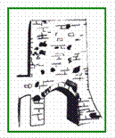

***Through Time Ltd.***

***Professional Archaeological Services***

***Old church Street, Athenry, Co. Galway***

**www.throughtimeltd.com**

**ARCHAEOLOGICAL ASSESSMENT**

**OF THE PROPOSED**

**CORGAR TO AGHAWILLAN GREENWAY,**

**COUNTY LEITRIM**

**Martin Fitzpatrick, M.A.**

**June 2021**



***Through Time Ltd.***

***Professional Archaeological Services***

***Old church Street, Athenry, Co. Galway***

**www.throughtimeltd.com**

**COPIES OF THIS**

**ARCHAEOLOGICAL REPORT**

**HAVE BEEN PRESENTED TO:**

***Client:* Leitrim County Council.**

***Statutory Bodies:*** The National Monuments,

Dept. of Housing, Local Government and Heritage.

The National Museum of Ireland.

**PLEASE NOTE**…

Any recommendations contained in this report are subject to the ratification of the National Monuments Service, Department of Housing, Local Government &, Heritage.

**COPYRIGHT NOTE**

Please note that the entirety of this report, including any original drawings and photographs, remain the property of **THROUGH TIME LTD**. Any reproduction of the said report thus requires the written permission of **THROUGH TIME LTD**.

**Disclaimer**

The results, conclusions and recommendations contained within this report are based on information available at the time of its preparation. Whilst every effort has been made to ensure that all relevant data has been collated, the authors and Through Time Ltd. accept no responsibility for omissions and/or inconsistencies that may result from information becoming available subsequent to the report’s completion.

**CONTENTS**

**I. List of figures and Plates**……………………………………...……………..... 6

**II. Abbreviations Acronyms and Definitions**……………………..….….. 7

**Introduction**…………………………………………………………………………………… 8

Project Background………………………………………………………………………….. 8

Site Location…………………………………….………………………................................ 8

**Relevant Legislation**………………………………………………………………………. **9**

Leitrim County Development Plan…………………………………………...……….. 11

Proposed Development……………………………………………………………………. 15

Purpose and Scope of the Assessment………………………………….................... 16

**Methodology**………………………………………………………..……...………………….. 16

Desk Study………………………………………………………..……………………………… 17

**Receiving Environment**………………………………………………………………….. 18

Recorded Archaeological Remains…………………………………………………….. 19

Detail of Recorded Monuments…………………………………………………………. 19

Previous archaeological investigations………………………………………............. 20

Cartographic Analysis………………………………………………………………………. 20

Architectural Heritage………………………………………………………………………. 22

Townland Names………………………………………………………………………………. 23

**Site Visit**………………………………………………………………………………………… 24

**Likely Impacts of the proposed development**….………............................… 25

**Conclusions & Recommendation**…………………………..................................… 26

**I. LIST OF FIGURES AND PLATES**

**FIGURES**

**Fig. 1:** General Site Location.

**Fig. 2:** Aerial view depicting proposed greenway route.

**Fig. 3:** Map indicating recorded archaeological monuments in vicinity of proposed development.

**Fig. 4:** Extract from first edition O.S. map relating to proposed car park.

**Fig. 5:** Extract from 25-inch edition O.S. map.

**PLATES**

**Plate 1:** View of railway cottage and route at Corgar.

**Plates 2 & 3:** Route immediately S of cottage and existing route heading E.

**Plates 4 & 5**: Overgrown nature of section of route and road spanning route.

**II ABBREVIATIONS ACRONYMS AND DEFINITIONS**

**LE** - This number is the number of the site on the SMR/RMP map. It begins with the county code, here LE for Leitrim, the 6-inch sheet number, followed by the number of the archaeological site.

**M** Meters, all dimensions are given in meters or part of a meter.

**NIAH** National Inventory of Architectural Heritage

**NMI** National Museum of Ireland

**NMS** National Monuments Service, Department of Culture, Heritage, and the Gaeltacht

**OS** Ordnance Survey

**OSI** Ordnance Survey of Ireland RMP

**RMP** Record of Monuments and Places. A record on which all known archaeological sites are marked and listed in an accompanying inventory. This resource is based on all publicly available material and cartographic sources and is read in conjunction with constraint maps. The RMP records known recorded monuments and the sites of such monuments (if the monument no longer survives).

**RPS** Record of Protected Structures

**SMR** Sites and Monuments Record

**GENERAL INTRODUCTION**

**Project Background**

Through Time Ltd. was engaged by Leitrim County Council to undertake an archaeological and cultural heritage assessment as part of a Part 8 planning application for a proposed greenway from Corgar to Lisgruddy and Corramahan in County Leitrim. The assessment aims to identify the likely significant effects on archaeology, architectural heritage, history and folklore and is based on a desk-based assessment and a site inspection. Conclusions and recommendations in relation to individual cultural heritage assets are included.

**Site Location**

The proposed development of a greenway is between the townlands of Corgar and Lisgruddy and Corramahan in County Leitrim. The development will be located along a section of the former Cavan and Leitrim railway track that ran from Ballinamore to Ballyconnell.

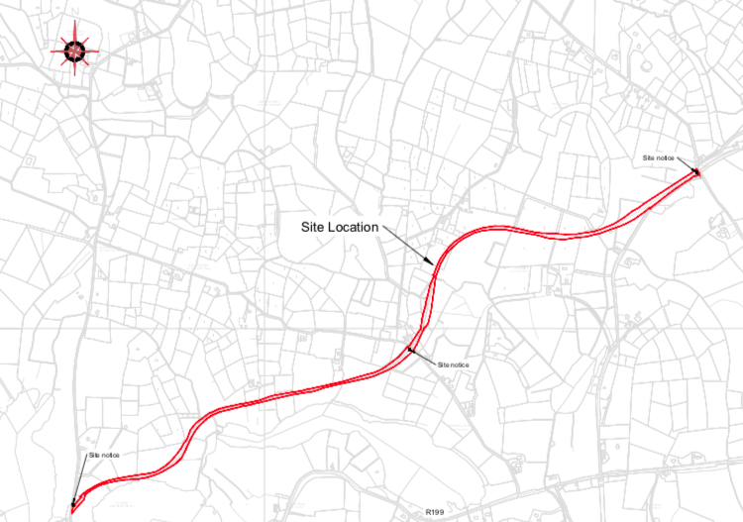

**Fig. 1:** General Site Location Map.

**RELEVANT LEGISLATION AND GUIDELINES**

Archaeological monuments are protected through national and international policy designed to secure the protection of the cultural heritage resource. This is facilitated in accordance with the provisions of the European Convention on the Protection of the Archaeological Heritage (Valletta Convention), which was ratified by Ireland in 1997.

The National Monuments Act 1930 to 2004 and relevant provisions of the National Cultural Institutions Act 1997 are the primary means of ensuring the satisfactory protection of archaeological remains, which includes all man-made structures of whatever form or date except buildings habitually used for ecclesiastical purposes. A National Monument is described as:

“*a monument or the remains of a monument the preservation of which is a matter of national importance by reason of the historical, architectural, traditional, artistic or archaeological interest attaching thereto*” (National Monuments Act 1930 Section 2).

A number of mechanisms under the National Monuments Act are applied to secure the protection of archaeological monuments. These include the Register of Historic Monuments, the Record of Monuments and Places and the placing of Preservation Orders and Temporary Preservation Orders on endangered sites.

The minister may acquire National Monuments by agreement or by compulsory order. The State or the Local Authority may assume guardianship of any National Monument (other than dwellings). The owners of National Monuments may also appoint the Minister or the Local Authority of that monument if the State or Local Authority agrees. Once the site is in ownership or guardianship of the State, it may not be interfered with without the written consent of the Minister.

Section 5 of the 1987 Act requires the Minister to establish and maintain a Register of Historic Monuments. Historic monuments and archaeological areas present on the Register are afforded statuary protection under the 1987 Act. Any interference with sites recorded on the Register is illegal without the permission of the Minister. Two months’ notice in writing is required prior to any work being undertaken on or in the vicinity of a Registered Monument. The Register also includes sites under preservation orders and temporary preservation orders with the written consent, and at the discretion of the Minister.

Section 12(1) of the 1994 Act requires the Minister to establish and maintain a Record of Monuments and Places where the Minister believes that such monuments exist. The Record comprises a list of monuments and relevant places and a map showing each monument and relevant place in respect of each county in the state. All sites recorded on the Record of Monuments and Places receive statuary protection under the National Monuments Act 1994.

Section 12(3) of the 1994 Act provides that:

*“Where the owner or occupier (other than the Minister) of a monument or place included in the Record, or any other person, proposed to carry out, or to cause or permit the carrying out of, any work at or in relation to such a monument or place, he or she shall give notice to the Minister to carry out work and shall not, except in the case of urgent necessity and with the consent of the Minister, commence the works until two months after the giving of notice”.*

The Architectural Heritage and Historic Properties Act 1999 and the Planning and Development Act of 2000 are the main built heritage legislation. The Architectural Heritage Act requires the Minister to establish a survey to identify, record and assess the architectural heritage of the country. The National Inventory of Architectural Heritage (“NIAH”) records all built heritage structures within specific counties in Ireland. The document is used to advise local Authorities on the register of a Record of Protected Structures (“RPS”) as required by the Planning and Development Act, 2000.

The Act of 2000 requires Local Authorities to establish a Record of Protected Structures to be included in the County Development Plan (“CDP”). Buildings recorded in the RPS can include Recorded Monuments, structures listed in the NIAH or buildings deemed to be of architectural, archaeological or artistic importance by the Minister. Once listed in the RPS the sites/areas receive statuary protection from injury or demolition under the 2000 Act. Damage to or demolition of a site registered in the RPS is an offence. The detail of the list varies from County to County. If the Local Authority considers a building to be in need of a repair it can order conservation and/or restoration works. The owner or developer must make a written application/request to the local Authority to carry out any works on a protected Structure and its environs.

Where a National Inventory of Architectural Heritage survey has been carried out, those structures which have been attributed a rating value of international, national or regional importance in the inventory are recommended by the Minister of Housing, Local Government and Heritage to the relevant planning authority for inclusion on the RPS. In accordance with Section 53 of the Planning and Development Act 2000, if a planning authority, after considering a recommendation made to it under this section, decides not to comply with the recommendation, it shall inform the Minister in writing of the reason for its decision.

**Leitrim County Development Plan 2015-2021**

Leitrim County Council has written policies on the preservation of archaeological, architectural and cultural heritage remains in relation to permitted development in the Leitrim County Development Plan. These relate to archaeological features and objects, built structures, views and scenic routes. In relation to tourism Leitrim County Council ‘is fully supportive of all future developments that will contribute positively to the tourism potential of the County, while protecting the heritage and environment of the County, so as to achieve maximum economic and social gain’ (p52). Objective 92 of the Development Plan states **‘It is an objective of the Council to promote the County’s archaeological heritage as a tourism resource, in partnership with key tourism organisations.’**

***Leitrim Heritage Plan 2020-2025***

Leitrim County Council and the Leitrim Heritage Forum prepared the County Leitrim Heritage Plan 2020-2025. This plan sets out the priorities for Leitrim over a six year period and is a commitment by Leitrim County Council to promote and protect Leitrim’s heritage. The aim of the Heritage Plan is “*to connect all Leitrim residents with their shared heritage and to work together to conserve and celebrate Leitrim’s unique heritage, for the benefit of both present and future generations”.*

The objectives of the Heritage Plan include:

* Support the Conservation and Recording of Leitrim’s Heritage
* Raise Awareness of Leitrim’s Heritage
* Engage Communities with their Heritage
* Support Sustainable Heritage Tourism in Leitrim

**Architectural Heritage**

The term ‘architectural heritage’ is defined in the *Architectural Heritage (National Inventory) & Historic Monuments Act, 1999,* as “all (a) structures and buildings together with their settings and attendant grounds, fixtures and fittings, (b) groups of such structures, and (c) sites”, which are of architectural, historical, archaeological, artistic, cultural, scientific, social or technical interest.

**Protected Structure**

A Protected Structure is a structure that Leitrim County Council considers to be worthy of protections from an architectural, historical, archaeological, artistic, cultural, scientific, social or technical point of view. The built heritage is an important element in the character of County Leitrim and every Planning Authority is required to have a Record of Protected Structures in its functional area.

The Inventory of Appropriate Buildings/Structures for Inclusion in the New Record of Protected Structures prepared by CAAS in November 2000 and the National Inventory of Architectural Heritage in County Leitrim (Dúchas, the Heritage Service), the Carrick‐on‐Shannon Architectural Heritage Study (Dúchas, the Heritage Service) and the Urban Framework Plans for Drumkeeran, Drumshanbo, Ballinamore, Mohill, Manorhamilton and Dromahaire shall be used as the basis for the preparation of any new Record of Protected Structures. All structures of local, regional and national importance will be considered for protection.

|  |  |
| --- | --- |
| **Policy 104** | It is the policy of the Council to protect all structures in the Record of Protected Structures . |

|  |  |
| --- | --- |
| **Objective 84** | It is an objective of the Council to seek the protection of all structures within the County that are of special architectural, historical, archaeological, artistic, cultural, scientific, social or technical interest. |

|  |  |
| --- | --- |
| **Objective 85** | It is an objective of the Council to review the record of Protected Structures during the lifetime of this plan. |
| **Objective 86** | It is an objective of the Council to seek funding for the conservation and restoration of Protected Structures. |

|  |  |
| --- | --- |
| **Objective 87** | It is an objective of the Council to seek the appointment of a Conservation Officer/Heritage Officer to improve the level of expertise available to the Council |

**Archaeological Heritage**

|  |  |
| --- | --- |
| **Policy 105** | It is the policy of the Council to promote public awareness of the rich archaeological heritage that exists in County Leitrim. |

The archaeological heritage of County Leitrim includes, according to the *European Convention for the Protection of Archaeological Heritage, 1992 (Valetta Convention)* structures, constructions, groups of buildings, developed sites, all recorded monuments as well as their contexts, and moveable objects; situated both on land and under water. This means that the archaeological heritage is not confined to the archaeological sites within the Record of Monuments and Places, but also includes any archaeological site that may not have been recorded yet, as well as archaeology beneath the ground surface, as well as the context of any site. Leitrim has one underwater heritage order in the County (UHO 1/90), which refers to Lough Donogher, located to the north east of Cloone.

|  |  |
| --- | --- |
| **Objective 92** | It is an objective of the Council to promote the County’s archaeological heritage as a tourism resource, in partnership with key tourism organisations. |

**Archaeological Assessments**

|  |  |
| --- | --- |
| **Policy 106** | It is the policy of the Council to secure the preservation (i.e. preservation in‐ situ or in particular circumstances where the Council is satisfied that this is not possible, preservation by record as a minimum) of all archaeological remains and sites of importance such as National Monuments, Recorded Monuments, their setting and context. |

The Council will protect all such sites and monuments and their settings from inappropriate development. All planning applications likely to interfere with such a recorded site, monument or zone of archaeological interest will be referred to the Development Applications Unit of the Dept. of Housing, Local Government and Heritage, An Taisce and the Heritage Council. Regard will be given to the advice and recommendations of these bodies in respect of whether or not planning permission should be granted and the nature of conditions to be attached to any grant of planning permission.

Proposed development on, or in close proximity to, a site and monument of archaeological significance will only be allowed where development does not adversely affect their character and setting. Where allowed, the Council will use planning conditions and agreements to enable an archaeological assessment, on site monitoring, testing and/or excavation by a licensed archaeologist.

In assessing development proposals that affect sites and monuments, the Council will have regard to the recommendations of both the Development Applications Unit of the Dept. of Housing, Local Government and Heritage, An Taisce and the Heritage Council. The Council will also have regard to the guidance document *Framework and Principles for the Protection of the Archaeological Heritage*, as published by the Department of Arts, Heritage, Gaeltacht and the Islands in 1999.

|  |  |
| --- | --- |
| **Objective 93** | It is an objective of the Council to ensure that any development (above or below ground), within the vicinity of a site of archaeological interest shall not be detrimental to the character of the archaeological site or its setting. |

|  |  |
| --- | --- |
| **Objective 94** | It is an objective of the Council to require, where appropriate, that an archaeological assessment be carried out by a suitably qualified person prior to the commencement of any activity that may impact upon the archaeological heritage. |
| **Objective 95** | It is an objective of the Council to protect the zones of archaeological potential, as identified in the Record of Monuments and Places. |

|  |  |
| --- | --- |
| **Objective 96** | It is an objective of the Council to protect archaeological sites discovered since the publication of the Record of Monuments and Places. |

**Industrial Archaeology & Canals**

The Council is aware of the cultural importance of the County’s industrial heritage and in particular of the canal and waterway systems that traverse the County. Canals, lough gates and associated structures are fine examples of 19th century industrial engineering, which have mellowed over time to form an intrinsic part of the County’s landscape. The importance of protecting these structures is all the greater given the increased importance of the canal and navigation network as a tourism and recreational resource.

|  |  |
| --- | --- |
| **Policy 107** | It is the policy of the Council to protect and enhance public accessibility to the County’s industrial heritage. |

**PROPOSED DEVELOPMENT**

The development of approximately 2.9 kilometre section of ‘greenway’ linking the townlands of Corgar and Lisgruddy and Corramahan in County Leitrim. The greenway will be located along the route of a former railway track.

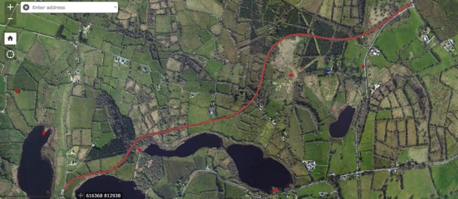

**Fig. 2:** Aerial view indicating proposed greenway with recorded monuments (red dots) and structure recorded in National Inventory of Architectural Heritage (blue dot).

**Purpose and Scope of this Assessment**

The purpose of this assessment is to identify likely significant effects on cultural heritage (archaeology, architectural heritage and/or folklore and history) as a result of the proposed works, and to determine whether further investigations or other measures would be required to mitigate any likely adverse effects. This report concerns …

1. The proposed development of the greenway route connecting the townlands of Corgar and Lisgruddy and Corramahan.

**METHODOLOGY**

The methodology used in the preparation of this assessment is based on guidance provided in the Environmental Protection Agency (EPA)’s draft Guidelines on the Information to be contained in Environmental Impact Assessment Reports (EPA 2017) and Advice Notes on Current Practice (EPA 2003). It is also consistent with other guidance including the National Roads Authority’s (NRA, now TII) Guidelines for the Assessment of Archaeological Heritage Impacts on National Road Schemes (NRA 2005a) and Guidelines for the Assessment of Architectural Heritage Impacts on National Road Schemes (NRA 2005b) in relation to route selection.

The study was divided into three main components:

1. Desk-based assessment, including gathering and analysing baseline data.

2. A site inspection of the proposed work areas in relation to known cultural

heritage assets and any previously unidentified assets that may be impacted; and

3. Report writing.

**Desk Based Assessment**

The desk-based assessment involved examination of the following databases and available documentary sources:

**Archaeology**

Record of Monuments and Places (RMP) – the statutory list of protected places and monuments, with accompanying constraints maps, published for County Leitrim;

Sites and Monuments Record (SMR) – the archive of current information on sites and monuments, including whether or not sites are to be included on the next RMP revision; available online at

http://webgis.archaeology.ie/historicenvironment/ ;

 Lists of National Monuments in State Care: Ownership and Guardianship, published for County Leitrim;

The list of Preservation Orders held by the National Monuments Service (published 2010);

Excavations Bulletins (www.excavations.ie);

Topographical Files of the National Museum of Ireland;

Cartographic sources, including the first-edition six-inch Ordnance Survey (OS) map, the 25-inch OS map along with other available maps;

Historical photographs viewed online via the National Library of Ireland website (http://www.nli.ie/digital-photographs.aspx); and Aerial photography (Google Earth, and Digital Globe via the Historic Environment Viewer).

**Architectural Heritage**

Record of Protected Structures (RPS); and

National Inventory of Architectural Heritage (NIAH).

**Site Inspection**

A site inspection was carried out in June 2021. The purpose of the inspection was to undertake a visual examination of the proposed greenway to assess the potential effects on known and unknown archaeological and architectural heritage assets.

**RECEIVING ENVIRONMENT**

The archaeological and cultural heritage assessment of the proposed greenway was assessed in relation to the archaeological monuments that form part of the landscape and particularly those that are encountered along the route of the proposed greenway.

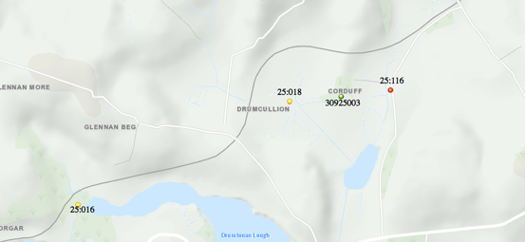

**Fig. 3:** Recorded monuments in area of the proposed greenway. Red dot indicates a recorded monument, yellow dot indicates a redundant record and green dot indicates a structure recorded in the National Inventory of Architectural Heritage.

A total of three recorded monuments are located within 200m of the proposed greenway route examined. Two of these are redundant records. None of these monuments will be directly impacted by the proposed Greenway route.

**Recorded Archaeological Remains**

|  |  |  |  |
| --- | --- | --- | --- |
| **No.** | **RMP Ref.** | **Townland** | **Monument Type** |
| 1. | *LE025-016----* | *Corgar* | *Redundant Record* |
| 2. | *LE025-018----* | *Drumcullion* | *Redundant Record* |
| 3. | *LE025-116-* | *Garradice* | *Ringfort* |

**Table 1:** Recorded monuments within 200m of proposed greenway route.

No recorded monuments are located in the area of the proposed greenway route. A total of three monuments are located within 200m of the proposed route. Two of these monuments are now redundant records indicating that following consideration they are no longer proposed as recorded monuments. One recorded monument is a ringfort (LE025-116) located c. 200m to south of the proposed greenway route, but this will not be impacted.

**Details of Recorded Monuments**

The following descriptions are derived from 'The Archaeological Inventory of County Leitrim' compiled by Michael J. Moore (Dublin: Stationery Office, 2003). In certain instances the entries have been revised and updated in the light of recent research.

**LE025:016---- Corgar Redundant Record**

Situated at the W end of the narrow western part of Drumlonan Lough (dims c. 600m E-W; c. 50m-100m N-S). A small oval island (dims c. 15m NE-SW; c. 10m NW-SE) is marked only on the 1944 edition of the OS 6-inch map where a stream enters the lake from the S. The area is now silted up and the feature is likely to be a naturally silted sand-bar.

**LE025:018---- Drumcullion Redundant Record**

Located in a flat, low-lying landscape. A protuberance, which may be rock outcrop, is indicated at the W edge of a small oval lake (dims c. 150m NW-SE; c. 40-70m NE-SW) depicted on the 1835 edition of the OS 6-inch map and visible as a faint feature in a silted landscape on aerial photographs (GSIAP: H 109-8). This is an area of sally bushes but cannot be confirmed as an antiquity.

**LE025:116---- Garradice Ringfort**

Located in a low-lying position surrounded by drumlins. This is a grass-covered D-shaped area (dims 43m N-S; 17m E-W) defined by a scarp (H 0.4-0.7m) S-W-N which is truncated at E by a N-S roadway. An old grass-covered quarry (diam. 17m; D 0.5m), from which the spoil has been removed is excavated in the surviving portion. There is no visible fosse or identifiable original entrance and there is no trace of the monument on the E side of the road, but it was undoubtedly a rath.

**Previous Archaeological Investigations**

No archaeological works are recorded along the route of the proposed greenway.

**Cartographic Analysis**

Consultation of the Ordnance Survey Maps from 1838 to the present day provided further information to aid the Archaeology and Cultural Heritage Assessment.

**Proposed Greenway Route**

The railway track and associated infrastructure is not indicated on the 1837 OSi 6-inch map. The proposed Greenway route (indicated red in map below) meanders through the countryside. North of Corgar lake it continues in a NE direction through the townlands of Glennan Beg to the townland of Drumcullion where it travels N, E and NE through Corduff to Lisgruddy and Corramahan. The landscape is depicted as enclosed farmsteads with a demesne landscape depicted surrounding Corduff House. No archaeological monuments are recorded along the route.

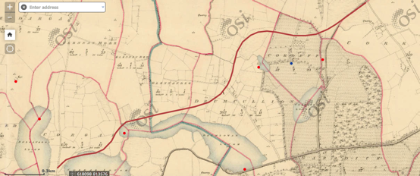

**Fig. 4:** Extract from 0Si first edition and Cassini editions 6-inch maps (After OSI).

The railway track is marked on the OSi 25-inch map of 1909 where it is depicted as a series of cuts and embankments meandering through the farmland from Corgar to Aughawillan. This map gives more detail of the landscape with further land division indicated from that represented on the first edition map. No archaeological monuments are recorded along the route or in close proximity. Corduff House is annotated on this map. The landscape is similarly depicted on Cassini 6 inch O.S. map.

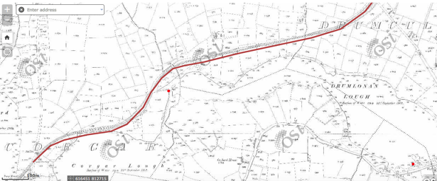

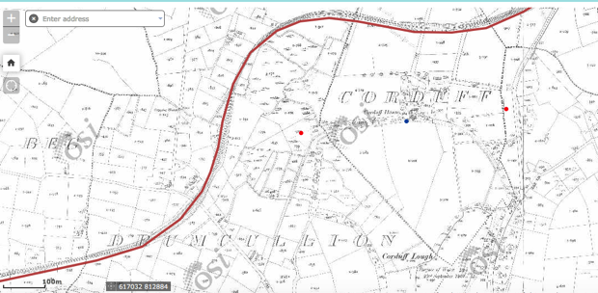

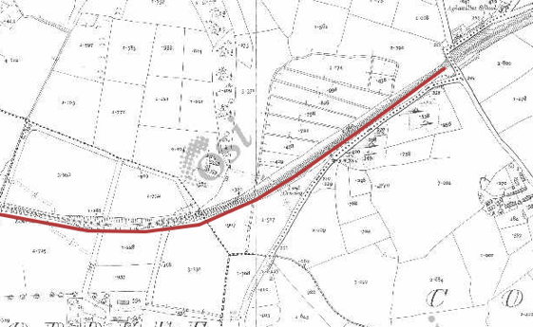

**Fig. 5 a-c:** Extract from OSi historic 25-inch map.

**Architectural Heritage**

Corduff House is located 200m S of the former railway track/proposed greenway.

The building is recorded in the National Inventory of Architectural Heritage (Reg. No. 30925003) where it is described as ‘a substantial, well-built stone house located on an elevated site overlooking Corduff Lough to the south. The enclosed rear yard retains its original cobbled surface’. The house was constructed c. 1750 and consists of a five-bay two-storey over basement house, with central half-octagonal breakfront to facade.

**Townland Names**

Townlands are the smallest land divisions in the Irish landscape and many may preserve early Gaelic territorial boundaries that pre-date the Anglo-Norman conquest. The layout of Irish townlands was recorded and standardised by the work of the Ordnance Survey in the 19th century. The Irish translation of townland names often refer to natural topographical features but name elements may also give an indication of the presence of past human activities within the townland. The table below (Table 2) provides the possible translation of the Irish origin of the townland names within or adjacent to the Proposed Development.

|  |  |  |  |  |
| --- | --- | --- | --- | --- |
| **Name** | **Derivation** | **Possible Meaning** | **Barony** | **Civil Parish** |
| **Corgar** | **na Coirre Giorra** | **Rounded hill**  **Pointed hill**  **Goirre/Short** | **Carrigallen** | **Oughteragh** |
| **Glennan Beg** | **an Ghleannáin Bhig** | **Small** | **Carrigallen** | **Oughteragh** |
| **Drumcullion** | **Dhroim Cuilinn** | **Ridge of the holly** | **Carrigallen** | **Drumreilly** |
| **Corduff** | **na Coirre Duibhe** | **Corr- Round hill**  **Dubh-Black** | **Carrigallen** | **Drumreilly** |
| **Lisgruddy** | **Lios Grúdaí** | **Lis- Fort** | **Carrigallen** | **Drumreilly** |
| **Corramahan** | **Corr Na Meathán** | **Round hill of the twigs** | **Carrigallen** | **Drumreilly** |

**Table 2:** Townland names in the area of the proposed development.

**SITE VISIT**

The area of the proposed development was visited in June 2021. The route is proposed to run along the line of the former railway track for the majority of its length. The first 60m of the route at Corgar will step off the former railway track until it passes the existing Corgar Railway Cottage. The section of the proposed greenway route meanders through the countryside for a distance of c. 2.9km between the townlands of Corgar and Lisgruddy and Corramahan. Much of the track was cut into the ground and has over the years become overgrown with vegetation.

The proposed greenway section will commence in the S at Corgar where the route will initially be stepped off the former railway track for a distance of approximately 60m, before it steps onto the former railway track that ran between the loughs of Corgar and Bolganard. The route will connect with a local road adjacent to Corgar Lough at a former level crossing. A stone constructed railway cottage, that serviced the level crossing, is located immediately N the proposed route.

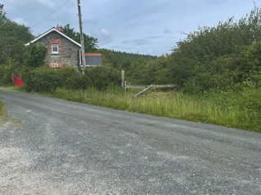

**Plate 1:** View of railway cottage and route at Corgar.

The route will travel along the northern edge of the lake and through an area of woodland before crossing another local road and continuing north through the townland of Drumcullion. This section of the route is again heavily overgrown. At the N end of Drumcullion townland the route skirts an area of planted foresty before continuing east, passing a former level crossing and travelling under stone constructed bridges spanning local roads as concludes south of the former Garadice Station in Lisgruddy townland.

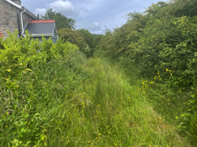 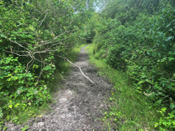

**Plates 2 & 3:** Route immediately S of cottage and existing route heading E.

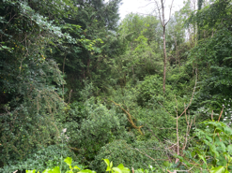 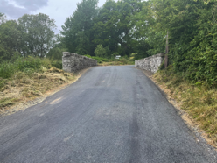

**Plates 4 & 5**: Overgrown nature of section of route and road spanning route.

**Likely Impacts on Cultural Heritage**

*Archaeology*

The greenway route will be located along a section of the former Cavan and Leitrim railway track that ran from Ballinamore to Ballyconnell. The Cavan and Leitrim railway was a narrow gauge railway which operated between 1887 and 1959. The railway is an important part of the industrial archaeology of the region and is of great significance to the local communities it passed through, the families associated with it and the memories of those that worked and used it. A local museum highlighting the significance of the narrow gauge railway is located in Dromod, 25km south of the proposed greenway route. The 2.9km section of the line between Corgar and Lisgruddy and Corramahan townlands is generally heavily overgrown and the track has been removed for a considerable time. The development of the greenway will provide the opportunity for the former railway route to be opened for an appreciation of the landscape the railway once travelled.

No recorded archaeological will be directly impacted by the proposed greenway.

An examination of the ordnance survey maps indicates the route travels along enclosed farmsteads, forestry and marshy ground. One recorded monument is located with 200m of the route and will not be impacted.

*Architectural Heritage*

The proposed development works will not impact on any architectural structures. The National Inventory of Architectural Heritage records one structure (Corduff House Reg. 30925003) within 200m of the proposed greenway. The greenway route is located along the line of the former Leitrim-Cavan railway, which marks an important industrial archaeological piece of infrastructure. While the route is currently heavily overgrown for the vast majority of the section proposed for a greenway it is possible from examination on the ground and from cartographic sources to identify elements of the former railway such as level crossings, stone bridges and railway buildings. It is not anticipated that any of these features will be impacted by the development of the greenway however no details of the development were available at the time of completing this report.

*Other Cultural Heritage*

The proposed development will have a positive impact on recreation and tourism and will facilitate an appreciation for the history, archaeology and folklore of the area.

**CONCLUSIONS & RECOMMENDATIONS**

The development of the greenway route between the townlands of Corgar and Lisgruddy and Corramahan will not impact on any recorded archaeological or architectural features.

The proposed greenway route travels along the former Leitrim & Cavan railway track which represents an important industrial archaeological piece of infrastructure in the region. The development of the 2.9km section of the former railway route will enable local communities to celebrate the important social and economic significance of the former railway. The route is currently heavily overgrown for the vast majority of the 2.9km route. However, clearing of the vegetation will enable any infrastructure associated with the former railway to be revealed and recorded.

**PLEASE NOTE…**

**These conclusions and recommendations are subject to the approval of the National Monuments Service (Department of Housing, Local Government and Heritage) and Leitrim County Council’s Heritage Officer who may issue additional or alternative requirements.**

**REFERENCES**

Primary Sources

Record of Monuments and Places (RMP)

Constraint maps and Catalogue

Sites and Monuments Record (SMR)

SMR archival files in National Monuments Service

Topographical Files in National Museum of Ireland

Finds Registers in National Museum of Ireland

Ordnance Survey 1st Ed. 6” Map

Ordnance Survey 2nd Ed. 6” Map

Ordnance Survey Revised Ed. 6” Map

Department of Arts, Heritage, Gaeltacht and the Islands. 1999a *Framework and Principles for the Protection of the Archaeological Heritage*. Dublin. Government Publications Office.

Department of Arts, Heritage, Gaeltacht and the Islands. 1999b *Policy and**Guidelines on Archaeological Excavation*. Dublin. Government Publications Office.

Environmental Protection Agency. 2003 *Advice Notes on Current Practice (in the preparation of Environmental Impact Statements)*. Dublin. Government Publications Office.

Environmental Protection Agency. 2003 *Guidelines on the Information to be Contained in Environmental Impact Statements*. Dublin. Dublin. Government Publications Office.

Electronic Sources

www.excavations.ie – Summary of archaeological excavation from 1970−2017

www.archaeology.ie – DCHG website listing all SMR sites with aerial photographs

www.buildingsofireland.ie – DCAHG website listing the result of the County Leitrim National Inventory of Architectural Heritage

www.googleearth.com – Aerial photographs of the proposed development area www.osiemaps.ie – Ordnance Survey aerial photographs dating to 1995, 2000 to present

Lewis, H.S. 1837(online version) *A Topographical Dictionary of Ireland*.

Secondary Sources

'The Archaeological Inventory of County Leitrim' compiled by Michael J. Moore (Dublin: Stationery Office, 2003).

Condit, T & Gibbons, M. 1989 ‘An introduction to County Leitrim’, Archaeology Ireland Vol. 3 (Spring), 6-9.

de Valera, R. and Ó Nualláin, S. 1972 Survey of the megalithic tombs of Ireland, vol. 3, Counties Galway, Roscommon, Leitrim, Longford, Westmeath, Laoighis, Offaly, Kildare, Cavan. Dublin. Stationery Office.

Cooney, G. 1979 ‘Some aspects of the siting of Megalithic Tombs in County Leitrim’ JRSAI Vol. 109, 74-91.

T.M O’Flynn History of Leitrim

Patrick J. Flanagan; *The Cavan & Leitrim Railway*; Pan Books, London, 1972.

Gerard MacAtasnet The Plantation of County Leitrim 1585-1670) 2013. Leitrim

Herity, M. 1974 Irish Passage Graves. Dublin. Irish University Press.