|  |  |
| --- | --- |
| Shailagh Healy Arboriculture | Arboricultural Impact Assessment, Tree Protection Plan & Method Statement for Acres Lake Amenity Block  July 27th 2021  Report produced for Leitrim County Council |

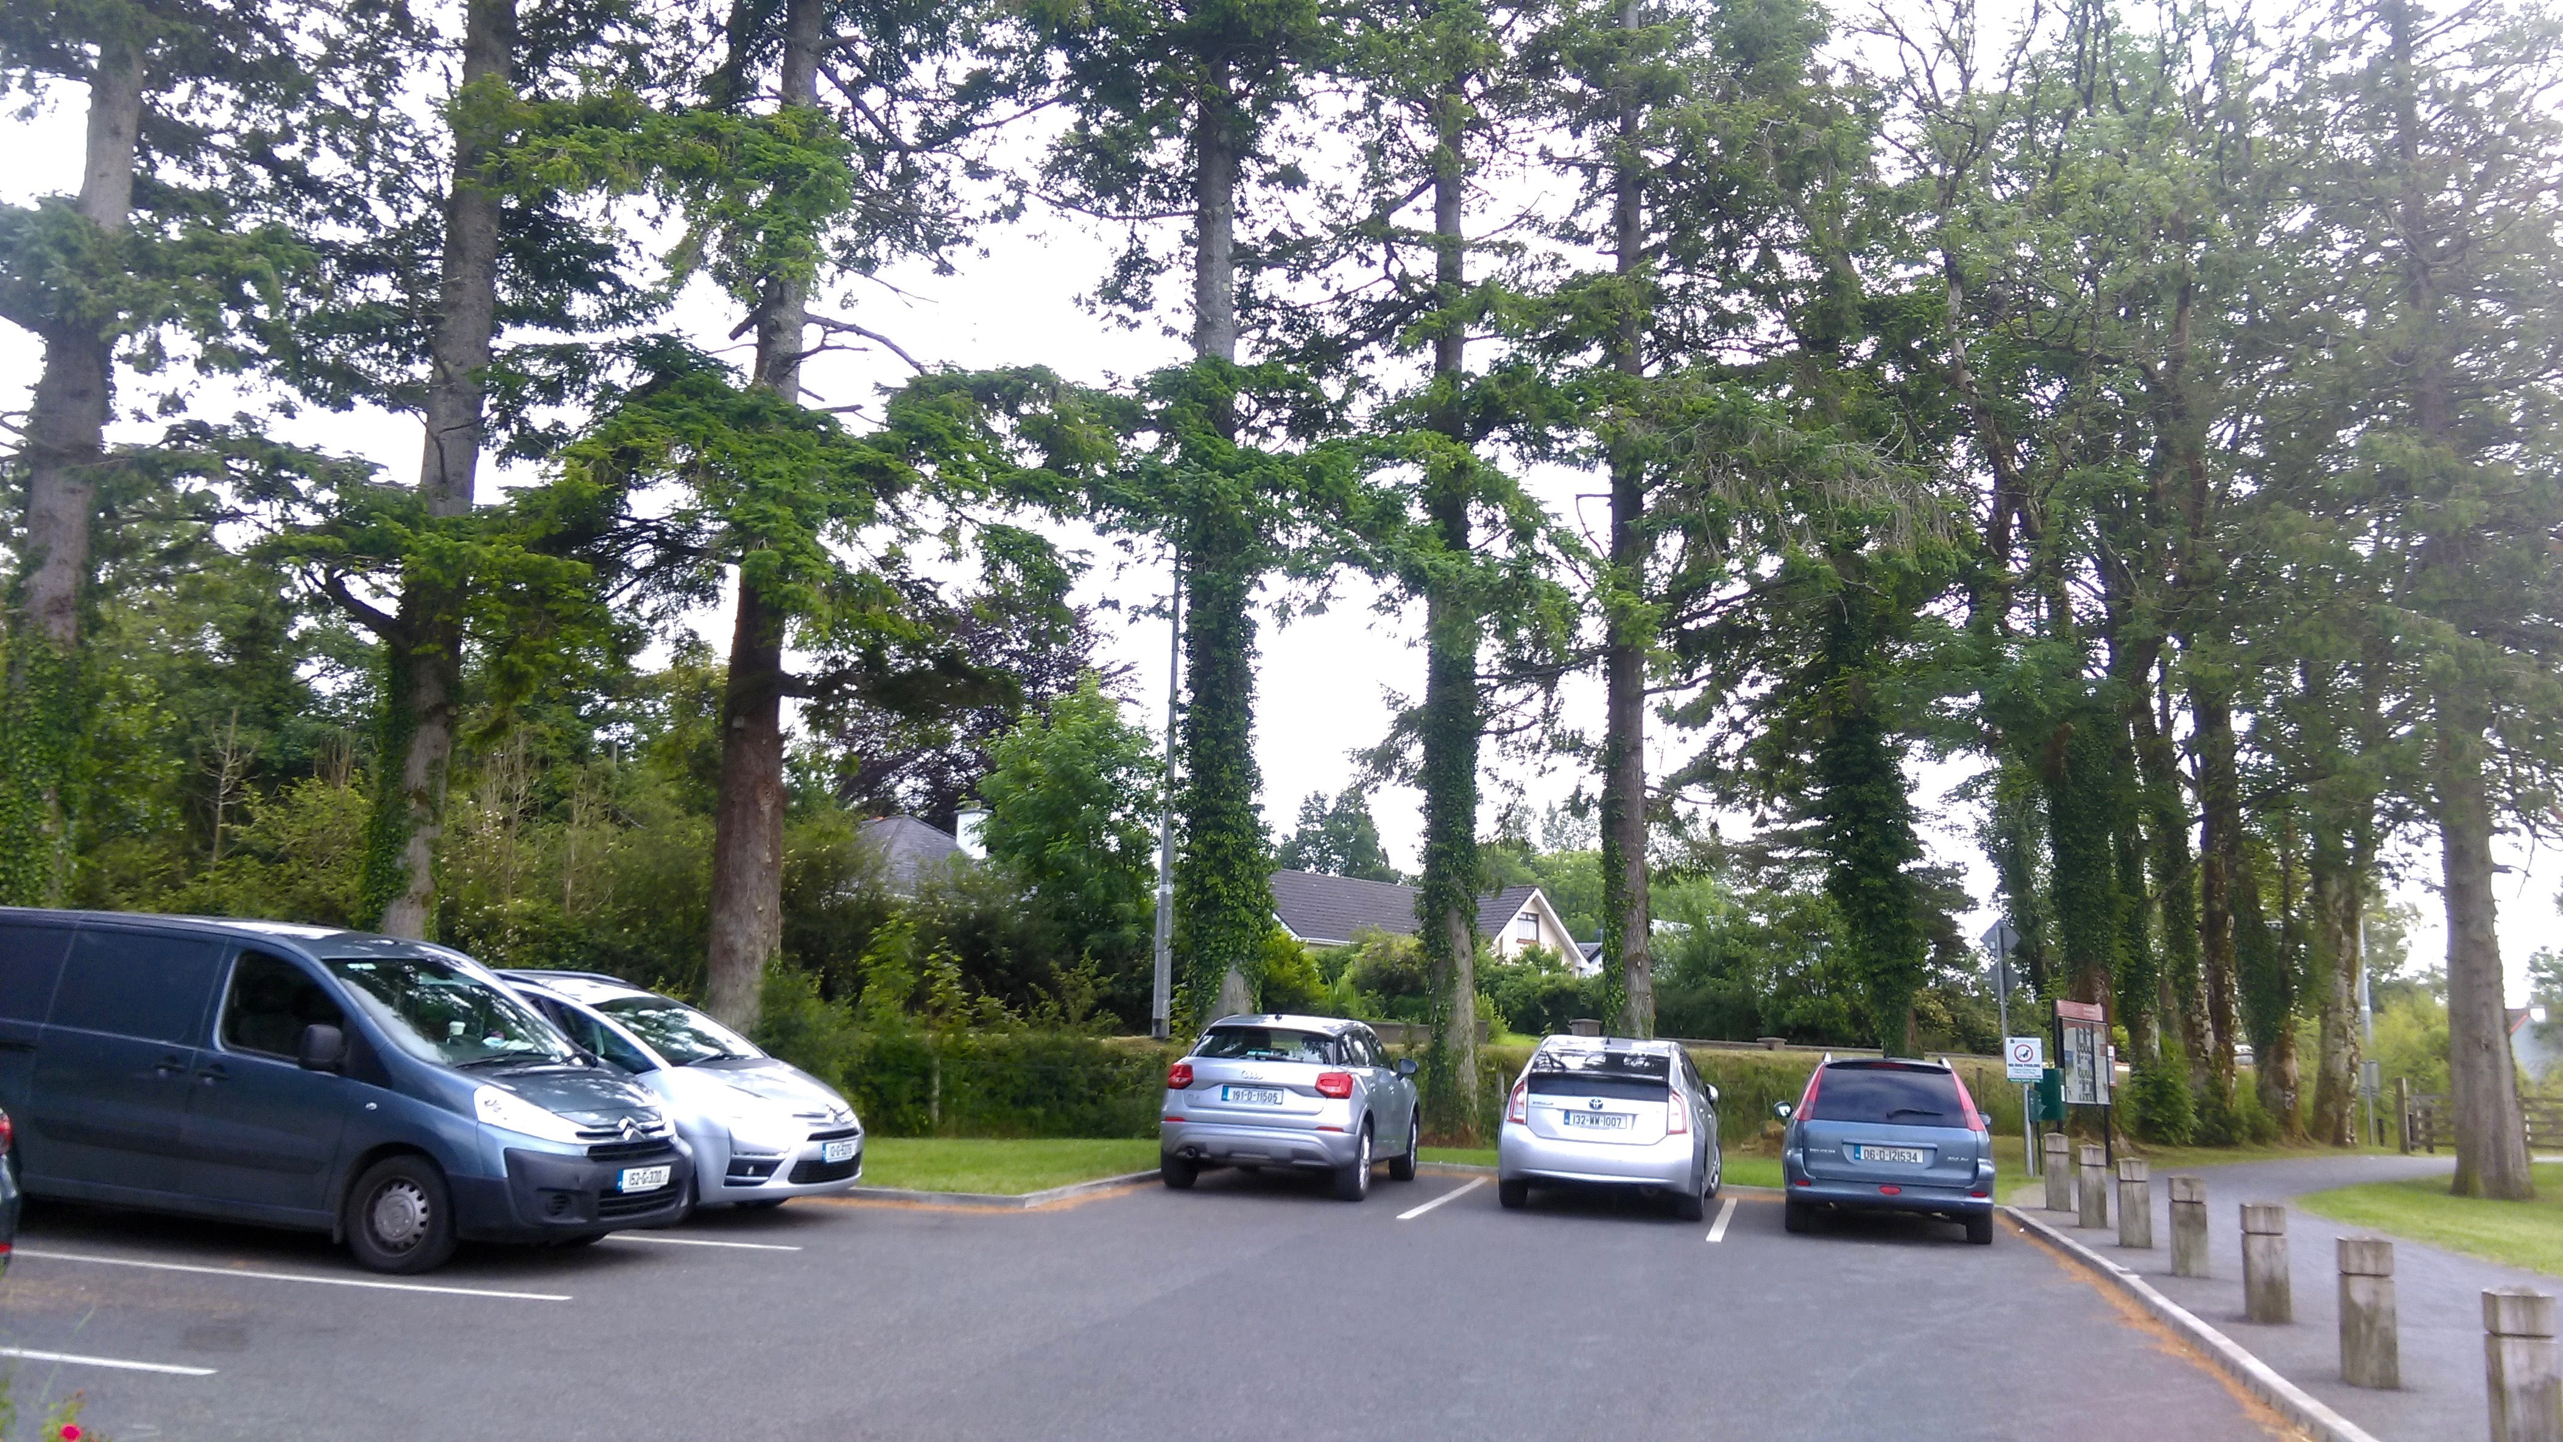

# Table of Contents

## Description Page

## 

Nature of Inspection 3

Site & Inspection Details

Preliminary Details

Tree Inspection:

~ Trees 1 to 9 5

~ Trees 15,16, 17

~ Trees 18 to 23 6

~ Trees 9 to 14

Arboricultural Impact Assessment (AIA) 7

~ Observations

~ Recommendations

Method Statement & Tree Protection Plan 8

~ Recommendations

~ The Construction Exclusion Zone: Barriers

& Ground Protection

~ Prohibited Activities 9

~ Timing & Order of Operations

~ Ground Protection 10

~ Underground Services 11

~ Low-Invasive Vehicular Access in Proximity to Trees

~ Suitable Planting Suggestions 14

## Appendices

*Appendix 1* Scaffolding within the RPA 12

*Appendix 2* Protective Barrier Fencing Example

*Appendix 3* Construction Exclusion Zone Map 13

*Appendix 4* Signage Example

Nature of Inspection

Arboricultural Impact Assessment to consider how the proposed amenity development and its associated trees will co-exist and interact in the present and future.

Arboricultural Method Statement & Tree Protection Plan detailing how a particular process will be carried out and describe how construction works can be implemented close to trees without causing damage to the crown or the root system.

Commissioned by Leitrim County Council.

## Scope of Work

* Tree Inspection of requested treed area to ascertain trees health and safety
* A schedule of tree works for all retained trees, specifying root protection area, pruning and other remedial or preventative work: whether for physiological, hazard abatement, aesthetic or operational reasons
* All works shall be carried out in accordance with BS3998-2010 Recommendations for Tree Work / BS 5837-2012 – Trees in Relation to Design, Demolition and Construction

# Site & Inspection Details

* Location: Acres Lake Amenity, Drumshanbo, Co Leitrim
* Date of Inspection**:** July 1st, 6th, 2021
* Weather Conditions**:** Partially cloudy with rain

# Preliminary Details

## Limited Visual Assessment

This survey was a basic visual assessment, which typically focuses on imminent and/or probable likelihood of failure and is conducted from a ground level perspective in order to identify certain obvious defects or conditions. A number of factors contrive to reduce accuracy of survey. Inspection is based on the trees current condition at the time of the survey and intended as a guide.

## Measurements

Approximate height reading notated in meters. Approximate trunk diameter is measured at 1.5 meters from the ground level and notated in mm.

Dimensions are to provide an approximate size for the tree.

## Re-Inspection

A re-inspection of all trees concerned should take place within 3 to 4 years (unless otherwise specified) and after severe storms.

## Seasonality

Potential fruiting bodies of fungi were out of season and are unavailable to view.

## Climbing Plants

Ivy whilst of itself is not indicative of ill health can readily obscure visual identification of disease.

## Glossary of Arboricultural Terms:

*Crown Clean*- In this instance only the removal of deadwood is sanctioned,

*Deadwood*: Branch or stem wood bearing no live tissues. Retention of deadwood provides valuable habitat for a wide range of species and seldom represents a threat to the health of the tree. Removal of deadwood can result in the ingress of decay to otherwise sound tissues and climbing operations to access deadwood can cause significant damage to a tree. Removal of deadwood is generally recommended only where it represents an unacceptable level of hazard

*Monolith*- A tree reduced to its main stem (ie. without branches), sometimes left on felling a dead or dying tree in appropriate contexts. Aside from bringing an aesthetic quality monoliths are considered to be highly beneficial for wildlife habitat and surrounding biodiversity.

*** All tree work recommendations shall be carried out by professional arborist contractors with appropriate qualifications and according to best arboricultural practices ***

* Refer to *Appendix 3* Map for Tree Numbers

# Eastern (back border) tree line – Trees 1 to 9

Dominate species: Pseudotsuga menziesii (Douglas fir)– Semi Mature

Diameter/Height Range: 50-80/ 24-27

## Observations:

* Compromised health and foliage die back due to previous car park development encroaching within root protection area
* Previous removal of three trees for reason unknown
* Spent fruiting body of Laetiporus sulphureus (chicken of the woods) fungus growing from old stump removal indicating wood decay
* Majority of trees were previously limb “pruned” on eastern side over road, depriving trees of energy producing foliage and decreasing wind buffering
* Trees 3, 5 and 8 show crown leader dieback

## Preliminary Management Recommendations:

* Remove dead crown leaders on Trees 3,5 and 8 up to *but not into* live wood
* All trees shall be deadwood pruned, providing deadwood is greater then 4 inches in diameter
* Previous pruning stubs shorter then 2 feet shall remain in situ
* Tree 2 - Bottom west facing limb shall be pruned to branch collar at stem

# Trees 15, 16,17

Picea sitchensis (Sitka spruce) – Semi Mature

## Observations:

* All three trees have suffered irreversible loss of root area, presumably due to car park works and are in decline.
* These trees are also in direct line with new building footprint

## Preliminary Management Recommendations:

Remove all three trees

# North Side Trees 18 to 23

False cypress and Thujas spp – Semi Mature

Trees show no obvious signs of stress and appeared in fair condition. The wildlife value is low for such species.

## Preliminary Management Recommendations:

*The building footprint plans have been altered to accommodate further root protection area of Trees 1 to 9*. As these five trees will be impacted they shall be removed before unit development work commences. After which the tree species in the following planting suggestions will be planted in North corner of site so as to screen off building.

# Trees 9 to 14

*Tree 9* Fraxinus excelsior (Common Ash) – Semi Mature

*Tree 10 to 13* Acer pseudoplatanus (Sycamore) – Semi Mature

Diameter/Height Range: 75-90 /17 average

*Tree 14* Thujas spp (Cedar) –Semi Mature ~ West side of footpath

Diameter/Height Range: 80/20

## Observations:

*Tree 9* Exhibits Hymenoscyphus fraxineus (Ash Dieback) disease

*Tree 13* Signs of foliage dieback as previous footpath construction resulted in loss of root area and therefore compromised health.

Wound wood at base of trunk due to strimmer damage.

*Tree 14* Soil grade change, raised canopy and lost root area due to previous footpath construction, resulting in stressed condition and foliage dieback

## Preliminary Management Recommendations:

* *Tree 9* shall be *monolithed* (cut back) to 8 meters from ground level
* *Trees 10 to 13* *Deadwood* prune, provided branch diameter is greater then 4 inches
* Alternatively to intensive grass cutting consider allowing vegetation to grow freely at and near base of trees, cutting solely along the footpath verge

# Arboricultural Impact Assessment (AIA)

## Observations:

## Above Ground Constraints

Any work carried out should not in any way disturb the above branches or trunk of the tree.

## Root Protection Area (RPA) Constraints

The aforementioned RPA has been encroached upon due to the previous car park development and subsequently is imperative the remaining roots are not compromised.

If area is to keep in situ the remaining trees the proposed development will need to take extra precautions and mitigation steps in ensuring the following recommendations be followed exclusively.

After RPA calculations (involving trunk diameter multiplied by 12) the RPA for the main trees in question (trees 1 to 9) is a minimum of ***9*** meters radius from the base of the tree’s trunk.

This protection area was formerly trespassed.

The remaining RPA can be safely protected from further compaction or other disturbance with barriers, which would incorporate ground protection. To ensure the long term health and longevity of these trees mitigating measures should be followed strictly.

## Recommendations:

*Tree 2* Should the planner consider it necessary, the lowest west facing branch can be cut back to branch collar at trunk to allow further head room.

*Tree 1* As this tree has been severely side pruned (east) it should be marked that the remaining foliage is very important for energy production and extreme care shall be taken to ensure the two lowest west facing branches remain if at all possible.

It is critical the soil grade level is not altered from original level, as this will further injure the tree’s remaining roots, blocking moisture infiltration and gaseous diffusion.

Moreover, it is important to note that the vast majority of a tree’s feeding roots exist in the top three inches of the soil. If the ground is excavated or heavily compacted the tree will go into stress from the loss of nutrient and water uptake capability.

Re-Inspection: A re-inspection of all trees should take place within *three* years time of this report so as to ascertain the long term impact of the previous car park along with additional development impact.

# Abroricultural Method Statement (AMS) & Tree Protection Plan (TPP)

## Recommendations

Pre development tree work (pruning) should be undertaken prior to the installation of tree protection and subsequent equipment or materials brought to site.

Once the layout proposals have been finalized a TPP should be followed containing the following Information.

The precise location for erection of the protective barriers and any other relevant physical protection measures including ground protection to protect the RPA and marked as a Construction Exclusion Zone (CEZ) on the plan. ~*Appendix 1* & 2

As the aforementioned RPA has previously been trespassed the standard distance for the CEZ will subsequently require modification, particularly for *Trees 3 to 6.* Therefore and if at all possible erect the CEZ at least one meter out from the stem of the tree.

## The Construction Exclusion Zone: Barriers and Ground Protection

All trees being retained on site should be protected by barriers and ground protection. Vertical barriers should be erected and ground protection installed before any materials or machinery are brought onto the site and before any demolition, development or stripping of soil commences. Once erected, barriers and ground protection should be regarded as sacrosanct, and should not be removed or altered without prior recommendation from Local Planning Authority (LPA).

Barriers should be fit for purpose of excluding construction activity; ensuring barriers remain ridged and complete and safeguarding the following:

* A copy of this document with the layout plan is easily accessible for site personnel to refer to before and during the time construction activity is taking place;
* All personnel working on the site are made aware of the tree protection plan covering any activities they will undertake. This duty includes delegating the task of briefing personnel in the absence of the manager.
* The tree protection measures are left in place until the construction phase of development is completed, except with the written consent of the LPA.

The default specification of Barrier Fencing is a vertical and horizontal scaffold framework, braced to resist impacts, as per *figure 1 &2* below. The vertical tubes spacing is a minimum interval of 3 meters and are driven securely into the ground. Welded mesh panels are securely attached to frame. It is important to consider during installation the position of services below ground and any structural roots, which must not be damaged.

Signage denoting the words “TREE PROTECTION AREA” at 4-meter intervals will be fixed to Protective Barrier Fencing (PBF) prior to work commencement and only taken down when development concludes. Once erected, signage shall not be tampered with in any way and if so development manager shall be contacted immediately. The contracted building company should supply and install PBF and signage. ~*Appendix 4*

## Prohibited Activities

The following must not be carried out under any circumstance:

* Cutting down. Uprooting, damaging or otherwise destroying retained trees.
* Lighting a fire within 10 meters of the canopy of retained tree.
* Equipment, signage, fencing, tree protection barriers, materials, components, vehicles or structures shall not be attached to or supported by retained tree.
* Mixing cement, chemical toilets and other use or storage of anything that would be harmful to trees shall not take place within, or close to RPA. The distance away from the RPA must be sufficient, and the slope of the site must be that contamination of soil in the RPA would not occur if there were spillage, seepage or displacement.
* No plant or equipment or vehicle with hydraulic or such as a mini digger shall be operated within striking distance of the stem and branches of the RPA of retained trees.
* No alterations or variations shall be made to the approved tree protection measures without written approval from the LPA.

## Timing and Order of Operations

The development must be carried out in the following order unless otherwise agreed in writing with the LPA. Each step should be completed before moving onto the next:

1. Tree Works
2. Installation of tree protection barriers and signage
3. Construction
4. Removal of the remaining barriers
5. Removal of extraneous soil, stone or other ground aggregate from original soil level grade

## Ground Protection

Possible effects of construction activity should be addressed by a combination of barriers and ground protection. The position of the barrier may be shown within the RPA at the edge of the agreed working zone but the soil structure beyond the barrier to the edge of the RPA should be protected with ground protection. For pedestrian movements within RPA the installation of ground protection in the form of a single thickness of scaffold boards on top of a compressible layer laid onto a geotextile, or supported by scaffold, may be acceptable.

Fore wheeled or tracked construction traffic movements within the RPA the ground protection should be designed by an engineer to accommodate the likely loading and involve the use of proprietary systems or reinforced concrete slabs.

Care should be taken when planning site operations to ensure that wide or tall loads, booms or jibs can operate without coming into contact with retained trees. Such contact can result in serious damage and possibly make retention impossible.

Material which will contaminate the soil, e.g. concrete mixings, diesel oil and vehicle washings, should not be discharged within 10m of the tree stem.

Notice boards should not be attached to any part of the tree.

Once the ECZ has been protected by barriers and ground protection, construction work can commence.

Root damage can be minimalized by using a combination of the following:

* Piles or radial strip footings both of which should be located to avoid major tree roots
* Beams, slabs, suspended floors, where all should be laid at or above ground level, and cantilevered as necessary to avoid tree roots.

Where piling is to be installed near to trees, the smallest practical pile diameter should be used as this reduces the possibility of striking major tree roots, and reduces the size of the rig required to sink the piles. The latter is particularly important where piling within the branch spread is proposed, as mini-rigs reduce the need for access facilitation pruning. Sheathed piles protect the soil and adjacent roots from potential toxic effects of concrete.

## Underground Services

As previously discussed on site, proposed utilities will be installed in the North Eastern corner and following the existing ditch line.

Trenching for the installation of underground services severs any roots present and may change the local soil hydrology in a way that adversely affects the health of the tree. For this reason particular care should be taken in the routing and methods of installation of all underground services. Wherever possible, they should be kept together and trenchless techniques used.

Such plans should also show the levels and access space needed for installing the services.

As an alternative to trenchless techniques, a possible solution is to hand excavate a narrow trench. Preferably less then 750 mm deep.

## Low-Invasive Vehicular Access in Proximity to Trees

Where the construction of hard surface access cannot be avoided within protection area, a no dig design should be used to avoid root loss due to excavation. In addition the structure of the hard surface should be designed to avoid localized compaction, by evenly distributing the carried weight over the track width and wheelbase of any vehicles that will use the access. Such designs might include the use of a three dimensional cellular confinement system as an integral component of the sub-base, to act as a load suspension layer.

The use of two dimensional load suspension systems is not recommended.

It should be constructed so as to allow moisture infiltration and gaseous diffusion.

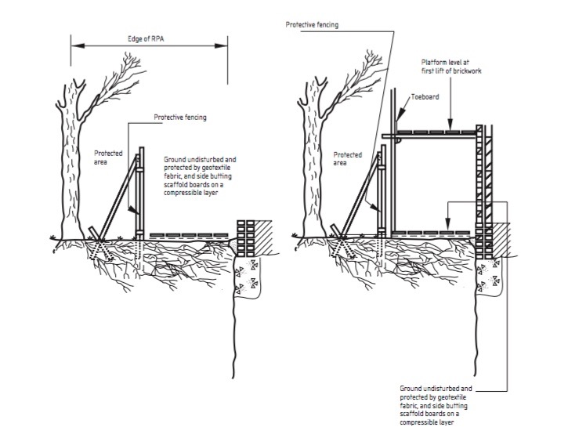

*Appendix 1~* Scaffolding within the RPA

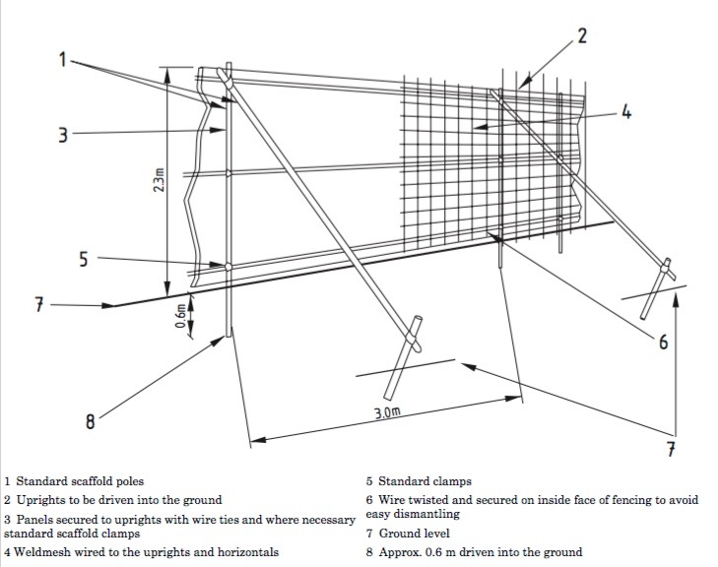

*Appendix 2* ~ Protective Barrier Fencing Example

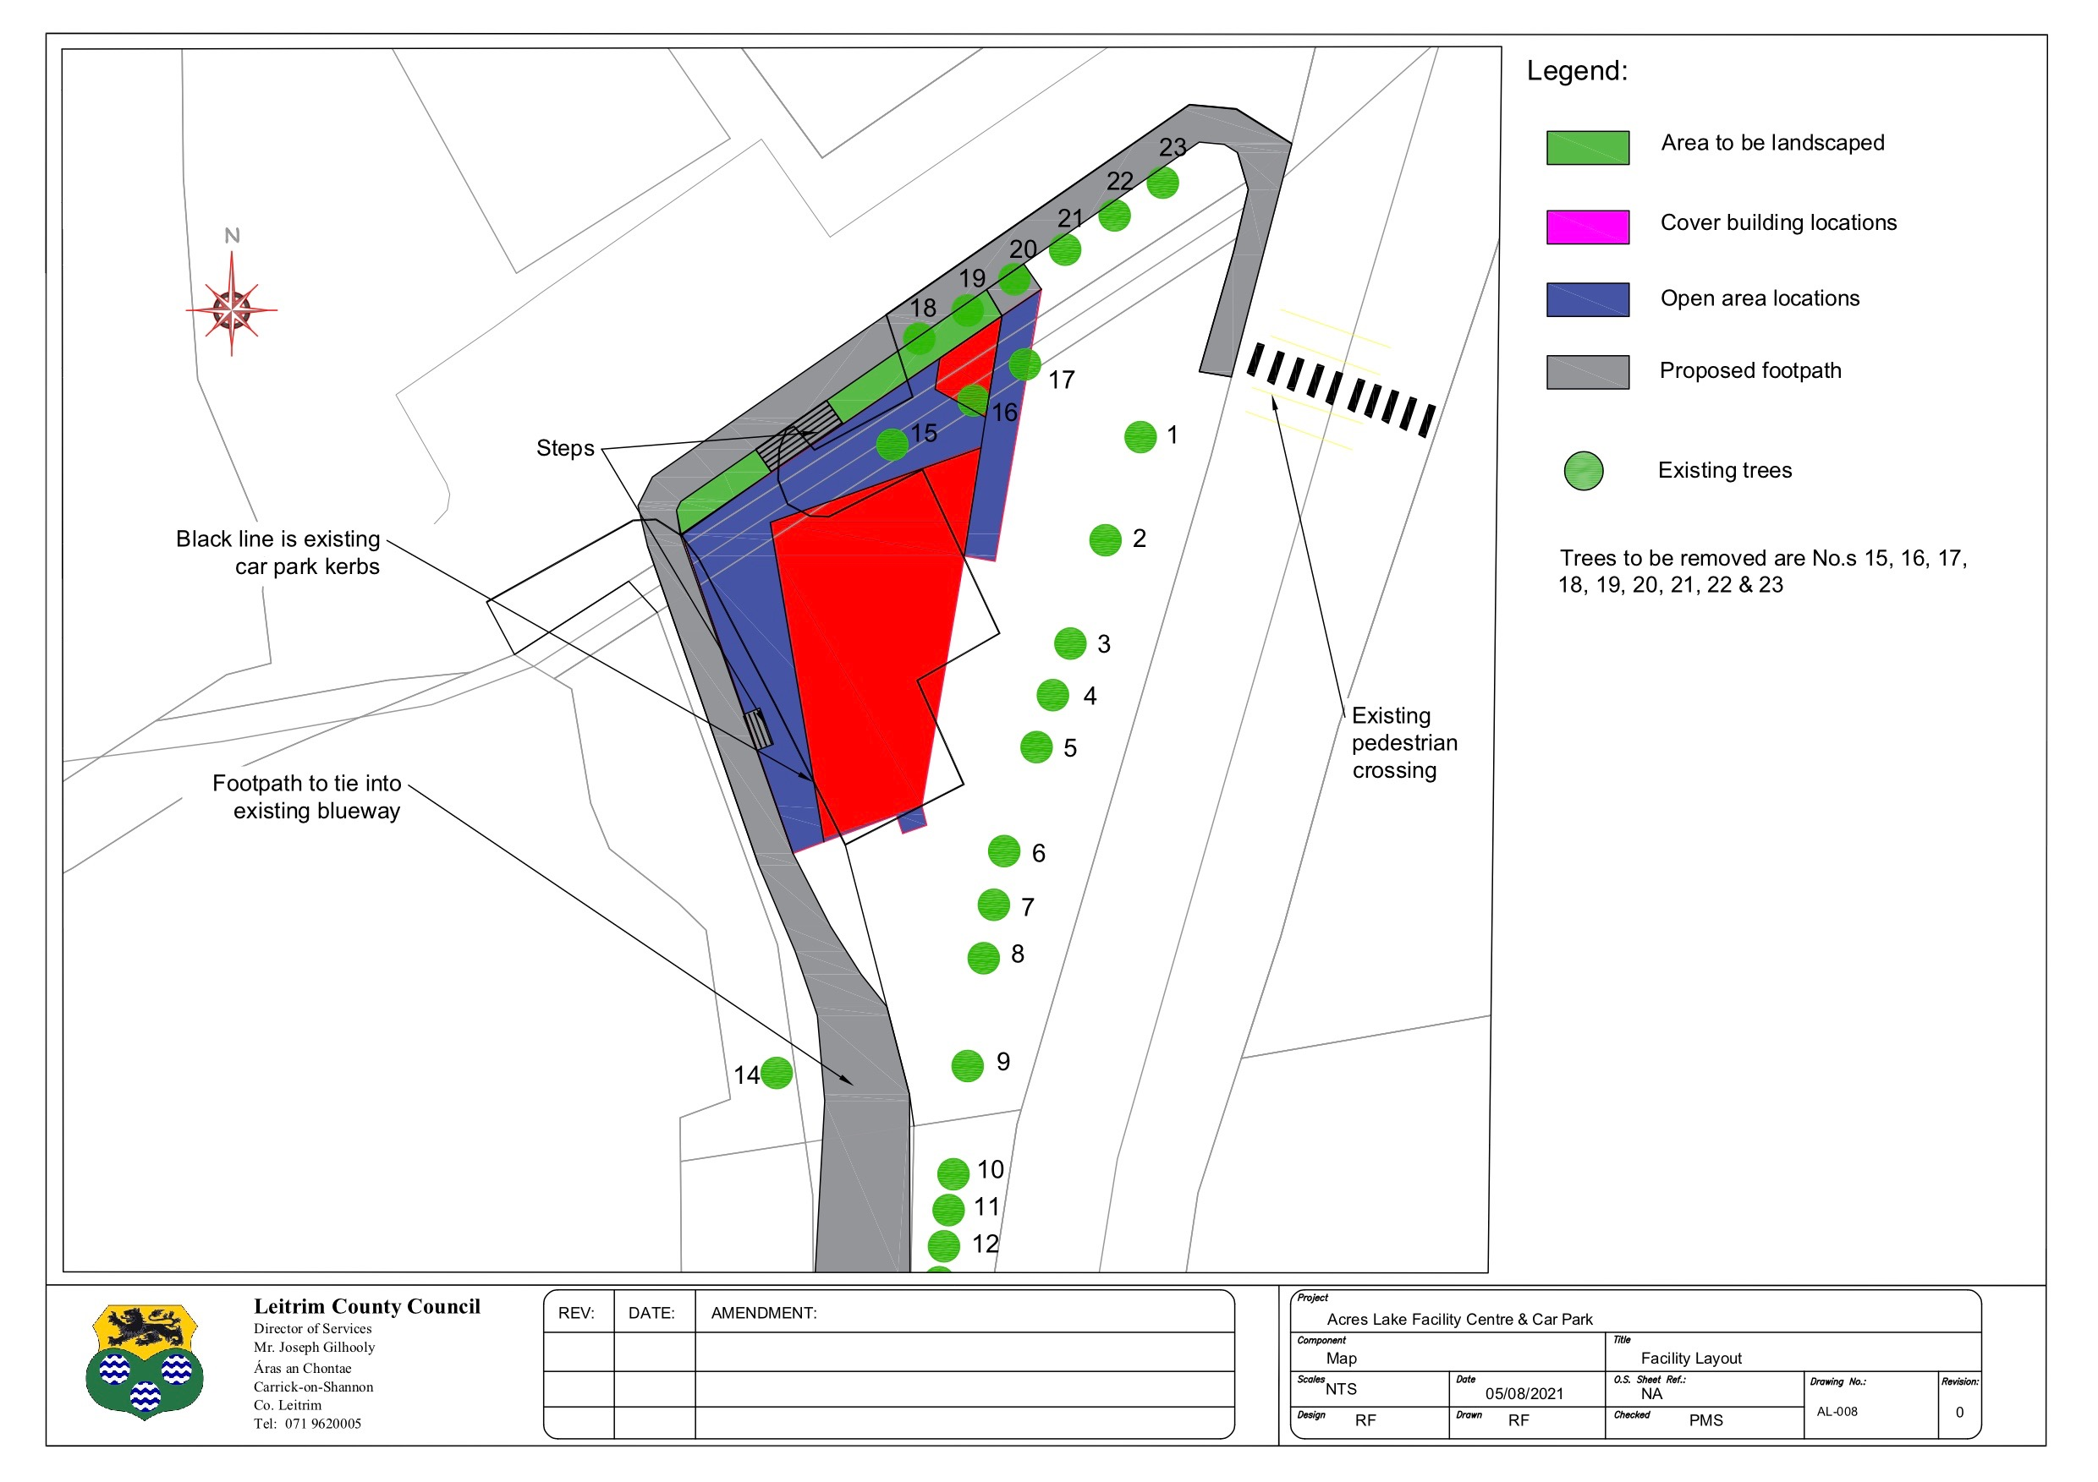

*Appendix 3* ~ Construction Exclusion Zone and Underground Services marked with BLUE Line

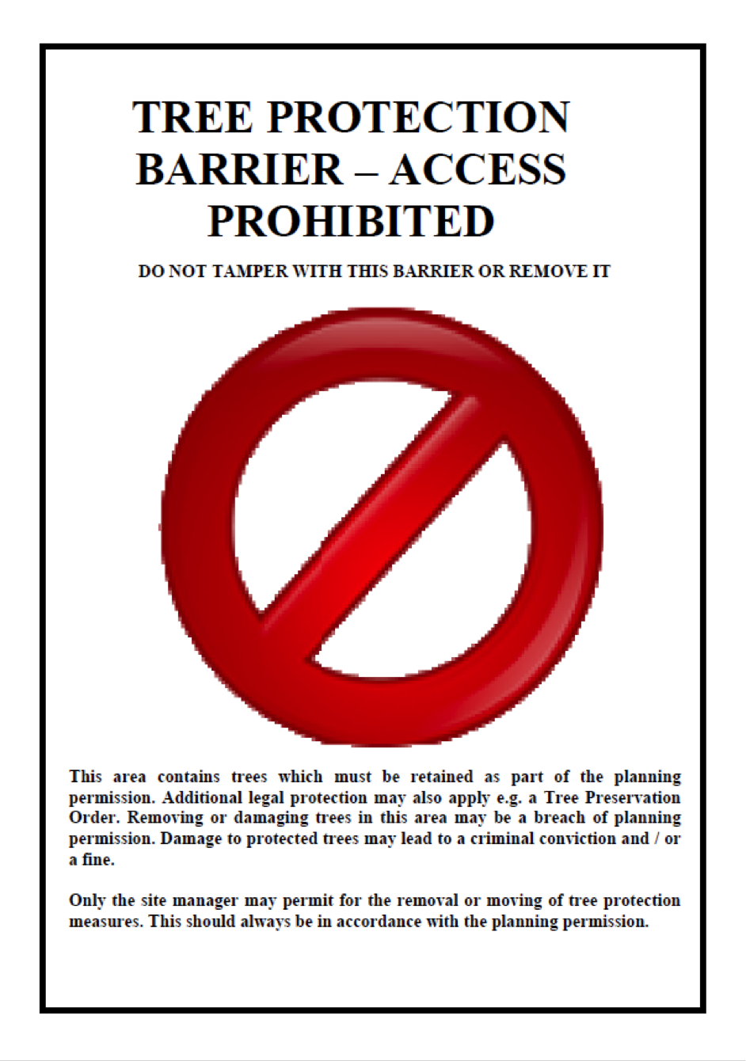

*Appendix 4* ~ Signage Example

# Suitable Planting Suggestions

## North Corner Trees

**Crataegus laevigata Crimson Cloud- Ornamental Hawthorn Crimson Cloud**

<https://futureforests.ie/products/crataegus-crimson-cloud?_pos=2&_sid=ecc0cc228&_ss=r>

**Liquidambar styraciflua Columnar* –Sweet Gum**

<https://futureforests.ie/products/liquidambar-styraciflua-worplesdon?_pos=1&_sid=901fcb815&_ss=r>

*Columnar would be ideal but not necessary.

**Sorbus x thuringiaca Fastigiata – Bastard Service Berry**

<https://futureforests.ie/products/sorbus-x-thuringiaca-fastigiata?_pos=3&_sid=acdbc6dc5&_ss=r>

**Metasequoia glyptostroboides- Dawn Redwood** ~ Larger type tree for the actual North corner

<https://futureforests.ie/collections/conifers/products/metasequoia-glyptrostroiboides>

## Landscape Strip Shrubs

**Viburnum opulus – Guelder Rose** ~ Native

https://futureforests.ie/products/viburnum-opulus

**Viburnum lantana – Wayfaring Tree** ~ UK Native

<https://futureforests.ie/products/viburnum> lantana?_pos=1&_sid=45d5a74db&_ss=r

**Magnolia x soulangeana-Magnolia**

<https://futureforests.ie/products/magnolia-x-soulangeana?_pos=14&_sid=58b05a8b1&_ss=r>

**Hamamelis x intermedia Jelena-Witch Hazel Jelena**

<https://futureforests.ie/products/hamamelis-x-intermedia-jelena?_pos=1&_sid=d10b22f39&_ss=r>

**Tamarix pentandra**

<https://johnstowngardencentre.ie/tamarix-pentandra.html>

**Ribes sanguineum – Flowering Currant**

https://futureforests.ie/products/ribes-sanguineum-pulborough-scarlet?_pos=3&_sid=9f961c38f&_ss=r

**Philadelphus coronarius – Mock Orange**

https://futureforests.ie/products/philadelphus-coronarius-aureus?_pos=1&_sid=8359b7f78&_ss=r

**Leycesteria formosa – Pheasant Berry**

https://futureforests.ie/products/leycesteria-formosa?_pos=1&_sid=aabfe11d2&_ss=r

**Hydrangea petiolaris**

https://futureforests.ie/products/hydrangea-petiolaris?_pos=1&_sid=fc7be0fcb&_ss=r

**Forsythia x intermedia**

https://futureforests.ie/products/forsythia-x-intermedia-spectabilis

**Euonymus europaeus – Spindle**~ Native

<https://futureforests.ie/products/euonymus-europaeus>

**Erica arborea – Tree heath** ~ Prune back after flowering

<https://futureforests.ie/products/erica-arborea-estrella-gold?_pos=1&_sid=6276d2220&_ss=r>

* Note descriptive heights are given at optimal height and majority of these species will take a hard prune

## Climbers up Posts of Overhanging Roof

**Parthenocissus quinquefolia – Virginia Creeper**

<https://futureforests.ie/products/parthenocissus-quinquefolia?_pos=1&_sid=fbc3490bb&_ss=r>

**Hydrangea petiolaris**

<https://futureforests.ie/products/hydrangea-petiolaris?_pos=1&_sid=fc7be0fcb&_ss=r>

## Ground Cover Plantings & Wildlife Value Perennials

**Vinca major – Greater Periwinkle**

<https://futureforests.ie/products/vinca-major?_pos=1&_sid=5c13a2416&_ss=r>

**Gaultheria shallon – Gaultheria**

https://futureforests.ie/products/gaultheria-shallon

**Mahonia aquifolium – Oregan Grape**

https://johnstowngardencentre.ie/mahonia-aquifolium-apollo.html

**Lupin**

**Teasle**

(Available from most garden nurserys)

## Shailagh E Healy

Arboricultural Association Technician & Member

Certified Urban Forester

Nora’s Field, Tawley, Cliffoney, Co Sligo

#085 244 5572

[**woodlandwanders@gmail.com**](mailto:woodlandwanders@gmail.com)

|  |
| --- |
| "The tree which moves some to tears of joy is in the eyes of others only a green thing that stands in the way.  Some see nature all ridicule and deformity... and some scarce see nature at all.  But to the eyes of the man of imagination, nature is imagination itself"  ~William Blake |