**Leitrim County Council**

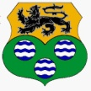

**PLANNING AND DEVELOPMENT ACT, 2000 (As Amended)**

**PART XI**

***PLANNING AND DEVELOPMENT REGULATIONS 2001 (As Amended)***

**PART VIII**

**PLANNING REPORT**

***Proposed facility Centre for Water Sports Activities, car park and controlled pedestrian Crossing on the R207 in the townlands of Acres and Drumduff North, Drumshanbo.***

**Introduction and Project Overview**

Acres lake is located south of Drumshanbo town adjacent to the R207 in Co. Leitrim. There are several facilities beside the lake, including an outdoor swimming pool, tennis courts, playground, Sliabh an Iarainn Visitor Centre and the Blueway.

Leitrim County Council in conjunction with Failte Ireland is proposing the development of a facility centre for water sports, a new car park and a controlled pedestrian crossing on the R207 that will complement the existing facilities at Acres Lake Amenity and the Blueway from Drumshanbo to Battlebridge.

The Blueway has a unique attraction which is that the beginning of it is a floating boardwalk that goes out onto Acres Lake and then joins onto the bank of the canal. This is the only floating Blueway in Ireland. This walk extends to for approx. 7km to Battlebridge, 1Km from Leitrim Village. Water sports take place during the summer months on Acres Lake, such as paddle boarding, kayaking, and canoeing. Acres lake is connected to the river Shannon by a canal network. This is navigable by cruisers from the River Shannon and has a mooring beside the proposed project location. There is a high footfall of people in this area all year round. The proposed facility centre for water sports will provide much needed indoor and outdoor showers, toilets, external and internal seating, communication workspace which will be multifunctional, multimedia education and learning area for the operators of, and visitors too, the proposed facilities.

There is currently a limited number of carparking spaces available at the amenity, when the amenities are busy, there is insufficient parking spaces to cater for the number of visitors that drive to this location. Currently when the car park is full, vehicles then park on footpaths and along the regional road which causes hazards for both motorist and pedestrian. The proposed new car park will be to the south of the new facility building. It will be able to park 70 cars safely with a footpath from it to the new facility. A new controlled pedestrian crossing will be created at the entrance for the safe crossing for pedestrians to the eastern side of the regional road.

**Background to the Development of the Project in conjunction with Failte Ireland**

‘Platforms for Growth’ is Fáilte Ireland’s new multi-annual capital investment programme designed to support Fáilte Ireland’s strategic imperative of Building Brilliant Visitor Experiences. Platforms for Growth is part of the Grants Scheme for Large Tourism Projects 2016 – 2020. It is Fáilte Ireland’s intention to base their future investments in large-scale capital projects on ‘platforms’ over the medium term. This is the second ‘platform’ to invite applications under the Platforms for Growth Investment Programme. This platform will enable sector growth and support the recovery of Irish tourism.

In order to be recognised internationally as a best-in-class activity destination, it is crucial that Ireland invests in compelling activity infrastructure, the visitor experience and building the capacity of the activity providers to ensure the Irish experience meets and exceeds visitor expectations. With a temperate climate, Ireland has the potential to offer high-quality outdoor experiences for a minimum of nine months of the year, however, the quality of activity experience currently lags behind international standards due to the lack of adequate visitor facilities and an ad hoc approach to the delivery of activity experiences.

This scheme is designed for Local Authorities only and is anticipated to deliver an appropriate range of new activity visitor facilities around the country via a collaborative approach. The outcomes Fáilte Ireland is aiming to achieve with the addition of activity visitor facilities are all-weather changing facilities at existing water sports locations, the key components of which will be;

* sustainable and accessible design
* toilet provision
* shower provision
* changing provision
* secure storage
* induction space
* external terrace
* equipment washdown facilities
* orientation points and security

The facilities are likely to be a combination of new builds or appropriate repurposing of existing facilities on the identified sites.

**Audit of Activity providers**

In order to align the scheme with the strategic objectives of investment in activity tourism infrastructure and experiences, Fáilte Ireland conducted a spatial mapping exercise to identify potential priority locations and suitable sites for the development of an Activity Facility Centre. This mapping identified a range of ‘activity hotspots’ and clusters across the country that are considered to have the potential to become significant ‘activity hubs’.

When conducting the spatial mapping, a series of criteria were applied to the exercise. It was a requirement that the potential locations and sites identified comprised or displayed particular features and characteristics. These included (but were not limited to) the following:

• Candidate locations should include two or more commercial water sports activity operators.

• Candidate locations must be at or in close proximity to Blue Flag or Green Coast beaches or a Blueway or well-established destinations for water sports activities.

• Candidate locations should be in close proximity to other visitor provision such as accommodation facilities, food and beverage outlets/services, visitor attractions and other visitor experiences, and other things to see and do in the locality

**Site shortlisting process**

Fáilte Ireland initially identified 136 eligible locations. This long list was distilled down to a shortlist of 22 locations. This was done in consultation with three key stakeholders; Fáilte Ireland’s local programme team, Industry representatives and the Local Authorities. Please note that there are now 21 perspective sites.

*Programme Team Consultations*

The “long list” of potential locations was shared with and discussed with Fáilte Ireland programme Teams to reinforce and verify the list of identified locations, taking into consideration the local knowledge, alignment with VEDP’s, destination priorities and Local Authority capacity. This engagement further refined the list and identified a number of locations for further investigation and formed the basis for the Local Authority consultation phase. Ongoing dialogue continued with the Programme Teams throughout the design of the scheme.

*Industry Engagement*

A representative sample of industry providers specialising in water sports in the candidate locations were interviewed to ascertain the gaps and opportunities in the delivery of best-in-class water-based visitor activities. At least two letters of support from water sport operators, from each candidate location, were included in the Local Authorities’ initial application.

*Local Authority Engagement*

Conversations were had with a number of Local Authorities as part of the scoping phase of the scheme. This confirmed the need and appetite for the scheme. More detailed engagement with Local Authorities examined each prospective site in detail. In December 2020 the Local Authorities were invited to formally nominate sites which were subsequently evaluated against eligibility criteria by Fáilte Ireland’s Investment Analysis Division.

*Environmental Constraints & Opportunities*

Fáilte Ireland developed a four phased environmental assessment approach to contribute to the site selectin process. Further details on this approach can be viewed under “Environmental *Assessment”*

**Final site locations**

**Exemplar Design**

The concept and strategy behind the scheme’s design-led approach was to appoint one design team (procured by Fáilte Ireland) that developed universal and standardised design options for all of the Activity Facility Centres delivered under the scheme, but which can be adapted to suit individual location and site specifications (size, dimensions, capacity, etc.) as well as the surrounding environment and landscape.

The design-led approach is anticipated to deliver the following benefits:

• A consistent approach to activity visitor product, service, and experience provision across the country (including minimising possible variance in provision between different locations and sites)

• A readily recognisable facility by way of its physical structure and composition and associated branding

• An ‘off-the-shelf’ exemplar design solution informed through stakeholder consultation and engagement and ‘proof of concept’

• A collaborative approach with Local Authorities, Activity Operators and key stakeholders with robust, ongoing support and expertise from Fáilte Ireland

• Cost savings due to economies of scale and efficiencies in delivering the Activity Facility Centres

**Design development**

An outline brief was created by Fáilte Ireland which informed the project aspirations. MCA were awarded the contract. Three sample water sport operators were consulted by MCA in order to inform practical elements of the design. A concept design was created based upon a number of clear project aspirations including;

* Structural requirements, robustness, life cycle and reduced maintenance over time
* Sustainable service provision and low running cost
* Universal access – fully accessible regardless of ability or disability
* An aesthetic design which had a clear relationship to and was complementary to its environs

MCA concept design sample

The concept design was presented back to the local authorities for further consultation and a cost check performed by external quantity surveyors in order to ensure that the concept design was affordable within parameters of the Platforms for Growth scheme.

This Exemplar Design was shared with the Local Authorities along with a works document which outlines how Fáilte Ireland envision the design to be used. The level of detail shared with each authority constitute design intent. It is intended that each authority adapt the Exemplar Design to each site context. A set of design points within the works document specifies key features which are to be retained irrespective of any other adaptations. This will help to ensure a level of brand consistency across all site locations.

**Environmentally Sustainable principles of Design/Build**

As a condition of the investment grant scheme, all new build facilities are required to conform to nearly zero energy building standards and be appropriately and sensitively designed to integrate with the site’s natural environment and surrounding location. The facility should be built to the highest possible environmental specifications, including the following solutions:

* The development of carbon neutral buildings
* The use of sustainable building materials that are sourced locally (projects should use recycled building material where possible)
* The use of solar heating panels for hot water
* The use of windows and natural daylight to reduce the need for electricity usage
* Being sympathetic to the environment and landscape of the selected location and site
* Planting trees and native plants on the site
* Installing high efficiency utilities
* Construction stage environmental management plan
* Consideration for innovative and sympathetic construction methodologies e.g., floating foundations

The above solutions are not an exhaustive list, and Local Authorities are encouraged to adopt any further appropriate and environmentally sound actions and measures for the ongoing management and operation of the facility.

**Management and Maintenance**

The concept behind the scheme’s collaborative design-led approach is to drive innovation, create efficiencies, leverage economies of scale and deliver a consistent, world class experience for visitors. The investment grant scheme proposes that following the initial capital investment by Fáilte Ireland in the construction and fit-out of the facility centre, the Local Authority will own, operate, maintain, and reinvest in the facility.

It will be a condition of an award of investment grant funding that the Local Authority agrees to enter into a Management Agreement for the ongoing management cleaning, maintenance, and repair of the facility centre to ensure its upkeep to the highest possible standards and the facilitation and promotion of users’ health and hygiene.

The Management Agreement will be put in place for the term of the investment, a period of 15 years.

Fáilte Ireland and Local Authorities recognise that these facilities should be of the highest hygiene standards to meet and preferably, exceed visitor expectations at all times. This will require a consistent approach to the day-to-day operation and maintenance of the facilities.

As such, a Standard operating procedure (SOP) for cleaning and maintenance of the facility will be established as a condition of the Investment Grant Agreement in line with industry best practice and will contain a detailed cleaning and hygiene of the facility including specifications for cleaning, minimum cleaning frequencies and maintenance responsibilities.

The facility should be visited, inspected, and cleaned in accordance with this cleaning schedule, in order to ensure compliance with the standard operating procedure and grant terms and conditions. SOP’s will be developed based on environmentally sustainable best practice.

**Landownership**

There are three landowners that are affected by this project. Waterways Ireland own the car park where the facility is to be built. The adjoining land belongs to a local landowner. The third landowner is Leitrim County Council.

The necessary lands have now been acquired by Leitrim County Council and agreements are in place.

**Planning Policy Context**

National Level

**Project Ireland 2040 National Planning Framework**

The National Planning Framework (NPF) The NPF is the overarching planning policy for the state (published in February 2018 under Project 2040) and contains ten National Strategic Outcomes and 75 National Policy Objectives. This planning framework sets out where development and investment should be guided to shape the national, regional and local spatial development in economic, environmental and social terms to 2040. A National Strategic Outcome prescribed in the NPF is ‘Enhanced Amenities and Heritage’ with the objective to;

***Invest in and enable access to recreational facilities, including trails networks, designed and delivered with a strong emphasis on conservation, allowing the protection and preservation of our most fragile environments and providing a wellbeing benefit for all.***

**National Tourism Policy 2015: ‘People, Place and Policy: growing Tourism to 2025’**

The Department of Transport, Tourism & Sport published national tourism policy in March 2015 entitled ‘‘People, Place and Policy: growing Tourism to 2025’.

The National Tourism Policy notes that to provide an effective tourism product, there must be a diverse range of activities for visitors. While much of our attractiveness as a tourism destination is down to the natural environment, since the early 1990s, the State has supported the development and improvement of our place by investing in our physical visitor attractions, visitor infrastructure, and facilities for visitor activities.

***Policy Proposal 1.3.3 states: The design of future supports for capital investment in tourism will recognise the need for investment in both physical assets and in other areas that provide a lasting improvement in the overall quality of the visitor experience.***

In order to be recognised internationally as a best-in-class activity destination, it is crucial that Ireland invests in compelling activity infrastructure, the visitor experience and building the capacity of the activity providers to ensure the Irish experience meets and exceeds visitor expectations. It is considered the proposed development is critically important to implementing on a key national tourism policy.

**National Marine Planning Framework**

The NMPF contains a vision, objectives, and planning policies for all marine-based human activities. It outlines how those activities will interact with each other in an increasingly pressured ocean space. It is to be the key decision-making tool for Government departments, State agencies, regulatory authorities, and policy makers for decisions on marine activities up to 2040.

The NMPF has numerous objectives and planning policies which supports the development of tourism, tourism facilities and improved access.

Key Objectives of the NMPF are to;

* Increase participation in a range of water-based sports and recreation activities for the benefit of public health and wellbeing, as well as developing our tourism offering.
* Position Ireland as a world-class sustainable coastal and marine tourism destination through the sustainable development of coastal and marine recreation activities and industries in Ireland

***Tourism Policy 1***

***Where appropriate, proposals enabling, promoting or facilitating sustainable tourism and recreation activities, particularly where this creates diversification or additional utilisation of related facilities beyond typical usage patterns, should be supported.***

***Sport & Recreation Policy 1***

***Proposals that promote sustainable development of water-based sports and marine recreation, while enhancing community health, wellbeing and quality of life, should be supported, provided that due consideration is given to environmental carrying capacities and tourism pressures.***

***Sport & Recreation Policy 4***

***Proposals that improve access to marine and coastal resources for tourism activities, and sport and recreation should be supported, where appropriate, at the applicable scale and aligned with existing development plans.***

***Access Policy 2***

***Proposals demonstrating appropriate enhanced and inclusive public access to and within the maritime area, and that consider the future provision of services for tourism and recreation activities, should be supported, subject to the outcome of statutory environmental assessment processes and subsequent decision by the competent authority, and where they contribute to the policies and objectives of this NMPF.***

A number of planning policies support the proposed development

The principal statutory purpose of the RSES is to support the implementation of Project Ireland 2040 and the economic policies and objectives of the Government by providing a long-term strategic planning and economic framework for the development of the Eastern and Midlands, Northern and Western and the Southern Regions. The development of Regional Strategic Outcomes in the RSES is also closely aligned and supportive of both the NSO’s prescribed in the NPF and the UN Sustainable Development Goals.

**(NWRA) Applicable for the following counties – Donegal/Leitrim/Sligo/Mayo/Galway**

It is a strategic objective of the Northern & Western Regional RSES to ensure across the family of Fáilte Ireland Brands that this region ensures adequate investment in the following areas:

1. Visitor Experience Development: Capital investment in flagship tourism products that can create scale.

2. Visitor Awareness: Experiences, products and places are appropriately and comparably marketed and that IWAK and our key seaports are promoted as international access points.

3. Enablers: Resources, Capital Programme and Capacity Building are three requirements to address the imbalance in tourist visitor numbers.

New proposals for activity tourism, particularly in rural areas, National Park’s, uplands, coasts and rivers is a key element of the tourism strategy of the RSES (section 4.4 page 154)

The proposed development is supported by the following Regional Policy Objectives;

***RPO 4.1***

***To support working with relevant landholders and recreational/tourism agencies to increase access to the countryside and our coastal areas, and to ensure maintenance and access to the existing network of trails, paths, ways etc.***

***RPO 4.12***

***Develop the water-based leisure sector in the region in a sustainable manner making the best use of existing and planned infrastructure and resources, in a manner that is sensitive to the natural and cultural heritage resources***

***Leitrim County Development Plan 2015 – 2021***

Leitrim County Council have several policies and objectives set out in our County Development Plan which supports the proposed development. Policy 1 states that it is the policy of the Council to deliver a *County Tourism Strategy* which will, inter alia, forge strategic and operational partnerships in tourism planning, marketing, and promotion with surrounding Counties in the Northwest and Northern Ireland.

Section 3.6.1 of the County Development Plan deals with Sustainable Transportation. The policies and objectives contained therein are guided by the national policy document “*Smarter Travel: A Sustainable Transport Future*, (2009)” which is referred to above. The promotion of initiatives that can reduce congestion, improve local environments, and encourage healthier and safer lifestyles are key features of sustainable transportation. Leitrim County Council seeks to influence people’s travel behaviour towards more sustainable options and seeks to do so by working closely with relevant organisations in improving public transport facilities and promoting opportunities for alternative transportation such as walking and cycling.

Leitrim County Council also recognises the importance of walking and cycling to the wellbeing and quality of life of residents. It will support and encourage the continued development of walking as a sustainable form of transportation and will work with organisations and groups in the promotion of safe walking throughout the county, including heritage walks and the protection of public rights of way, which are an important amenity and tourism resource.

In accordance with the principles of sustainable development, the basis of the Council’s transportation policies includes the encouragement of walking and cycling as a recreational activity and a healthy exercise.

Section 3.6.3 of the County Development Plan deals specifically with Walking and Cycling. A number of long-distance walking and cycling tourist routes have been laid out and signposted throughout the County. The Council will facilitate the maintenance of existing routes and further expansion of these networks in co-operation with local community groups and the Regional Tourism Authority. These routes will be appropriately signposted to facilitate tourists and warn motorists.

**Objective 29** It is an objective of the Council to seek opportunities for the development of suitable walking routes, cycle tracks and bridle paths along redundant railway lines and other suitable locations such as along waterways and historical access routes.

Section 3.10.2 of the County Development Plan deals with the ‘*Provision for Recreation and Amenity*’. The Council is aware that the tourism potential of its amenities has not yet been fully developed and will facilitate, and where necessary become directly involved in, the promotion and development of amenities.

Relevant policies and objectives in this regard include:

**Policy 46** It is the policy of the Council to encourage safe walking and cycling by providing linear parks, footpaths, cycle paths and public lighting in towns and villages.

**Policy 47** It is the policy of the Council to seek to improve the facilities for pedestrians

and access facilities for people with special mobility needs in line with the

aims of the European Charter of Pedestrian Rights.

In relation to Natura 2000 sites which refer to Special Areas of Conservation and Special Protection Areas, the County Development Plan states that the Council shall take appropriate steps to avoid, in these areas, the deterioration of natural habitats and the habitats of species, as well as disturbance of the species for which the areas have been designated, in so far as such disturbance could be significant in relation to the objectives of the *EU Habitats Directive (92/43/EEC Directive)*.

With regards to Natura 2000 sites, the County Development Plan includes the following policies:

**Policy 76** It is the policy of the Council to protect and conserve Special Areas of Conservation and Special Protection Areas including ‘Candidate’ and ‘Proposed’ areas.

**Policy 77** It is the Policy of the Council to ensure that all Plans and Projects that have the potential to negatively impact on the integrity of the Natura 2000 network, will be subject to a Habitats Directive Assessment (HDA), in accordance with Article 6 of the Habitats Directive and in accordance with best practice and guidance.

**Environmental Assessment**

NATURA 2000 sites are protected habitats for flora and fauna of European importance. They comprise Special Areas of Conservation (SACs), designated under the Habitats Directive and Special Protection Areas (SPAs), designated under the Birds Directive. The proposed amenity and car park is located approximately 6km from the NHA that is Lough Allen, South Ends and Parts. It is approximately 7.1km from the NHA that is Carrickaport Lough and 10km from the NHA that is Kilronan Mountain Bog.

Fáilte Ireland developed a four phased approach to ensuring that environmental protection and promotion form an integral element of the development, assessment and implementation of this Platforms for Growth and resulting proposed facility.

An initial list of 47 potentially suitable sites were considered under this Platform for Growth and this environmental approach contributed to refining the final list of proposed sites to 21

In developing this approach, it was intended that the following are achieved:

* The Platform is in line with the VICE Model for Sustainable Tourism Development
* Compliance with all required environmental legislation & regulation
* Aid the applicants in choosing suitable sites
* Contribute to suitable design, siting, construction & operation of facilities
* Ensure full compliance with the Habitats Directive i.e. consider the requirement for Appropriate Assessment for each site that is considered under the Platform
* Develop environmental mitigation and monitoring that will be implemented during both development & operation

The following are a summary of the four phases

|  |  |  |  |  |  |  |  |  |
| --- | --- | --- | --- | --- | --- | --- | --- | --- |
| **Phase 1 – Environmental Opportunity & Constraints Assessment**   * Scope: Desktop review of initial list of sites resulting in matrix table and categorising sites through a traffic light system * Purpose: To aid local authorities to refine site list. * Output: Traffic Light Matrix for all sites * Parameters Considered:      * Ecological Sensitivities: SAC/SPA, Annex I habitats present, known threats & pressures to the ecology at that site. * Planning Issues * Archaeology * Landscape/ Scenery * Traffic * Water Services   A traffic light system was used to categorise the sites according to the following criteria:   |  |  |  |  | | --- | --- | --- | --- | | **Green** | **Mild Amber** | **Deep Amber** | **Red** | | No obvious ecological constraints | Ecologically sensitive site with potential to be managed appropriately | Ecologically sensitive site which may provide supporting habitat for protected species. | Clear ecological constraints are evident | |

|  |
| --- |
| **Phase 2: Site Visits – Site Visit & Habitat Assessments**   * Scope: Ecologist to visit sites from refined list in order to carry out detailed habitat and environmental mapping * Purpose: - To determine further site constraints and opportunities * To gather relevant information required for future appropriate assessments * To review current site issues (e.g. traffic, wastewater, other site activities) beyond ecology * To offer input to design process –suitable locations, environmental solutions etc. * Output 1: Habitat & Environmental Mapping for each site * Output 2: Update & finalisation of Environmental Opportunity & Constraints Assessment |

|  |
| --- |
| **Phase 3 – Further Detailed Surveys for the Purposes of the Habitats Directive**   * Scope: Complete specialist ecological surveys for sites that identify the requirement for same form Phase 1 and 2 e.g. wintering bird surveys * Purpose and Output: To ensure all required survey work is completed on sites going forward in the scheme in order to fully inform the Appropriate Assessment (AA) process if required for that site. |

|  |
| --- |
| **Phase 4 – Appropriate Assessment**   * Scope: Having consideration for Phase 1, 2 & 3 and for the application sites consider requirements under the Habitats Directive e.g. AA Screening & possible full Appropriate Assessment. * Purpose: * To ensure the scheme is compliant with the requirements of the Habitats Directive * To develop where required compliance requirements through mitigation & monitoring * To aid in streamlining the consent process for each applicant * Output 1: Appropriate Assessment Screening – Screened Out - Part 8 Planning * Output 2: Appropriate Assessment Screening - Screened in - Full Appropriate Assessment Report – Section 177AE – Application to the Board. |

An Appropriate Assessment Screening Report has been prepared by CAAS to assist the Planning Authority in their determination. The Appropriate Assessment Screening Report concludes that the project will have no significant effect on any Natura 2000 sites and that the project does not require to be progressed through to Stage II Appropriate Assessment under the Habitats Directive.

**Arboriculture Report on Trees**

This report was carried out to consider the impact of the proposed facility for water sports will have on the existing trees on the site. A tree inspection was completed to ascertain the health of these trees and recommends some pruning of number of trees and outlines a Tree Protection measures at construction stage. There will also be the removal of some trees along the entrance roadway to facilitate the development.

**Appendix I Photographs of Proposed Footway / Cycleway**

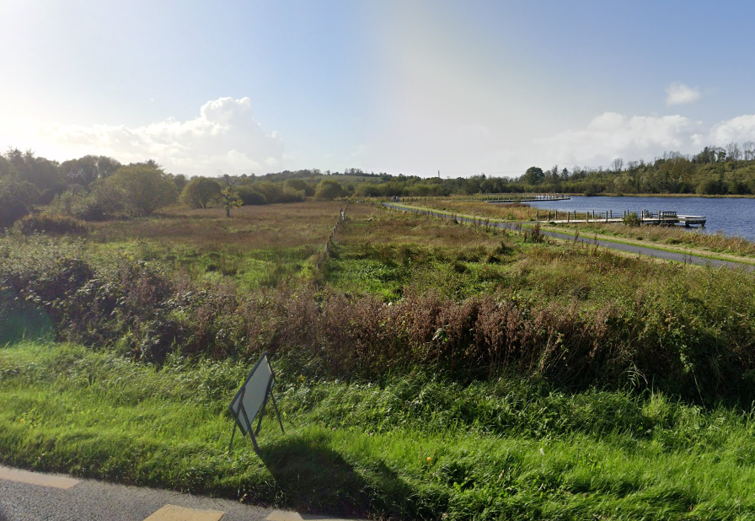

Figure 1: View west from proposed entrance location of R207

The entrance to the car park will be at this location

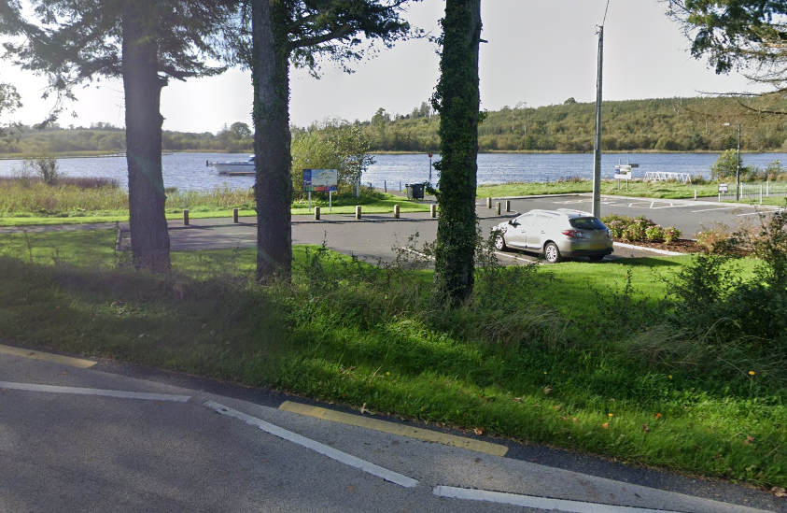

Figure 2 View west to proposed location of Amenity

The new amenity will be located on the existing car park area.

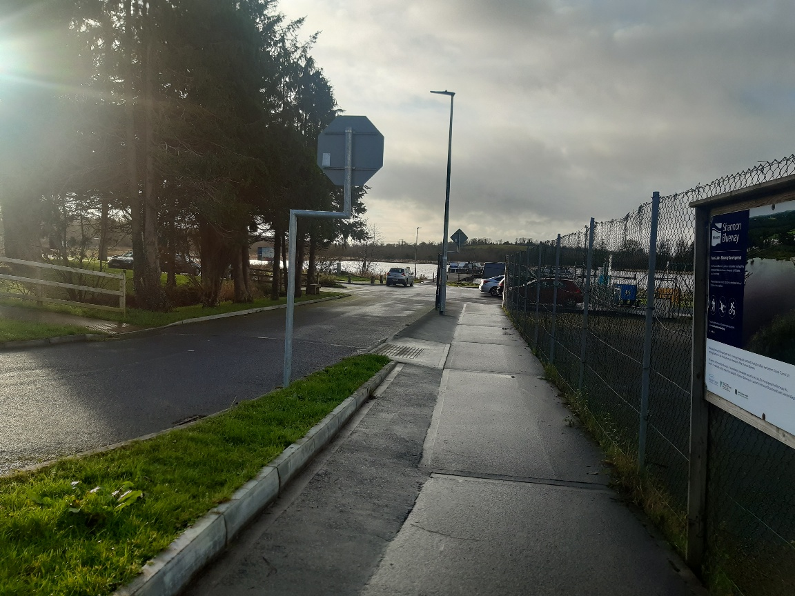

Figure 3: View of entrance to proposed Amenity location

The building will be located to the left of this picture.

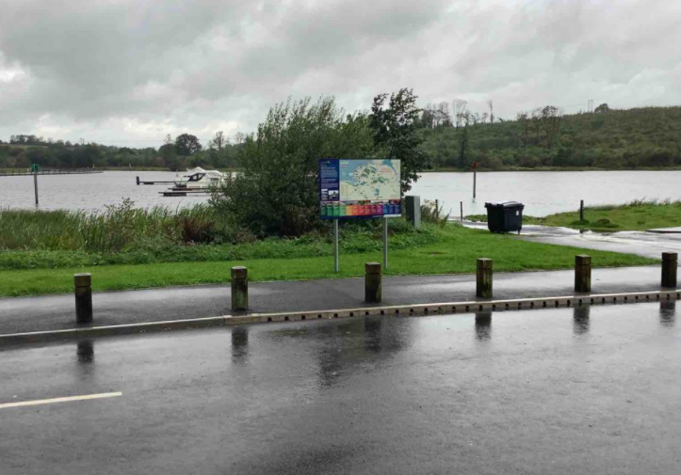

Figure 4: View of from front of proposed building location

This is the view onto Acres Lake from the proposed building location.