Appropriate Assessment
Screening Report

Roosky Towns & Villages Public Footpath Scheme
traversing the townlands of Moher, Knockmacrory and Killinaker at Roosky, County Leitrim.

Prepared By:
Capital Projects Office
Leitrim County Council

June 2022
Contents

1.0 Introduction
1.1 Purpose of this report
1.2 Overview of proposed development
1.3 Requirement for Appropriate Assessment
2.0 Natura Sites
2.1 Special Areas of Conservations (SAC’s)
2.2 Special Protected Areas (SPA’s)
2.3 Map of Area
2.4 Assessment Criteria/Screening Matrix
3.0 Conclusion
4.0 Data Collection
5.0 Appendices

Introduction

Leitrim County Council proposes to construct a new footpath with public lighting on the L-1601 (the old N4 route) traversing the townlands of Moher, Knockmacrory and Killinaker at Roosky, Co. Leitrim. The main objective of this proposal is to provide walking infrastructure to the speed limits of the village whilst also incorporating a reduction in the road carriage width to the centre of Roosky. It is envisaged that this will aid in reducing the speed of vehicles entering the village and deliver a safe pedestrian route to the outer extents of the village.
The provision of the proposed footpath is aligned with the following policy and objectives of the County Development Plan 2015 - 2021:
- Policy 44
It is the policy of the Council to support the National Policy document Smarter Travel: A Sustainable Transport Future and implement, where feasible, guidance provided within the Design Manual for Urban Roads and Streets, or any updated versions of these documents issued within the lifetime of the Plan.
- Policy 46
It is the policy of the Council to encourage safe walking and cycling by providing linear parks, footpaths, cycle paths and public lighting in towns and villages.
- Policy 47
It is the policy of the Council to seek to improve the facilities for pedestrians and access facilities for people with special mobility needs in line with the aims of the European Charter of Pedestrian Rights.
- Objective 39
It is an objective of the Council to ensure all towns and villages have adequate footpaths and public lighting.

1.1 Purpose of this report

This report has been prepared specifically to address Article 6(3) obligations under the European Community (EC) Directive 92/43/EEC on the conservation of natural habitats and of wild flora and fauna (commonly known the Habitats Directive), which is transposed into Irish legislation under the European Communities (Birds and Natural Habitats) Regulations 2011 (as amended).

Overview of the Proposed Development

The proposed project to carry out the following works traversing the townlands of Moher, Knockmacrory and Killinaker at Roosky, County Leitrim: -

- Construction of a public footpath of 2.0m wide and associated public lighting along the L-1601 outbound from Roosky Village, from the end of the existing footpath as far as the 80km/hr speed limit north of the village, extending for a distance of approximately 340m. By doing this, the road carriageway will be reduced from a width of 7.3m to 6.2m

- The scheme will also include landscaping, the replacement of an existing hedgerow with a wall, underground of ESB overhead lines, the installation of timber fencing

- Removal and reinstatement of road line marking.

- All necessary ancillary works.

The purpose of these works is to improve access for locals and visitors to the area and to reduce vehicular speeds entering and travelling through the village.

Requirement for Appropriate Assessment

The purpose of this Appropriate Assessment (AA) screening report is to consider whether, based on best scientific knowledge, this project will have potential impacts upon the conservation objectives of any Natura sites, and if so, the development where necessary, of mitigation or avoidance measures to preclude negative effects.
Natura Sites refer to Special Areas of Conservation (SAC’s) designated under the Habitat’s Directive and Special Protection Areas (SPA’s) designated under the Bird’s Directive. These sites are protected habitats of Flora and Fauna of European importance.
It is also the policy of Leitrim County Council to take appropriate steps to avoid, in these areas, the deterioration of natural habitats of species as well as disturbance of the species for which the areas have been designated, in so far as the disturbance could be significant in relation to the objectives of the Habitat’s Directive 92/43/EEC Directive.
This is outlined in the County Development plan 2015-2021 which states “ it is the policy of the council to protect and conserve Special Area of Conservation and Special Protection Area including Candidate and Proposed areas”
This report has been prepared to provide the relevant information to inform the assessments to be undertaken for the Screening Statement for AA for the Proposed Footpath Development at Roosky, Co. Leitrim and has been prepared to assist address Article 6(3) obligations under the Habitats Directive and to inform the AA determination of the competent authorities.

2.0 Natura Sites

Natura sites are protected habitats for Flora and Fauna of European importance. They comprise of Special Areas of Conservation (SAC’s) and Special Protected Areas (SPA’s). Site synopses in respect to SAC’s and SPA’s relevant to Roosky are included in this report.

2.1 Special Areas of Conservation (SAC’s)

These are prime wildlife conservation areas in the country, considered to be important on a European as well as Irish level. The EU Habitats Directive (92/43/EEC) lists certain habitats and species that must be protected. Sites proposed for designation are called candidate special areas of conservation (SAC) and are legally protected under the Habitats Directives and EU Regulations. Details of these sites will be formally designated by the Minister as SAC. The SAC’s closest to Roosky are indicated on the attached map (Map No 1) and are listed below.

Special Areas of Conservation in adjacent 15 km of the proposed works
Site Code | Site Name
001626 | Annaghmore Lough (Roscommon) SAC
002346 | Brown Bog SAC
002348 | Clooneen Bog SAC
001818 | Lough Forbes Complex SAC

2.2 Special Protected Areas (SPA’s)
These sites are areas of importance for birds (and often are also important for other types of wildlife). The EU Birds Directive (79/409/EEC) requires designation of SPA’s for listed rare and vulnerable species, regularly occurring migratory species and wetlands, especially those of international importance, which attract large numbers of migratory birds each year. Any development in, near or adversely affecting an SPA should avoid any significant adverse impact on the feature for which the site has been designated. SPA’s were given effect in Irish Law mainly under the Conservation of Wild Birds Regulations 1985 (SI 291 of 1985)
The SPA’s which relate to this proposed project in Roosky are indicated on the attached map and listed below.
Site Code | Site Name
004101 | Ballykenny Fisherstown Bog SPA

2.3 Map of Area (15km radius)

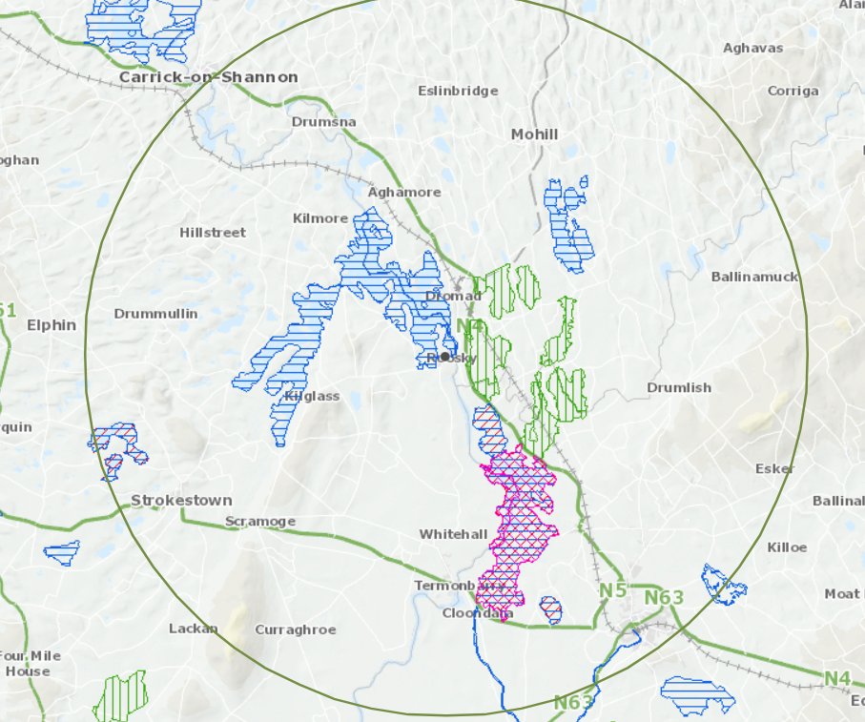

2.4 Assessment Criteria/Screening Matrix

2.4.1 Description of the Project
Leitrim County Council proposes to construct a new footpath and public lighting on the L-1601 traversing the townlands of Moher, Knockmacrory and Killinaker at Roosky, Co. Leitrim. The strategic aim of this project is to support and develop structures which will provide a change in how people travel. The proposal is to provide walking infrastructure to connect the developments within the speed limits to the village centre of Roosky. This project will promote safer pedestrian facilities and slow down vehicle speeds approaching and driving through the village of Roosky.

The proposed development consists of the following:
- Construction of a public footpath of 2.0m wide and associated public lighting along the L-1601 outbound from Roosky Village, from the end of the existing footpath as far as the 80km/hr speed limit north of the village, extending for a distance of approximately 340m. By doing this, the road carriageway will be reduced from a width of 7.3m to 6.2m
- The scheme will also include landscaping, the replacement of an existing hedgerow with a wall, underground of ESB overhead lines, the installation of timber fencing
- Removal and reinstatement of road line marking,
- All necessary ancillary works.

The provision of the proposed footpath is aligned with the following policy and objectives of the County Development Plan:
- Policy 44
It is the policy of the Council to support the National Policy document Smarter Travel: A Sustainable Transport Future and implement, where feasible, guidance provided within the Design Manual for Urban Roads and Streets, or any updated versions of these documents issued within the lifetime of the Plan.
- Policy 46
It is the policy of the Council to encourage safe walking and cycling by providing linear parks, footpaths, cycle paths and public lighting in towns and villages.
- Policy 47
It is the policy of the Council to seek to improve the facilities for pedestrians and access facilities for people with special mobility needs in line with the aims of the European Charter of Pedestrian Rights.
- Objective 39
It is an objective of the Council to ensure all towns and villages have adequate footpaths and public lighting.

2.4.2 Special Area of Conservation and Qualifying Interests
Annaghmore Lough (Roscommon) SAC
Qualifying Interest (*=Priority Habitat) | Ecological Group | Conservation Objective
Alkaline fens [7230] | Annex I freshwater/ terrestrial aquatic habitat | To maintain favourable conservation condition
Geyer’s Whorl Snail (Vertigo geyeri) [1013] | Annex II terrestrial species | To restore favourable conservation condition
Clooneen Bog SAC
Qualifying Interest (*=Priority Habitat) | Ecological Group | Conservation Objective
Active raised bog* [7110] ** | Annex I freshwater/ terrestrial habitat | To restore or maintain favourable conservation condition
Degraded raised bogs still capable of natural regeneration [7120] | Annex I freshwater/ terrestrial habitat | To restore favourable conservation condition
Depressions on peat substrates of the Rhynchosporion [7150] ** | Annex I freshwater/ terrestrial habitat | To restore or maintain favourable conservation condition
Bog woodland [91D0] | Annex I freshwater/ terrestrial habitat | To maintain the favourable conservation condition
Lough Forbes Complex SAC
Qualifying Interest (*=Priority Habitat) | Ecological Group | Conservation Objective
Natural eutrophic lakes with Magnopotamion or Hydrocharition - type vegetation [3150] | Annex I freshwater habitat | To restore favourable conservation condition
Active raised bogs [7110] | Annex I freshwater/ terrestrial habitat | To restore favourable conservation condition
Degraded raised bogs still capable of natural regeneration [7120] | Annex I freshwater/ terrestrial habitat | To restore favourable conservation condition
Depressions on peat substrates of the Rhynchosporion [7150] | Annex I freshwater/ terrestrial habitat | To restore favourable conservation condition
Alluvial forests with Alnus glutinosa and Fraxinus excelsior (Alno-Padion, Alnion incanae, Salicion albae) [91E0] | Annex I terrestrial habitat | To restore favourable conservation condition
Brown Bog SAC
Qualifying Interest (*=Priority Habitat) | Ecological Group | Conservation Objective
Active raised bogs [7110] | Annex I freshwater/ terrestrial habitat | To restore favourable conservation condition
Degraded raised bogs still capable of natural regeneration [7120] | Annex I freshwater/ terrestrial habitat | To restore favourable conservation condition
Depressions on peat substrates of the Rhynchosporion [7150] | Annex I freshwater/ terrestrial habitat | To restore favourable conservation condition
Ballykenny-Fisherstown Bog SPA
Qualifying Interest (*=Priority Habitat) | Ecological Group | Conservation Objective
Greenland White-fronted Goose (Anser flavirostris) [A395] | Annex I bird species | To maintain or restore favourable conservation condition

2.4.3 Assessment Criteria

Describe the individual elements of this project that have potential for having significant effects on the Natura site.

This project has been devised to ensure that it will not give rise to significant adverse impact on the integrity of the SAC and the SPA in so far as the objectives and criteria for determining the needs of the site can be inferred from the relevant sites’ synopsis.

Environmental and ecological best practice as outlined in the National Roads Authority publications and guidelines will be always adhered to. This includes, but is not limited to, the Guidelines for the Protection of Trees, Hedgerows and Scrub (NRA (2006), Guidelines on the Management of Noxious Weeds and Non-Invasive Plant Species (NRA, 2010), with regard to the protection of riparian and wetland vegetation and habitats.

Removal of Mature Trees

Care will the taken to ensure no unnecessary removal of any mature trees or the disturbance of the roots of trees during construction works.

Removal of Hedgerows

Care will the taken to ensure hedgerows will not be affected by these works, apart from being pruned back in places.

Construction of footpath

The volume of excavated material for the new footpath is minimal. Waste material is topsoil and sub soil. All spoil to be taken off site to a waste permitted facility in a timely manner to reduce any impact of silt run off. There will be no significant impact on any natura sites. Material and topsoil storage areas will be cordoned off next to the site and stabilised outside of the SAC and SPA boundaries and away from any watercourse or drain to prevent the possible entry of suspended solids to the river.

All other works i.e road markings and signage will have no impact on any of the Natura sites.

The proposed works allows for proper planning and sustainable development of the area. All construction work will be undertaken in line with best practice, ensuring the minimisation of any impact of the surrounding environment.

Describe any likely direct/indirect or secondary impacts of the project (either alone or in combination with other plans or projects) on the Natura 2000 site

This project will not give rise to adverse direct, indirect or secondary impacts on the integrity of any Natura site arising from its size, scale, area or land take.

Describe any likely direct/indirect or secondary impacts of the project (either alone or in combination with other plans or projects) on Water Supply

The implementation of this project will not have any impact on drinking water in this area.

Describe any likely direct/indirect or secondary impacts of the project (either alone or in combination with other plans or projects) on Emissions and waste

As described previously, any waste material generated by the works will be taken off-site to a waste permitted facility in a timely manner to reduce any potential for silt run off.
Due to the small-scale nature of this project, the emissions produced by vehicles/machinery involved in the construction work are deemed not to be significant.

Describe any likely direct/indirect or secondary impacts of excavation requirements for this project (either alone or in combination with other plans or projects)

The minimal excavation required for this project will not give rise to significant adverse direct, indirect or secondary impacts on the integrity of the Natura sites. Given this, in combination effects will be minimal.

Describe any likely changes to the Natura site arising as a result of reduction of the Habitat

This project will not require any land-take within the Natura Site

Describe any Habitat or Species Fragmentation as a result of this project

This project will not give rise to reduction of habitat or species fragmentation

Describe any Disturbance to Key Species as a result of this project

The Ballykenny Fisherstown Bog SPA, Annaghmore Lough SAC, Clooneen Bog SAC, Lough Forbes Complex SAC and the Brown Bog SAC collectively contain the following habitats and/or key species listed on Annex I / II of the E.U. Habitats Directive

[7110] Active Raised Bog
[7120] Degraded Raised Bog
[7150] Rhynchosporion Vegetation
[91D0] Bog Woodland
[91E0] Alluvial Forests
[7230] Alkaline Fens
[1013] Geyer's Whorl Snail (Vertigo geyeri)
[3150] Natural eutrophic lakes
[A056] Shoveler (Anas Clypeata)
[A052] Teal (Anas Crecca)
[A050] Wigeon (Anas Penelope)
[A061] Tufted Duck (Aythya Fuligula)
[A067] Golden Eye (Bucephala Clangula)
[A038] Whopper Swan (Cygnus)
[A098] Merlin (Falco Columbarius)
[A017] Cormorant (Phalacrocorax Carbo)

No disturbance to the sensitive habitats or species will occur as part of this project.

Describe any reduction of Species Density as a result of this project

This project will not give rise to reduction of Species Density

Describe any impact on Climate Change
The provision of the proposed footpath will facilitate a direct increase in pedestrian usage along the route. This will result in a reduction in the carbon footprint caused by vehicular traffic, thereby providing a positive contribution to Climate Change.

Describe any likely impacts on the Natura site in terms of the key relationship that define the structure of the site
Disturbance to the surrounding environment will be limited to noise and vibration during the construction period. No disturbance to sensitive habitats or species will occur as part of this project.

3.0 Conclusion

Following a comprehensive evaluation of the potential direct, indirect and cumulative impacts on the SCIs in light of their Conservation Objectives, it has been concluded that the proposed development will not have a significant effect on any European site.

It is the opinion of the author that a Stage II Appropriate Assessment is not required. No Natura 2000 site was found to have the potential to be affected by this small-scale infrastructure project.

4.0 Data Collection

This assessment was a Desk top study carried out by members of Leitrim County Council Capital Projects Office. Following completion of the assessment, the draft report was reviewed by the Planning Department in advance of the proposed PART 8 application being placed on public display.

5.0 Appendices

5.1 002348 – Clooneen Bog SAC Site Synopsis

5.2 002348 – Clooneen Bog SAC Standard Data Form

5.3 002348 – Clooneen Bog SAC Conservation Objective Series

5.4 001626 – Annaghmore Lough (Roscommon) SAC Site Synopsis

5.5 001626 – Annaghmore Lough (Roscommon) SAC Standard Data Form

5.6 001626 – Annaghmore Lough (Roscommon) SAC Conservation Objective Series

5.7 002346 – Brown Bog SAC – Site Synopsis

5.8 002346 – Brown Bog SAC – Standard Data Form

5.9 002346 – Brown Bog SAC – Conservation Objective Series

5.10 001818 – Lough Forbes Complex SAC - Site Synopsis

5.11 001818 – Lough Forbes Complex SAC - Standard Data Form

5.12 001818 – Lough Forbes Complex SAC - Conservation Objective Series

5.13 004101 – Ballykenny Fisherstown Bog SPA - Site Synopsis

5.14 004101 – Ballykenny Fisherstown Bog SPA - Standard Data Form

5.15 004101 – Ballykenny Fisherstown Bog SPA - Conservation Objective Series

