**Leitrim County Council**



**PLANNING AND DEVELOPMENT ACT, 2000 (As Amended)**

**PART XI**

***PLANNING AND DEVELOPMENT REGULATIONS 2001 (As Amended)***

**PART VIII**

**PLANNING REPORT**

***Proposed public car park and public access to the Coastline from Tullaghan Village.***

**Introduction and Background to Project**

Leitrim has a short but beautiful coastline that opens into Donegal Bay. This shoreline is also very popular with surfers that come to the area from neighbouring Bundoran, Co. Donegal. The currents and waves that come into the bay are ideal for surfers. There is currently no public access to the shoreline from any public road in County Leitrim. Surfers currently access the shoreline through private lands.

Tullaghan is the only coastal town in County Leitrim with its rich archaeology and history this is an untapped resource belonging to the area. Creation of a public access to the shore and a car park would increase visitor numbers to the area and boost the local economy.

Leitrim County Council is proposing the development of a public car park and a public access route to the Coastline from Tullaghan Village.

These works include

1. The widening and surfacing of the existing access road to the Wastewater Treatment Plant site to include the provision of a 1.8m wide footpath with public lighting and the restoration of the existing piers and boundary wall at the entrance area off public road L2059.
2. Provision of carparking at the Treatment Plant site, including hard and soft landscaping of the site and the provision of public lighting.
3. Construction of a 4m wide road from the proposed carpark to the coastline for pedestrian and emergency vehicle access with a Turning circle and the provision of seating and a Biodiversity Area.

**Scheme Overview**

The scheme is located close to the centre to Tullaghan Village. The scheme will start from the public road L2059. There is an existing footpath from the centre of the village to the start of the scheme. It will follow the existing access roadway to the wastewater treatment plant. This roadway will be upgraded and new fencing erected alongside.

The area adjacent to the wastewater treatment plant is in ownership of Leitrim County Council. This is where the car park will be constructed with the provision of 15 car park spaces. A new fence and hedge will be installed around this new car park. A pedestrian roadway will follow around the fenceline of the wastewater treatment plant and join the proposed 4m wide roadway to the shoreline. This will have a stockproof fence and hedging on the eastern side of it. To the west of the roadway, there will be a biodiversity area created. This will be an additional attraction for the scheme. There will also be a seating areas installed near the shoreline.

When visitors reach the shore, there are many attractions that can be viewed from the scheme. The nearby cairn, folly tower and sea views are areas of interest.

The location and details of the project accompany the Part VIII application drawings.

**Landownership**

The first section of the existing access route from the public road has been recently purchased by Tullaghan Community Development and they fully support this Project. Leitrim County Council have a registered right of way over this section of road way as it is part of the access to the Wastewater Treatment plant Site. Leitrim County Council own the area of land around the Wastewater treatment plant site where the carpark is proposed and have a land acquisition agreement in place to acquire the remaining lands that form part of this Scheme subject to Planning.

**Planning Policy Context**

***National Policy***

Smarter Travel: A Sustainable Transport Future, (2009) is the transport policy for Ireland for the period 2009-2020. It recognises the vital importance of continued investment in transport to ensure an efficient economy and continued social development, but also promotes more sustainable transport modes such as walking, cycling and public transport.

National Cycle Policy Framework (2009-2020)

The National Cycle Policy Framework (as part of Smarter Travel – A Sustainable Transport Future 2009) sets out a national policy for cycling, in order to create a stronger cycling culture, a friendlier environment for cycling and improved quality of life. The vision is that all cities, towns and rural areas will be bicycle friendly. The policy document sets a target of 10% of all trips by bicycle by 2020 and places emphasis on promoting and integrating cycle networks.

***Leitrim County Development Plan 2015 – 2021***

Leitrim County Council has a number of policies and objectives set out in our County Development Plan which supports the proposed development. Policy No 1 states that it is the policy of the Council to deliver a *County Tourism Strategy* which will, inter alia, forge strategic and operational partnerships in tourism planning, marketing and promotion with surrounding Counties in the Northwest and Northern Ireland.

Section 3.6.1 of the County Development Plan deals with Sustainable Transportation.The policies and objectives contained therein are guided by the national policy document “*Smarter Travel: A Sustainable Transport Future*, (2009)” which is referred to above. The promotion of initiatives that can reduce congestion, improve local environments, and encourage healthier and safer lifestyles are key features of sustainable transportation. Leitrim County Council seeks to influence people’s travel behaviour towards more sustainable options and seeks to do so by working closely with relevant organisations in improving public transport facilities and promoting opportunities for alternative transportation such as walking and cycling.

Leitrim County Council also recognises the importance of walking and cycling to the well being and quality of life of residents. It will support and encourage the continued development of walking as a sustainable form of transportation and will work with organisations and groups in the promotion of safe walking throughout the county, including heritage walks and the protection of public rights of way, which are an important amenity and tourism resource.

In accordance with the principles of sustainable development, the basis of the Council’s transportation policies includes the encouragement of walking and cycling as a recreational activity and a healthy exercise.

Section 3.6.3 of the County Development Plan deals specifically with Walking and Cycling. A number of long distance walking and cycling tourist routes have been laid out and signposted throughout the County. The Council will facilitate the maintenance of existing routes and further expansion of these networks in co-operation with local community groups and the Regional Tourism Authority. These routes will be appropriately signposted so as to facilitate tourists and warn motorists.

**Objective 29** It is an objective of the Council to seek opportunities for the development of suitable walking routes, cycle tracks and bridle paths along redundant railway lines and other suitable locations such as; along waterways and historical access routes.

Section 3.10.2 of the County Development Plan deals with the ‘*Provision for Recreation and Amenity*’. The Council is aware that the tourism potential of its amenities has not yet been fully developed and will facilitate, and where necessary become directly involved in, the promotion and development of amenities.

Relevant policies and objectives in this regard include:

**Policy 18** It is the policy of the Council that in the coastal area, with particular reference to

the seaward side of the coast roads (LP‐2059‐1, LP‐2059‐2 and LP‐2059‐3),primary importance will be given to the conservation or enhancement of the landscape and coast, subject to any changes in the National Foreshore Policywhich is currently under review.

**Policy 19** It is the policy of Leitrim County Council to actively promote and protect public

access to the coast.

**Policy 46** It is the policy of the Council to encourage safe walking and cycling by providing linear parks, footpaths, cycle paths and public lighting in towns and villages.

In relation to Natura 2000 sites which refer to Special Areas of Conservation and Special Protection Areas, the County Development Plan states that the Council shall take appropriate steps to avoid, in these areas, the deterioration of natural habitats and the habitats of species, as well as disturbance of the species for which the areas have been designated, in so far as such disturbance could be significant in relation to the objectives of the *EU Habitats Directive (92/43/EEC Directive)*.

With regard to Natura 2000 sites, the County Development Plan includes the following policies:

**Policy 76** It is the policy of the Council to protect and conserve Special Areas of Conservation and Special Protection Areas including ‘Candidate’ and ‘Proposed’ areas.

**Policy 77** It is the Policy of the Council to ensure that all Plans and Projects that have the potential to negatively impact on the integrity of the Natura 2000 network, will be subject to a Habitats Directive Assessment (HDA), in accordance with Article 6 of the Habitats Directive and in accordance with best practice and guidance.

**Appropriate Assessment**

NATURA 2000 sites are protected habitats for flora and fauna of European importance. They comprise Special Areas of Conservation (SACs), designated under the Habitats Directive and Special Protection Areas (SPAs), designated under the Birds Directive. The proposed Greenway is located near two areas of interest. Donegal Bay is a Special Area of Conservation (SAC) and Lough Melvin is both a Natural Heritage Area (NHA) & Special Area of Conservation (SAC).

An Appropriate Assessment Screening Report has been prepared to assist the Planning Authority in their determination. The Appropriate Assessment Screening Report concludes that the project will have no significant effect on any Natura 2000 sites and that the project does not require to be progressed through to Stage II Appropriate Assessment under the Habitats Directive.

**Archaeological Assessment**

An archaeological assessment was carried out to assist the Planning Authority in May 2021. The findings from this report were that there are some nearby historical features such as a cairn, tower folly and Tynte Lodge. None of these features will be affected by the works in this scheme. The report recommends that the proposed scheme be subject to a programme of archaeological monitoring during construction, where ground works involve removal of topsoil or subsurface works such as drainage.

**Appendix I Photographs of Proposed Access to the Sea**

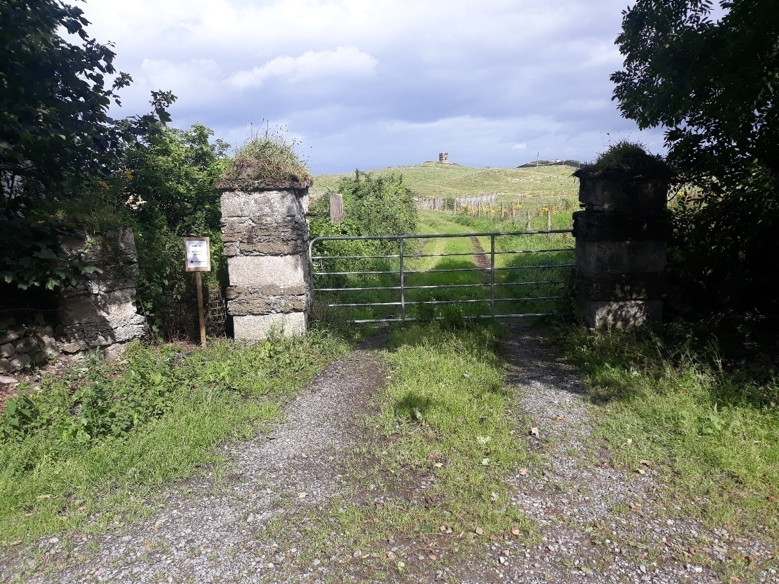

Figure 1: View north from L2059

This is looking north into the existing access road to the wastewater treatment plant.

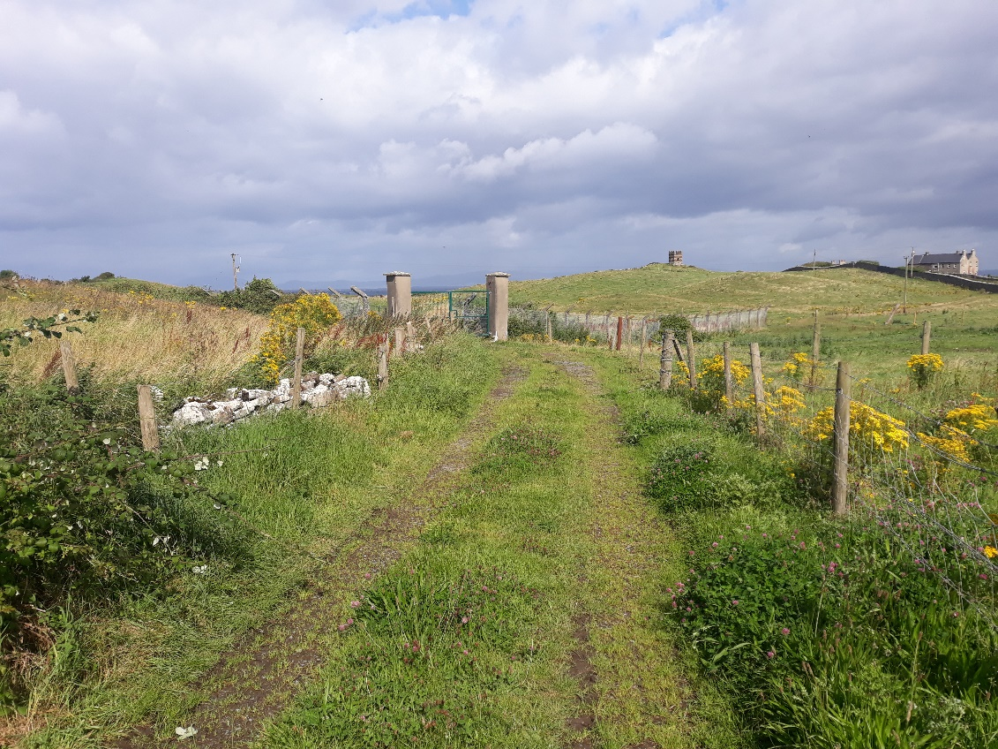

Figure 2 View north towards wastewater treatment plant

The access road will follow this existing roadway.

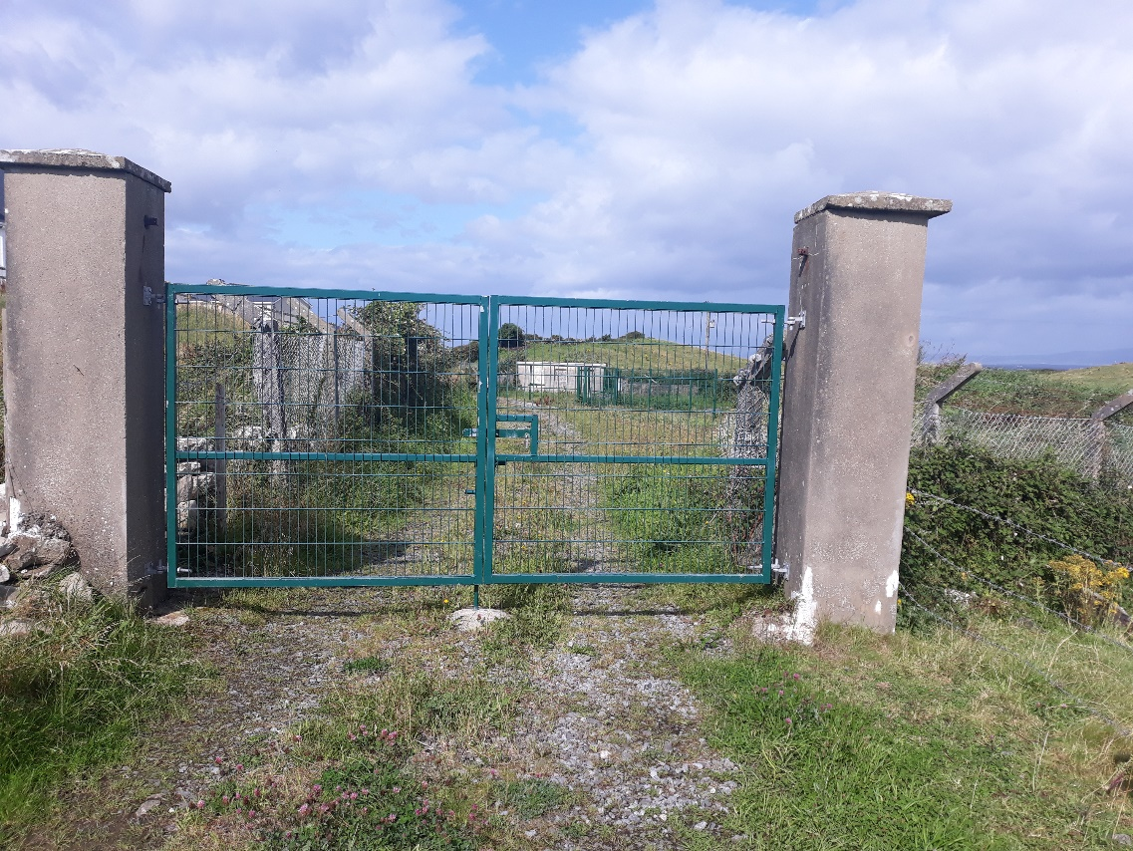

Figure 3: Entrance to proposed car park

This is the entrance to the grounds where the proposed car park will be located.

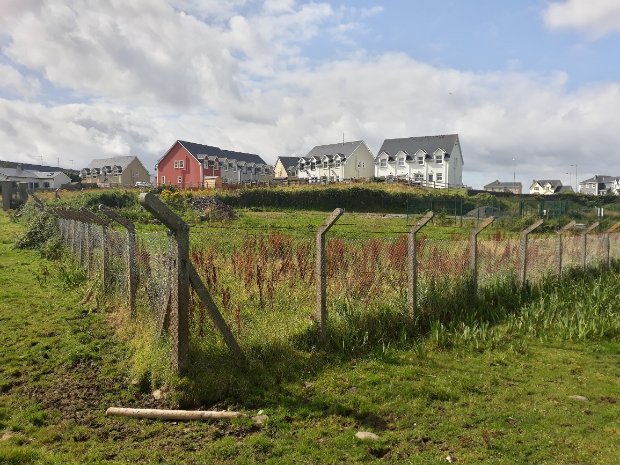

Figure 4: View of location of proposed car park

Looking southwest into location of proposed car park. The existing fence will be replaced and hedging planted alongside it.

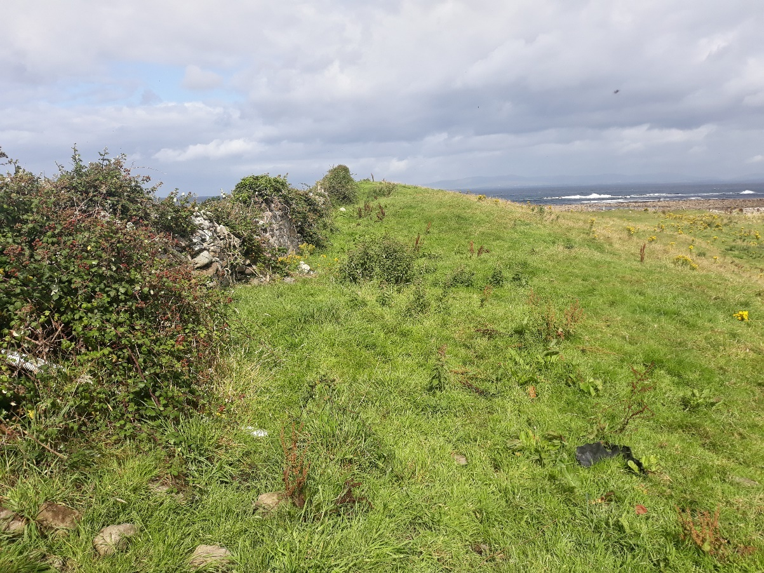

Figure 5: Looking north towards shoreline.

Looking north at proposed biodiversity area.

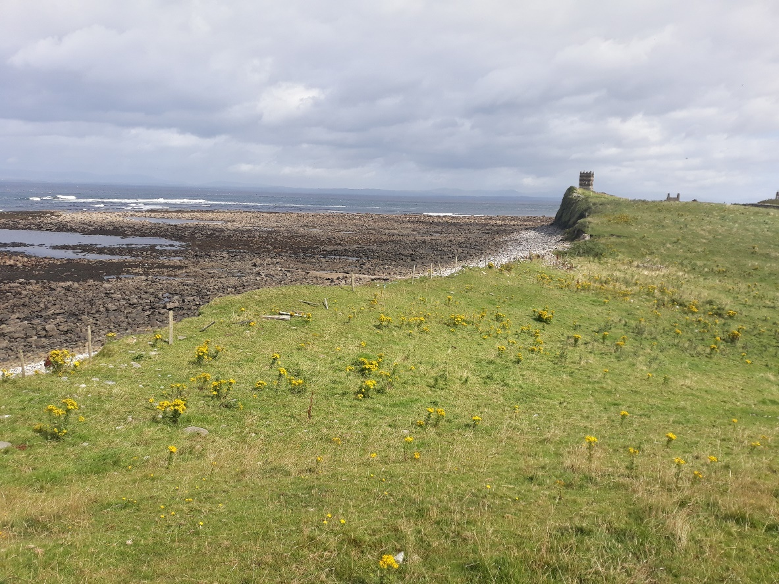

Figure 6: Looking to area where proposed picnic area and turning area will be created along shoreline.