# **SUBMISSION TO LEITRIM COUNTY DEVELOPMENT PLAN**

# **GOOD ENERGIES ALLIANCE IRELAND**

# **AUGUST 2020**

1. INTRODUCTION

Good Energies Alliance Ireland (GEAI) is an environmental NGO located in Leitrim since 2012. Initially taking a lead role in the campaign against fracking in Ireland, it now focuses on climate change and the just transition to a low emissions economy, and in particular, to the move from fossil fuels to sustainable sources and uses of energy.

GEAI carries out research, working with 3rd level institutions, e.g. IT Sligo, GMIT, DCU. On its Board of Directors are scientists, engineers, healthcare personnel and business executives. GEAI hosts highly qualified young European volunteers through the Erasmus+ programme to assist them with their work. Their qualifications include environmental science, economics, planning, IT and communications, and law.

Achievements include: influencing 2017 legislation to ban fracking in Ireland; Cróga initiative (see below), submissions to national policies on climate action; household energy surveys (2018/2019) in Leitrim, Roscommon and Sligo (with IT Sligo); position papers on wind and solar energy and microgeneration; conferences (2013, 2015, 2018); seminars, climate dialogue sessions, climate action schools programme for TY, delivered to 3 local schools.

1. CRÓGA PROJECT

*“While focusing on the immediate challenge of getting people back to work, we are also conscious of the importance of Just Transition as we end fossil-fuel dependence and as digital disruption and automation becomes more prevalent. We will create economic opportunity through climate action and establish bottom up mechanisms to ensure local and national policy making addresses community needs to ensure that nobody is left behind…*

*We will support the European Green Deal, which provides a roadmap for Europe to take advantage of the opportunities presented by moving to a low-carbon future. We will direct any relevant funding under the European Green Deal towards decarbonising projects such as renewable energy, retrofits, ecosystem resilience and regeneration, clean research and development spending and reskilling needs…”*

(Programme for Government 2020)

GEAI is very aware of the climate crisis now upon us and as part of our response, we initiated the CRÓGA project in 2019. Cróga means “brave” and also is the acronym for *Climate Resilient Opportunities for Generations Ahead.* The CRÓGA project takes an area-based approach to the issues of greenhouse gases (GHG) emissions, focusing initially on County Leitrim, and is therefore very relevant to local climate actions.

Stage 1 of the project involved taking all major sectors in Leitrim and calculating the GHG emissions from each. This included agriculture, energy, transport and the built environment (residential and commercial); it also included a study of the sequestration of carbon by our natural sinks, mainly forests, hedgerows and bogs. The methodologies and results are described in the Cróga Report and Executive Summary. <https://www.goodenergiesalliance.ie/projects/leitrim-croga/>

Infographs have been designed to summarise and clarify the results for each sector. The following shows the GHG emissions for all sectors of Leitrim activities.

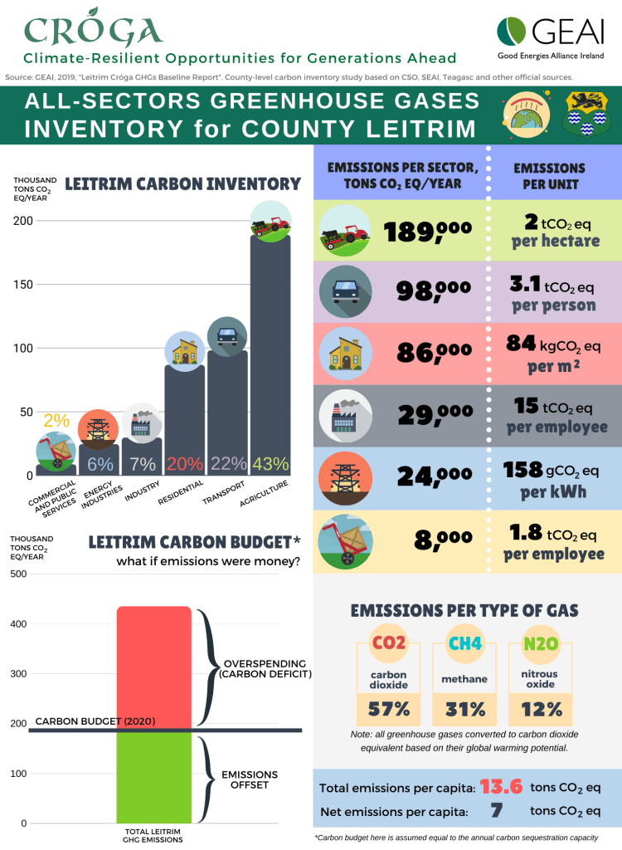

Additional Infographics for each sector are on the GEAI website: <https://www.goodenergiesalliance.ie/projects/leitrim-croga/croga-report/croga-infographics/>

Agriculture is the heavyweight of the emitting sectors – although it represents less than 1% of the sector’s emissions at national level. It is followed by Transport and the Residential sector. Industry and Energy Production Industries have a low impact, due to the lack of a large industrial base in the county, including fossil fuel power plants. Overall, Leitrim GHG emissions are estimated to be c. 0.7% of the total national emissions.

**Leitrim gross emissions per capita** are **13.6 tons CO2 equivalent per year** (on par with national value).

**Net Emissions per capita** (after the sinks are counted) are **7.7 tons CO2 equivalent per year,** 32% less than the national figure.

***The Cróga Report is an important document that should be considered in the context of preparation of a revised Development Plan for Leitrim.***

1. CLIMATE DIALOGUE

Nationally, Climate Dialogue sessions provide opportunities for everyone who has a stake in the Climate Crisis to contribute with ideas and actions to tackle it. The goal of **Cróga Climate Dialogue** was bring the Leitrim community together to come up with **bottom-up initiatives and policies** to make **Leitrim climate proof**, while protecting the **well-being of current and future generations**. Twosessions were facilitated by GEAI staff and entailed many interactive activities and “design thinking” workshops.

The result of these sessions was the identification of 32 separate climate actions, some small, others on a regional or national scale. Among them were:

Agriculture:

* Reform of the CAP system to reward high nature farming
* Land use survey

Energy

* Community solar farms
* Small-scale anaerobic digesters

Forestry

* Agro-forestry

Housing

* New retrofitting programme
* Free BER assessment scheme
* Use of hemp for construction

Transport

* Expansion of Local Link bus service
* Local Carpooling schemes

The outstanding feature of our climate dialogue sessions was the attendance by people from all walks of life, and acceptance by all present that we are in a climate crisis and that business as usual is not an option. The opportunity for members of the community to discuss various topics and contribute to new ideas was welcomed and there was a general feeling that such sessions should be held more often and more widely.

For more details of our Climate Dialogue sessions, see website:

<https://www.goodenergiesalliance.ie/projects/leitrim-croga/leitrim-croga-climate-dialogue/>

1. LEITRIM CLIMATE MITIGATION SCENARIOS

As part of the Cróga project, the researchers also looked at the national emissions targets and created scenarios of how those targets could be achieved in Leitrim. Mitigation scenarios are pathways to bring down GHG emissions in a particular area or economic sector, in a given time horizon. The three main emitting sectors in County Leitrim are **Housing, Transport** and **Agriculture,** 20%, 22% and 43% of the total, respectively.

Leitrim mitigation scenarios were developed by applying the National Climate Action Plan reduction targets to the current levels of emissions described in the Cróga Report. The pathways proposed are tentative and not ground-tested, but constitute explorative, what-if? **scenarios**, and can be a base on which to track future progress and initiatives.

The example given below is a scenario of what needs to be done in the **Residential sector** to bring down our emissions by **31%** by 2030. This emphasises the challenge that is before us. Radical and extensive measures must be put in place to achieve the national reduction targets. This is all the more challenging given that houses in Leitrim emit on average more than **25% more** than the national average.

<https://www.goodenergiesalliance.ie/projects/leitrim-croga/leitrim-croga-mitigation-scenarios/>

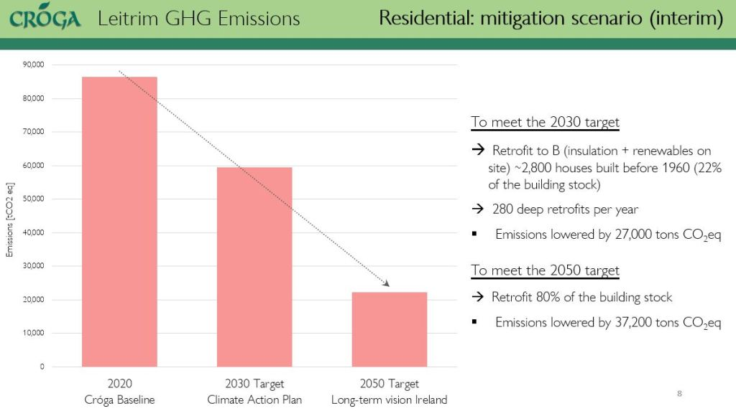

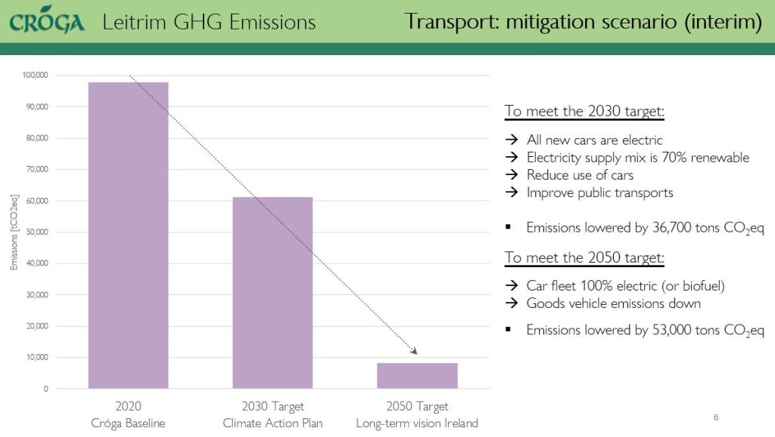

The scenario for **Transport** is even more radical. To reduce our transport emissions by **38%** will require individual as well as general changes in how we move around. These challenges are real and must be tackled. The improvement of public transport in Leitrim is essential, as is the move to electric cars.

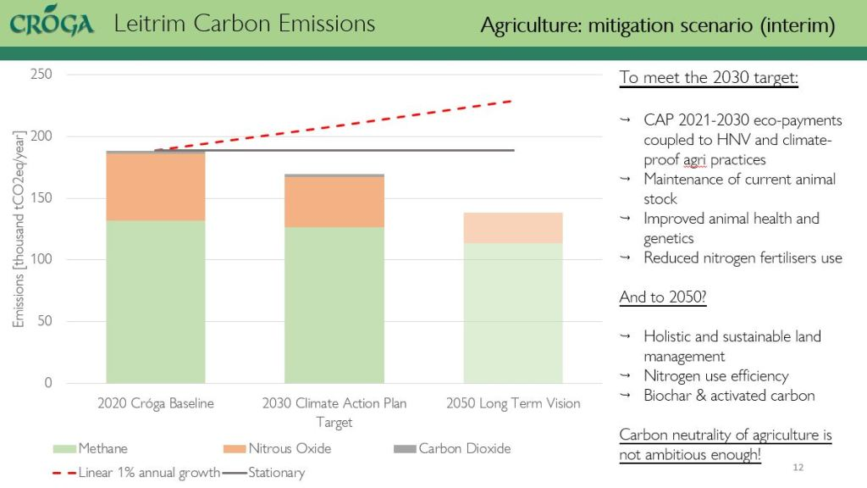

For the **Agriculture** sector, the national Climate Action Plan reduction target sets a reduction in GHGs emissions of **10%** by 2030. This could be achieved by Leitrim farms by adopting a combination of measures proposed by [Teagasc](https://www.teagasc.ie/publications/2019/the-climate-action-plan-and-agriculture.php) in their [MACC analys](https://www.teagasc.ie/media/website/publications/2018/An-Analysis-of-Abatement-Potential-of-Greenhouse-Gas-Emissions-in-Irish-Agriculture-2021-2030.pdf)is (Marginal Abatement Cost Curve).

CONCLUSION

We recognise that the public consultation process for the next edition of Leitrim Development Plan is only starting and that at present general views are required. We want to make the following points:

* Leitrim County Council has the opportunity to create a target of Net Zero Carbon Leitrim by 2030. This target is doable and would bring Leitrim to the forefront in its response to the climate crisis
* The climate crisis requires us to include consideration of climate change in every aspect of our lives, individual as well as societal.
* Leitrim requires a Climate Plan that takes all the above into consideration as well as abatement measures. This should be produced as part of the process towards a new Development Plan.
* Every development decision made must be climate proofed and must have regard for national emissions and mitigation targets.
* The road to Leitrim’s Climate Plan and new Development Plan must include a strong element of public consultation and dialogue with all stakeholders. Climate dialogue sessions are an excellent way of involving community members.